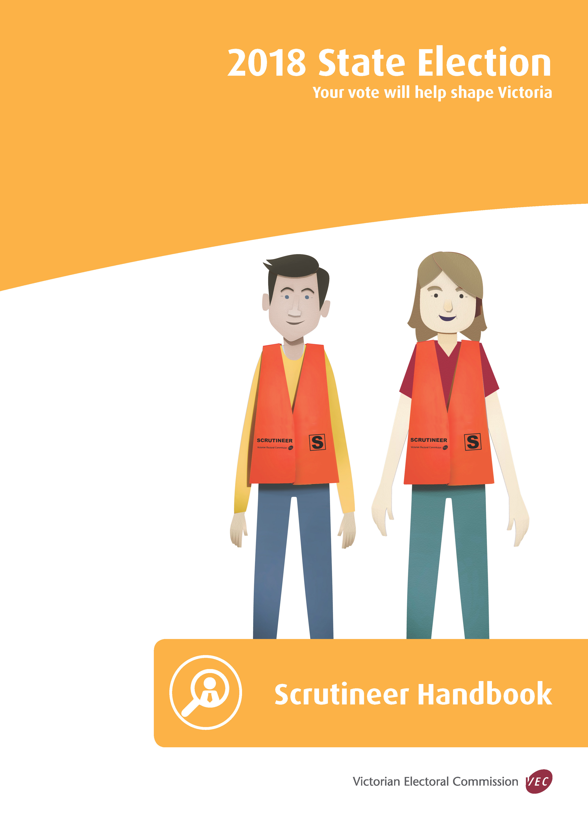
© State of Victoria (Victorian Electoral Commission)
August 2018
Version 1.0

This work, Scrutineer Handbook, is licensed under a Creative Commons Attribution 4.0 licence [http://creativecommons.org/licenses/by/4.0/]. You are free to share this work under that licence, on the condition that you do not change any content and you credit the State of Victoria (Victorian Electoral Commission) as author and comply with the other licence terms. The licence does not apply to any branding, including Government logos.
Introduction
This handbook provides information for scrutineers at Legislative Council (Region) and Legislative Assembly (District) elections for the Parliament of Victoria. It is not a substitute for electoral law and should be read in conjunction with the Electoral Act 2002 and the Electoral Regulations 2012.
Copies are available at legislation.vic.gov.au
Scrutineers are appointed by candidates to represent their interests at elections by ensuring the integrity of the election process. The role of scrutineers is defined by electoral law and is distinct from the role of party/candidate workers or supporters whose activities are not so defined.
Scrutineers have the right to observe all stages of voting and the counting of votes and may challenge decisions on the formality of ballot papers made by Election Managers or election officials. They must not, when in a voting centre, attempt to influence or unnecessarily talk to electors.
When in a voting centre, scrutineers must not wear or display a badge, emblem, or political slogan of a candidate or political party. Scrutineers will be requested to wear a scrutineer badge provided by the Victorian Electoral Commission (VEC) and at some locations may be required to wear a scrutineer’s vest.
Election officials are not full-time employees of the VEC. They are appointed only for election day and are often required to work under considerable pressure to ensure that elections are conducted smoothly and that results are obtained in an orderly way.
Scrutineers must co-operate with election officials and refrain from making unreasonable requests or queries. Any misconduct or failure to obey the lawful directions of the Voting Centre Manager or election official is an offence.
Where a scrutineer wishes to clarify procedures or question the activities of an election official, they must discuss the matter with the Voting Centre Manager or Election Manager (as appropriate).

Contents

Glossary of Terms 1

1. Appointment of Scrutineers 6

Form of Appointment 6

Declaration 6

2. Scrutineers at the Election 7

Scrutineer’s Rights 7

Relieving Scrutineers 8

Offences by Scrutineers 8

Other Offences 8

Public Access to Facilities 9

3. Canvassing at Voting Centres 10

The Six Metre Rule 10

Exhibition of Notices or Signs (100 metre rule) 10

Handing Out How-To-Vote Cards (400 metre rule) 10

Party/Candidate Workers 11

Protocol for Party/Candidate Workers 11

Identifying the Designated Entrance 12

Identifying the boundaries 12

4. Voting Methods 13

Ordinary Voting 13

Early Voting 13

Mobile Voting 13

Declaration Voting 14

Assistance to Vote 16

5. Formality of Ballot Papers 18

District vote formality 18

Damaged ballot papers 22

Region votes 23

Damaged ballot papers 32

6. The Count 33

Postal Votes 33

Election Day 34

Early Vote Sort and Count 35

Early Region and Mobile Voting Counts 35

Provisional Votes 35

Exchange 35

Absent, Interstate, Overseas, and Remaining Early Votes 36

District Counts 36

Region Primary Counts 37

Region Rechecks 37

Region Preference Distributions 37

7. Recount of Votes 39

8. Complaints 40

At the Election Office or other count centres 40

At the Voting Centre 40

Resolution 40

9. Lower House (District) Counting Timetable 41

10. Upper House (Region) Counting Timetable 42

Glossary of Terms
Absent Vote | A vote issued to electors who attend a voting centre outside their District on election day.
Authorised Period | The period on election day prior to the close of voting that allows for the extraction and sorting of votes. For early votes this is the period of two hours prior to the close of voting and for postal votes, 10 hours prior.
Candidate | A person who is nominated under section 69 of the Electoral Act 2002 to stand for election to Parliament.
Canvassing | Soliciting of votes at an election for a candidate or political party.
Central Count Centre | A venue established for entering below-the-line preferences from Region ballot papers into the Victorian Electoral Commission’s (VEC’s) computer count application and calculating Region results.
Close of Roll | The last day to enrol or update enrolment details prior to an election. The roll closes at 8.00 pm seven days after the date of the issue of the writ.
Declaration Issuing Officer | An authorised person (election official) appointed by the Election Manager to issue declaration votes (absent, provisional, and marked as voted) at an election day voting centre.
Declaration Vote | A vote on a ballot paper marked under the following sections in the Electoral Act 2002:  - 106 – Postal;  - 108 – Provisional Enrolment/Vote;  - 109 – Absent;  - 110 – Marked as Voted.
Designated Entrance to Voting Centre | An entrance or entrances to the grounds in which the voting centre is located or to the voting centre itself as designated by the Commission.
District | An electorate for the Legislative Assembly. There are 88 Districts, each electing one member. There are 11 Districts in a Region.
Early Vote | A vote cast by an elector during the early voting period before election day.
Early Voting Centres | Types of voting centres:  - static early voting centres where an eligible elector can vote up to 6.00 pm on the day before election day (either in Victoria, interstate, or overseas); or  - mobile voting centres where voting facilities are provided to patients/residents in a hospital, aged care facility, homelessness agency, or a prison. Mobile voting centres operate for a scheduled period of time.  The Electoral Commissioner appoints early and mobile voting centres for each election.
Election | Means:  - a general election;  - a by-election;  - a supplementary election; or  - a re-election.
Election Day | The day named as the election day on the Writ for an election (Saturday 24 November 2018).
Election Manager | A senior election official appointed by the Electoral Commissioner to conduct an election for an electorate.
Election Office | The location from where the Election Manager conducts the election for a District.  Details of the election office for each District will be available on the VEC website at vec.vic.gov.au
Election Official | An authorised person appointed by the Election Manager to assist the Voting Centre Manager with voting and counting at an election day voting centre.
Election Period | In relation to an election, means the period that starts on the day on which the writ was issued for the election and ends at 6.00 pm on election day.
Elector | A person whose name appears on the electoral roll for the election.
Electoral Commissioner | A person appointed by the Governor-in-Council to be responsible for the administration of electoral law in Victoria. The Electoral Commissioner is the Chief Executive Officer of the VEC with the power to appoint Election Managers, voting centres, and early voting centres.
General Postal Voter (GPV) | A person whose application to be a general postal voter is accepted under section 24 of the Electoral Act 2002. Ballot material is automatically forwarded to GPVs after the close of nominations.
Group | Two or more Region candidates whose names are grouped together on a Region ballot paper.
Group Names | Registered political parties registering a group of candidates for a Region may further request the name(s) of the party(ies) and logo(s) be printed on the ballot paper. Non-party groups may not request a name or logo.
Group Registration | When two or more Region candidates make a request to the VEC to have their names grouped together on a Region ballot paper.
Group Voting Ticket | A document that sets out a group’s order of voting preference for all candidates in the Legislative Council election. The ticket applies to ballot papers marked for a group above the line.
How-to-vote Card | Any electoral material that:  - is or includes a representation or partial representation or purported representation or purported partial representation of a ballot paper for use in an election; or  - lists the names of any or all of the candidates for an election with a number indicating an order of voting preference against the names of any or all of those candidates.
Independent Candidate | A candidate not endorsed by a political party registered with the VEC.
Joint Voting Centres | A voting centre located close to an electorate boundary where ordinary ballot papers are issued for the residing District and the neighbouring District.
Laptop | An electronic device to allow an authorised person to mark elector’s names off the roll stored electronically at the VEC. They are provided to all early voting centres and mobile voting teams to search for and mark electors off the roll.  Some election day voting centres will be provided with Laptops, where Declaration Issuing Officers will search for electors and mark absent electors off the roll.
Ordinary Vote | A vote issued to an elector who attends an election day voting centre in the District for which they are enrolled.
Ordinary Issuing Officer | An authorised person (election official) appointed by the Election Manager to mark ordinary electors off the roll, issue ordinary ballot papers, and count ballot papers at an election day voting centre.
Party/Candidate Worker | A person who assists a candidate on election day, usually by distributing ‘how-to vote’ material.
Penalty Unit | A unit used to define the amount payable for fines for many offences recorded in Victoria’s Acts and Regulations. The dollar amount of a penalty unit is updated from 1 July every year.
Provisional Vote | A vote issued to a person who claims to be entitled to vote at an election and the name of that person is not on or cannot be found on, the electoral roll.
Recheck | The standard procedure undertaken by an Election Manager when ballot papers are re-examined for formality and correct sorting. Should not be confused with the term ‘recount’.
Recount | A re-examination and count of all formal and informal ballot papers by an Election Manager before the declaration of the election.
Region | An electorate for the Legislative Council. There are eight Regions, each electing five members and comprising of 11 Districts.
Region Coordinator | A senior election official appointed by the Electoral Commissioner. The Region Coordinator will provide support during the rechecking and recounting of Region ballot papers, and dispatch of ballot papers marked below the line to the count centre.
Region Election Manager | The Region Election Manager oversees the count for the Regions and is responsible for decisions on below-the-line ballot paper formality at the central count centre.
Region Recheck Centre | A venue established for centralised rechecking all Region ballot papers within a Region after election day.
Restricted Area | The area established under s.110J (6) of the Act that allows early and postal vote extraction and sorting to take place prior to the close of voting to ensure the security and secrecy of the process.
Roll | The roll of electors as at the close of rolls for the election. If requested, an electronic copy of the roll is provided to candidates.
Scannable Roll | The electoral roll printed for marking electors as having voted, then scanned to capture marked electors.
Scrutineer | A person appointed by a candidate to observe certain procedures on the candidate’s behalf at an election.
Silent Elector | An elector whose address details are not included on the electoral roll because of a request made under section 31 of the Electoral Act 2002. Their address is listed on the roll as ‘Address Suppressed’. Such a person has declared that the inclusion of his or her address details on the roll will place that person’s or family’s safety at risk.
Tablet | A device provided to election officials to correctly identify each elector’s District and Region. It is used to confirm an elector’s enrolment status especially prior to issuing a provisional vote.
Telephone Assisted Voting | A secure voting facility provided by the VEC to enable electors who would not otherwise be able to vote without assistance, because they are blind or have low vision, or motor impairment.
Victorian Electoral Commission (VEC) | The Commission responsible for the conduct of state Parliamentary elections. In addition, it is responsible for the conduct of local government elections.  The VEC is established under section 6 of the Electoral Act 2002.
Voting Centre | A place appointed by the VEC for voting at an election as:  - an early voting centre;  - a mobile voting centre; or  - an election day voting centre.
Voting Centre Manager | An authorised person (election official) appointed by the Election Manager to conduct the voting and counting at an election day voting centre.

1. Appointment of Scrutineers

Form of Appointment
Forms for the appointment of scrutineers are available from Election Managers and the VEC. Appointments must:
- be in writing;
- contain the name and address of the scrutineer; and
- be signed by the candidate (a photocopied signature is not acceptable).
Appointment forms should be handed to the senior VEC election official at the venue.
On receipt of a completed appointment form the scrutineer will be issued with an identification badge to be worn during the activity they have been appointed to observe. At some locations scrutineers may also be provided with a scrutineer vest as well as the identification badge.
Separate appointment forms are required to be presented where the same scrutineer is working at different venues. If scrutineering for more than one electorate, scrutineers will need a separate appointment form for each electorate. If scrutineering at one venue for one electorate over a number of days, scrutineers only need one appointment form and their attendance each day will be recorded on the back of that form.

Declaration
Before representing a candidate, each scrutineer must sign a declaration that they will not attempt to ascertain the voting intention of any elector or divulge any knowledge acquired concerning the vote of any elector.
This declaration is included on the appointment form and must be signed in front of an election official.

2. Scrutineers at the Election

Scrutineer’s Rights
Scrutineers may observe any aspect of the electoral process where ballot papers are being handled by election officials.
A scrutineer may, at any election day or early voting centre:
- witness the exhibition and securing of an empty ballot box by an election official immediately before the commencement of voting;
- observe the questioning of electors by election officials. Each person claiming to vote must be asked the following questions:
- ‘What is your full name?’;
- ‘Where do you live?’ (silent or itinerant electors are not asked this question); and
- ‘Have you voted before in this election?’
- request the Election Manager or election official to require any person suspected of impersonating an elector to sign the Declaration of Identity before the issue of ballot papers;
- object to the right of any person to vote. The election official must record all such objections, however the person is still permitted to vote;
- observe the process for provisional, marked as voted, and absent voting including the enclosure of, and sealing in declaration envelopes of the ballot papers for all such electors; and
- observe voting by electors incapable of voting without assistance. A scrutineer may either enter a voting compartment to witness an election official marking the elector's ballot paper or, if asked by the elector, enter the voting compartment and mark the elector's ballot paper.
Scrutineers may also:
- accompany and observe the team conducting mobile voting prior to election day;
- observe the assembly and dispatch of postal ballot packs at the VEC’s mailhouse;
- observe the return of completed postal vote material at the VEC’s central processing centre;
- observe the verification of declaration envelopes at the VEC’s central processing centre and election offices after election day; and
- observe the checking of provisional votes by the VEC’s Electoral Enrolment Branch after election day.
Only one scrutineer for each candidate can be appointed for each election official handling ballot material at a particular venue for the District or Region for which the candidate is seeking election.
Access details and activity times for all venues mentioned are available from Election Managers and the VEC.

Relieving Scrutineers
A scrutineer may enter or leave a voting centre during voting or counting and may be replaced during any absence by another scrutineer. The relieving scrutineer must have an appointment form signed by the candidate.
Restrictions may apply to scrutineers attending the extraction and sorting of postal and early votes activities, prior to the close of voting, taking place within a restricted zone. Election Managers or election officials will fully brief scrutineers prior to the commencement of the extraction and sort.

Offences by Scrutineers
During voting a scrutineer must not:
- interfere with or attempt to influence any elector within a voting centre;
- communicate with any person in a voting centre except in so far as is necessary in the discharge of the functions of the scrutineer; or
- handle any ballot papers. [EA s. 76(5)]
PENALTY: 60 penalty units or six months imprisonment
In addition, a scrutineer must not wear or display any badge, emblem, or political slogan of any candidate or political party when inside or within six metres of the entrance to a voting centre. [EA s. 158]
PENALTY: Five penalty units
A scrutineer who commits such a breach, engages in misconduct, or who fails to obey the lawful directions of the Election Manager or election official may be removed from the venue by the police.

Other Offences
Scrutineers and party/candidate workers should also be aware that the following are offences:
To distribute any printed electoral material other than a registered ‘how-to-vote’ card within 400 metres of the entrance of, or within the building used as a voting centre on election day. [EA s. 156(1)]
PENALTY: 60 penalty units or six months imprisonment
To hinder or interfere with another person's electoral rights and responsibilities. [EA s. 152(1) and (1A)]
Indictable Offence
PENALTY: 600 penalty units or up to five years imprisonment
To influence the vote of a person by violence or intimidation.
EA s. 152(2) and (3)]
Indictable Offence
PENALTY: 600 penalty units or up to five years imprisonment
To provide orally or in writing false or misleading information under the Electoral Act 2002. [EA s. 148]
Indictable Offence
PENALTY: 600 penalty units or up to five years imprisonment
To disclose knowledge acquired concerning the vote of any elector or to induce or attempt to induce an elector to disclose how they intend to vote. [EA s. 154]
PENALTY: 120 penalty units or one year imprisonment
To vote in the name of another person, vote more than once at an election, or apply for a ballot paper in the name of another person. [EA s. 150]
Indictable Offence
PENALTY: 600 penalty units or up to five years imprisonment

Public Access to Facilities
VEC officials are encouraged to develop a cooperative relationship with scrutineers and party/candidate workers to facilitate access to facilities at voting and counting centres where possible.
However, the VEC does not own the buildings used as voting centres and in some cases, the building administration places restrictions on access to facilities, that may be some distance away from the room being used for voting. In some cases, building administrators insist that persons other than election officials may only use the facilities as long as they are accompanied by VEC personnel. This may not always be possible during peak voting periods. In both cases, restrictions are put in place for security purposes.

3. Canvassing at Voting Centres
Candidates are requested to ensure that party/candidate workers are aware of the legislative requirements and protocol as outlined below. This applies at early, mobile and election day voting centres.

The Six Metre Rule
A person is not allowed to canvass for votes, solicit the vote of any elector, induce any elector not to vote, or display any unofficial electoral notice within 6 metres of the designated entrance of, or within the building used as a voting centre. [EA s. 158]
PENALTY: Five penalty units
Party/candidate workers distributing registered how-to-vote cards must be outside this limit.

Exhibition of Notices or Signs (100 metre rule)
During the hours of voting a candidate or registered political party may display up to two notices or signs not exceeding 600 mm x 900 mm within 100 metres of the Designated Entrance of the voting centre. No other notices or signs in relation to the election, other than official notices, may be displayed in this area at this time.
Party/candidate workers need to be aware of the following potential situations:
- Candidate office/location – It is possible that a candidate office or other location controlled by the candidate/party may fall within 100 metres of a Designated Entrance of a voting centre. In such a case any signage displayed at the candidate/party location is subject to the 100-metre restricted zone regarding display of notices or signs.
- Private property – Private residences that fall within 100 metres of the designated entrance of the voting centre are exempt from this requirement. Signage displayed in a private residence is not subject to the 100-metre restricted zone regarding display of notices or signs [see s.158A EA].
An Election Manager or election official may remove, or cause to be removed any notice or sign that is reasonably considered as being in contravention.
[EA s158A]
PENALTY: Five penalty units

Handing Out How-To-Vote Cards (400 metre rule)
The only electoral material that may be distributed or made available during the hours of voting within 400 metres of a voting centre on election day are registered how-to-vote cards [EA s. 156]. Cards distributed outside early voting centres do not need to be registered.
PENALTY: 60 penalty units of six months imprisonment.

Party/Candidate Workers
Party/candidate workers may assist electors by handing out how-to-vote cards.
A person must not subject any person who within 100 metres of the designated entrance to the voting centre is handing out how-to-vote cards, or supporting a candidate in an election, to violence or intimidation [EA s152(4)]. A person who contravenes the above section of the Act is guilty of an indictable offence.
PENALTY: 600 penalty units or imprisonment up to five years
Additionally, party/candidate workers must not:
- enter a voting centre to retrieve how-to-vote cards from rubbish bins or voting compartments; or
- canvass within six metres of a designated entrance to a voting centre. The Voting Centre Manager will clearly indicate the six metre distance.
Party/candidate workers may only enter the voting centre:
- to cast their vote; or
- if nominated by an elector who needs assistance to complete the ballot paper.
Party/candidate workers must remove any candidate/party-related ID before entering a voting centre.

Protocol for Party/Candidate Workers
In addition to the legal requirements listed within this handbook, party and candidate workers must abide by the following guidelines in relation to all activities outside early and election day voting centres. Venues used as early and election day voting centres are not the property of the VEC. As such, much good will is relied upon in retaining the venue for subsequent elections.
All party and candidate workers should:
- be attentive to any local restrictions requested by venue owners and the VEC regarding the placement of personnel, notices or signs and ensure that the activities do not interfere with other concurrent activities at the venue;
- ensure the complete removal of any notices or signs (including ties), how-to-vote cards and equipment before leaving the venue at the end of each day; and
- ensure workers and materials do not impede or intimidate people moving in and out of the venue.
A spirit of cooperation is requested from all workers outside voting centres with an equal entitlement to convey their message.
Note that the Voting Centre Manager has the authority to respond to activities that are in breach of the legislation.
Voting Centre Managers will not arbitrate on disputes outside any venue between party/candidate workers.
Voting Centre Managers will request cooperation from all parties in the first instance, but if unsuccessful, the matter will be escalated to the relevant party/candidate administration to resolve, or if necessary, to the Police.

Identifying the Designated Entrance
At the 2018 State election the VEC will identify one Designated Entrance to the building used as a voting centre, unless circumstances apply where further entrances may be designated. An entrance to voting centre grounds (e.g. entrance to school yard within which the building sits) will not be a designated entrance unless there are specific reasons to require it. [158A (5)]
Designated Entrances for each election day voting centre will be identified by Voting Centre Managers. Designated Entrance information will be communicated in advance of election day via a Candidate Bulletin. On election day, Designated Entrances will also be identified via an official sign placed next to the entrance from 7.30 am.

Identifying the boundaries
Voting Centre Managers may make a determination that it is necessary to reduce the 6-metre distance from the Designated Entrance (e.g. due to inclement weather or for safety reasons). If so, this will be noted with the information about the location of the Designated Entrance made available in advance, and the Voting Centre Manager will affix a notice to the Designated Entrance declaring the distance that applies and the reason the distance has been reduced.
Voting centre staff will be able to provide guidance to candidate and party workers regarding the 6-, 100- and 400-metre boundaries on election day. The release of information about designated entrances will enable candidate and party workers to estimate the boundaries for voting centres in advance if they wish. Note, however, that on election day the definitive boundary will be determined by the Voting Centre Manager.


4. Voting Methods
During voting, various methods will be used by electors to record their votes and scrutineers should be aware of the differences.

Ordinary Voting
An ordinary vote is a vote recorded by an elector at an election day voting centre for the District and Region for which they are enrolled.
When voting, the elector must state their full name and address, and that they have not voted before at the election. If the election official is satisfied that the elector is entitled to vote, the roll is marked, ballot papers separated and initialled, and handed to the elector.
The elector must then proceed alone to a voting compartment, mark their vote on each ballot paper, fold them so that the votes are concealed, then place the ballot papers in the ballot boxes and leave the voting centre.

Early Voting
Any elector can vote before election day at an early voting centre.
Early voting centres will operate from the first working day after the close of nominations to 6.00 pm on the day before election day. Details of all early voting centres will be available on the VEC website.
Electors may vote in person at:
- any early voting centre in Victoria (including Melbourne Airport); or
- any of the interstate and overseas early voting centres.
Telephone assisted voting will be provided at the VEC telephone early voting centre for electors who otherwise could not vote without assistance because they are blind or have low-vision or a motor impairment.
People wishing to vote at an early voting centre who cannot be found on the roll will be entitled to apply to enrol and make a provisional vote, by completing a form and giving a proof of identity. The VEC will check these applications after election day.
An elector applying to vote by telephone who cannot be found on the roll will be required to attend a voting centre if they wish to complete a provisional vote.
How-to-vote cards that are distributed outside early voting centres do not have to be registered but must contain the name and street address of the person authorising the card and the name and place of business of the printer.

Mobile Voting
Mobile voting centres are venues such as hospitals and nursing homes appointed by the Electoral Commissioner at which voting facilities are provided at set times within the two weeks prior to election day. The mobile voting team may set up a voting area within the venue or move around the venue issuing early votes to patients and residents.
Candidates may appoint scrutineers to accompany the mobile voting team. An itinerary listing mobile voting centres, dates, and times of visits will be provided to candidates.
Scrutineers are not permitted to display election material or distribute how-to-vote cards while accompanying the mobile team.
Scrutineers and party/candidate workers are not permitted to canvass for votes or distribute election material, including how-to-vote cards, within six metres of the designated entrance to the voting centre while voting is in progress. Additional restrictions apply regarding the display of notices or signs within
100 metres of the designated entrance to the mobile voting centre. Refer to Chapter 3: Canvassing at Voting Centres.
Candidates, registered political parties, and others may provide copies of registered how-to-vote cards to Election Managers to be carried by mobile voting teams.
The registered how-to-vote cards carried by election officials will be enclosed in a folder in the order in which candidates’ or group names appear on the ballot paper.
Mobile voting teams will advise electors that registered how-to-vote cards have been supplied and show electors the cards if so requested. [EA s. 65(4)]

Declaration Voting
There are a number of situations where an elector will be required to complete a declaration vote. To make a declaration vote, an elector must complete and sign a declaration declaring that they are entitled to vote at the election.
Declaration votes include postal, absent, provisional, and marked as voted votes.
Postal Voting
An elector may apply before election day for a postal vote.
An application for a postal vote must:
- contain a declaration by the applicant that they are an elector entitled to apply for a postal vote;
- be made after the issue of the Writ for the election; and
- be made in sufficient time for the VEC to arrange for postal voting material to be mailed to the elector.
Ballot material is forwarded to the elector and the elector returns their completed ballot paper in the declaration envelope provided.
An elector enrolled as a general postal voter (GPV) does not have to apply for a postal vote as their ballot material is automatically forwarded after the close of nominations.
Completed postal vote declarations must be posted before 6.00 pm on election day but have until 6.00 pm on the Friday after election day to reach the Election Manager to be included for further checking and counting.
Absent Voting
An elector who is away from the District for which they are enrolled but still within Victoria may, upon making a declaration, vote on election day at any other voting centre in the State. If an Ordinary Issuing Officer cannot find a person on the roll within the District the voting centre is located in, they will direct the person to a Declaration Issuing Officer. If the Declaration Issuing Officer finds the person is enrolled in another District, the elector will be issued with an absent vote. If the person cannot be found on the roll, they will be issued with a provisional vote (see below).
If the voting centre has electronic roll marking facilities (Laptops connected to a central copy of the state-wide roll), the procedure is the same as it is for early voting. If not, the procedure below applies.
Declaration Issuing Officers will identify the District and Region for which the elector is enrolled by checking the List of Streets, Victoria or, at some centres, a tablet containing an electronic List of Streets.
When voting, the elector must state their full name and address, and that they have not voted before at the election. If the Declaration Issuing Officer is satisfied the elector is entitled to vote for a District other than the one the voting centre is in, the elector must fill in their details and sign the declaration on the envelope (the Declaration Issuing Officer may fill in the elector’s details if necessary). The Declaration Issuing Officer ticks the ‘Absent’ box, writes the elector’s District on the declaration envelope, and signs as a witness. The counterfoil from the declaration is filed.
Ballot papers are then separated, initialled, and handed to the elector. The elector must then proceed alone to a voting compartment, mark their vote on the ballot papers, and return them to the Declaration Issuing Officer. The ballot papers are placed into the declaration envelope, the envelope sealed, and placed in the declaration ballot box.
Provisional Voting
Provisional votes are issued to electors who are eligible to be enrolled but whose name cannot be found on the roll for any electorate in Victoria.
If a person’s name cannot be found on the roll after careful rechecking, an Ordinary Issuing Officer will take the person to a Declaration Issuing Officer. If the Declaration Issuing Officer finds the person on the roll for another District, the elector will be issued with an absent vote (see above).
The Declaration Issuing Officer will ensure the elector has read and understood the statement on the back of the Enrolment/Provisional Vote envelope P941.
The statement includes eligibility criteria for enrolment and the Proof of Identity requirements for completing an Enrolment/Provisional Vote. It also explains how their application will be processed and who will have access to their information. If after reading the statement the person claims to be entitled to be enrolled, a provisional vote will be given to that person.
The person or Declaration Issuing Officer will complete the elector’s details on the front of the envelope. The elector will be asked to provide proof of identity in the form of an Australian Driver Licence, Australian Passport, current Victorian Rates Notice, current electricity account, current Victorian identification (defined as current identification issued to a person by the State or a statutory authority that includes the person’s name, residential address, date of birth, and photograph, e.g. a proof of age card), or any other acceptable form of identification prescribed by the Electoral Regulations 2012.
If they do not have a designated proof of identity document, they can nominate VicRoads, their Council, electricity provider or in the case of a mobile voting facility, the service provider responsible for their care facility, so the VEC can make contact to verify their identity.
The Declaration Issuing Officer will confirm the elector’s District before issuing ballot papers to the elector. The elector signs the declaration on the envelope, which is witnessed by the election official.
The elector returns their completed ballot papers to the Declaration Issuing Officer who seals them in the elector’s declaration envelope and places them in the declaration ballot box. The VEC will check these declarations after election day.
Elector whose name has been marked-as-voted
An elector may vote as marked-as-voted if:
- the roll has been marked to show that a ballot paper has already been issued in that elector’s name; and
- the elector claims not to have voted.
The elector makes a declaration that they have not voted and their ballot papers are enclosed in the declaration envelope pending later investigation by the Election Manager.

Assistance to Vote
Electors may be assisted with voting in a number of ways by:
- election officials taking ballot material outside the voting centre when the elector is physically unable to enter the voting centre to vote; or
- in the marking of their ballot material by an election official, scrutineer, or other person nominated by the elector.
Strict procedures are in place to enable scrutineers, if present, to witness election officials helping electors with their vote. The Voting Centre Manager or the Election Manager will advise scrutineers of the procedures if an elector requests special assistance to vote.
Additionally, telephone assisted voting will be provided at the VEC Head Office telephone early voting centre for electors who otherwise could not vote without assistance because they are blind or have low-vision or a motor impairment.
An elector applying to vote by telephone who cannot be found on the roll will be required to attend a voting centre if they wish to complete a provisional vote.

5. Formality of Ballot Papers

District vote formality
District formality rules are:
- each ballot paper must have a number 1 in, adjacent to, or level with one box
- all boxes should be numbered using the full sequence of numbers as indicated on the ballot paper. The only exception is where one box is left blank and would logically have contained the last preference, i.e. with six candidates, the number 6 may be omitted
- more than one box left blank makes the vote informal
- any duplication or omission of a number from the sequence makes the vote informal
- numbers next to, or on the other side of the names, are acceptable providing the elector’s intention is clear
- amendments are acceptable providing the elector’s intention is clear. All other marks are to be ignored
- the number ‘0’ (zero) makes the vote informal. It is outside the range of numbers indicated in the instructions on the ballot paper
- poorly formed numbers must be considered in the context of the whole ballot paper and are acceptable if they can reasonably be construed as numbers comprising part of the sequence
- unconventional but recognisable numbers such as continental 1s and 7s are acceptable. Roman numerals are also acceptable if all numbers are clearly represented in this format. Other ‘non-English’ characters are not acceptable. Numbers may be written one, two, etc., but only in English
- ticks, crosses, As and Bs, etc. are not acceptable as indicators of preference
- a ballot paper that has not been initialled by an election official is not excluded for that reason alone, provided it is printed on VEC official security paper.
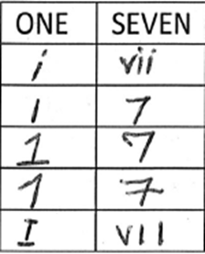
Examples of recognisable numbering.

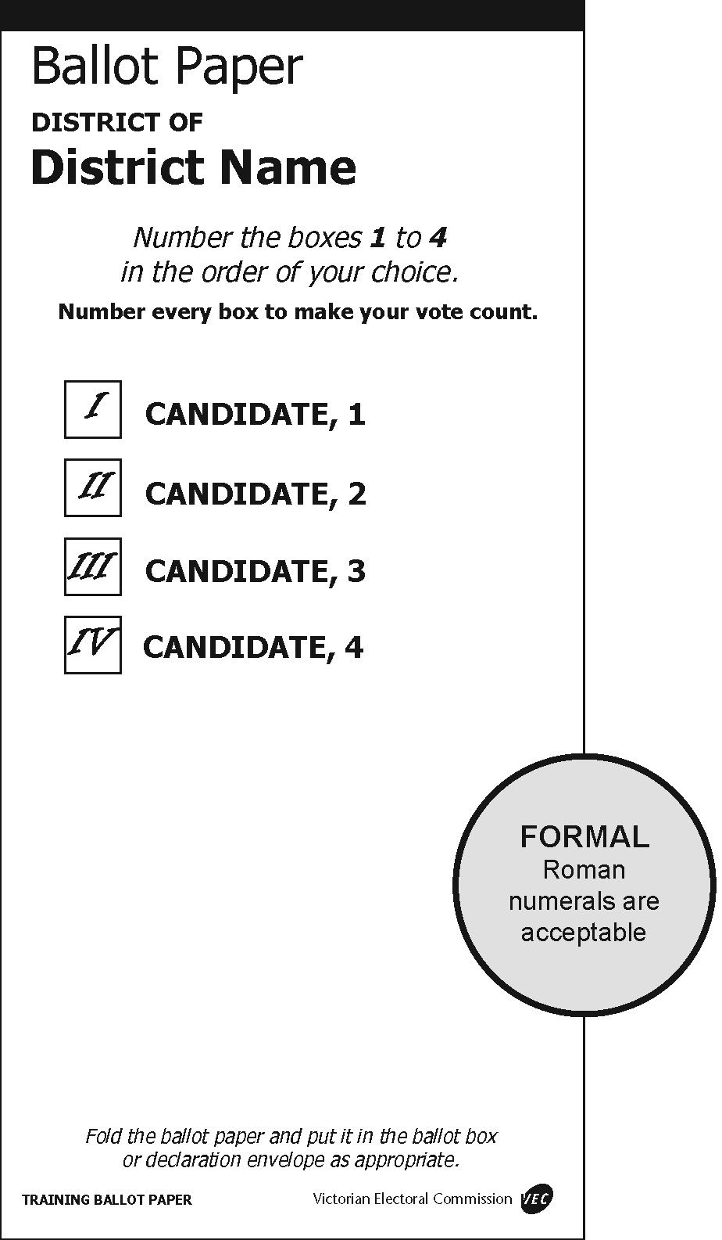 | 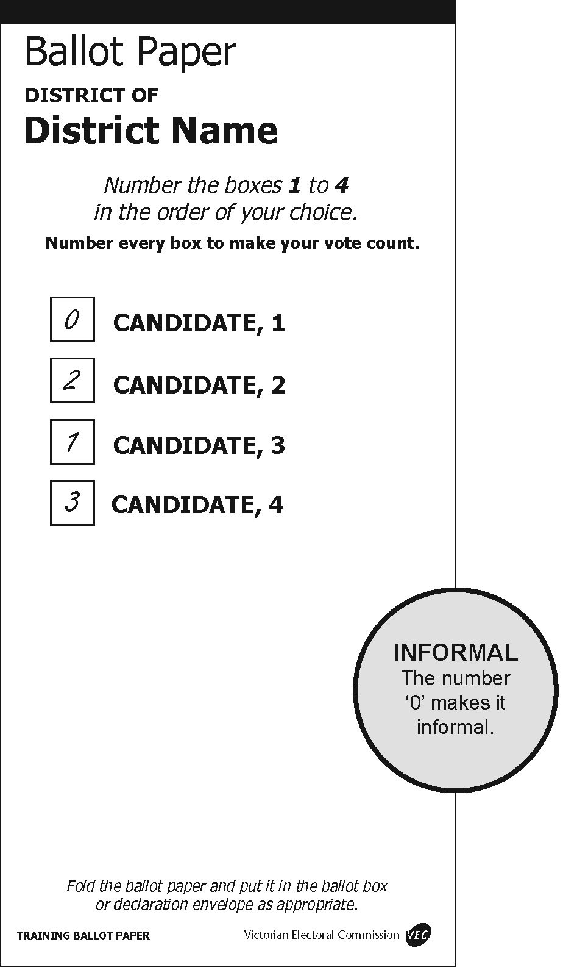
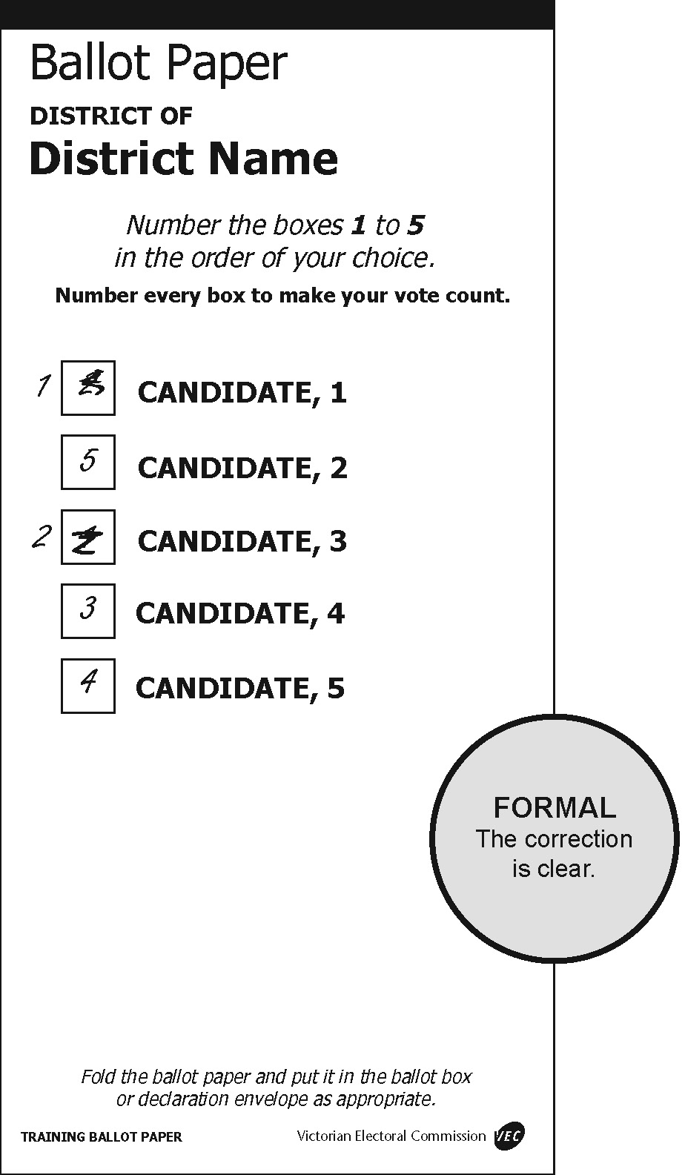 | 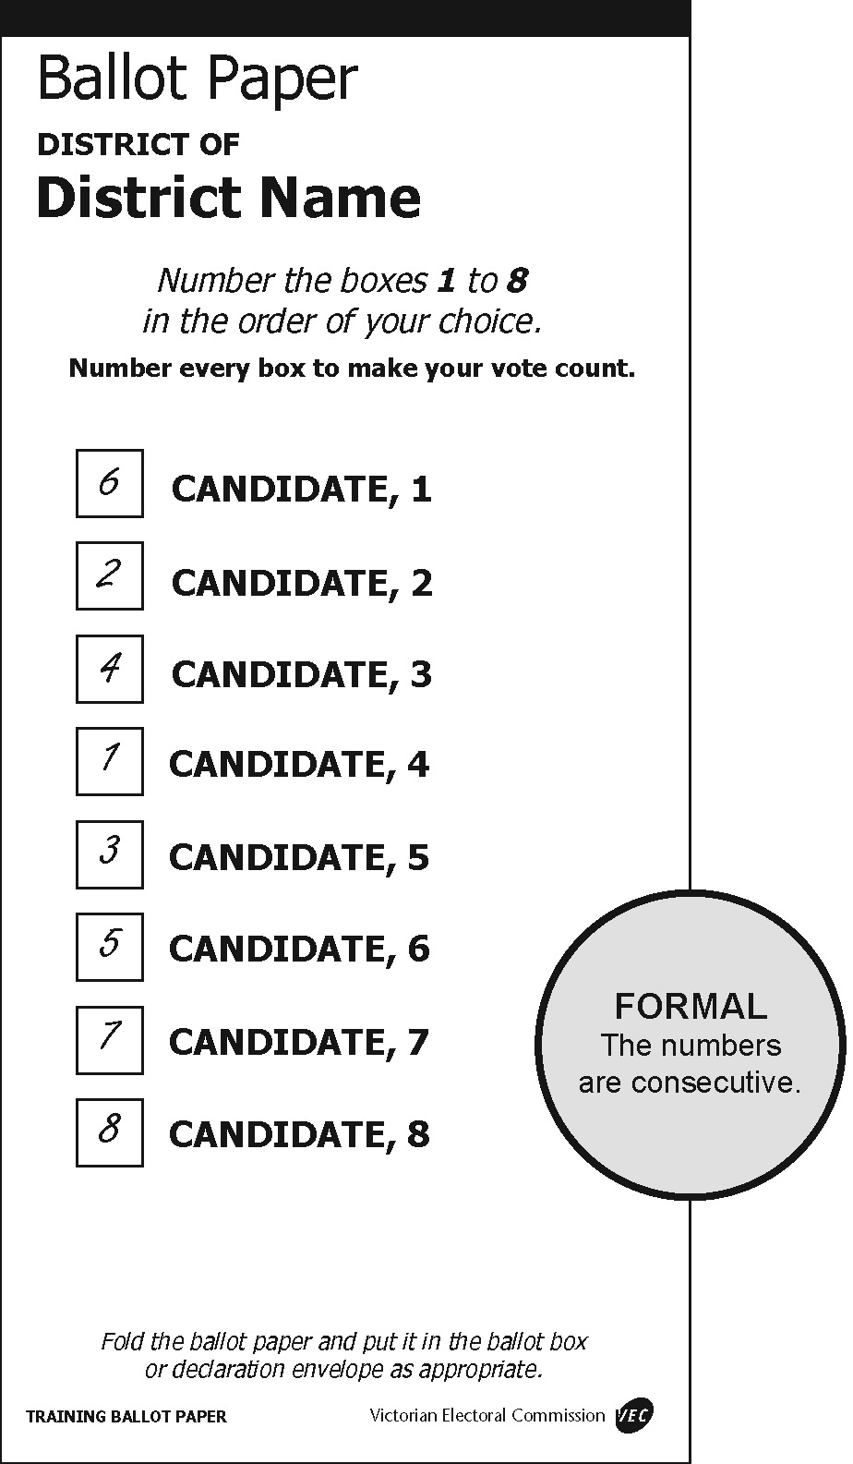
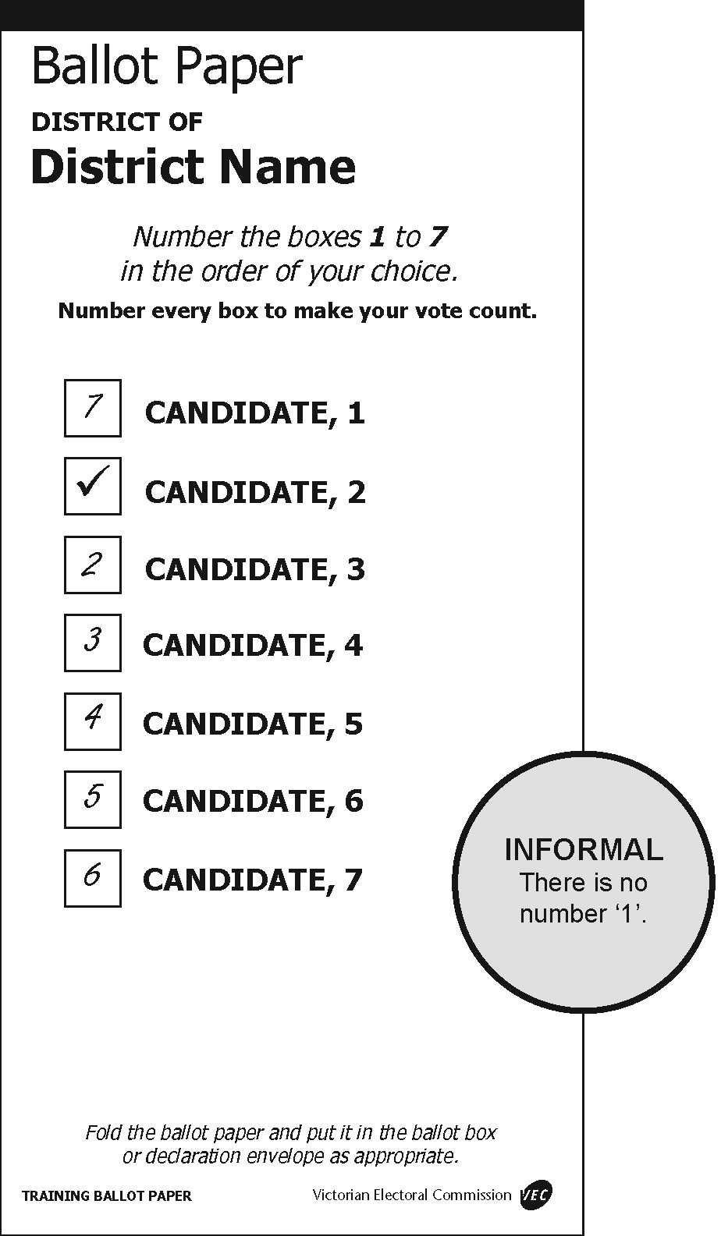 | 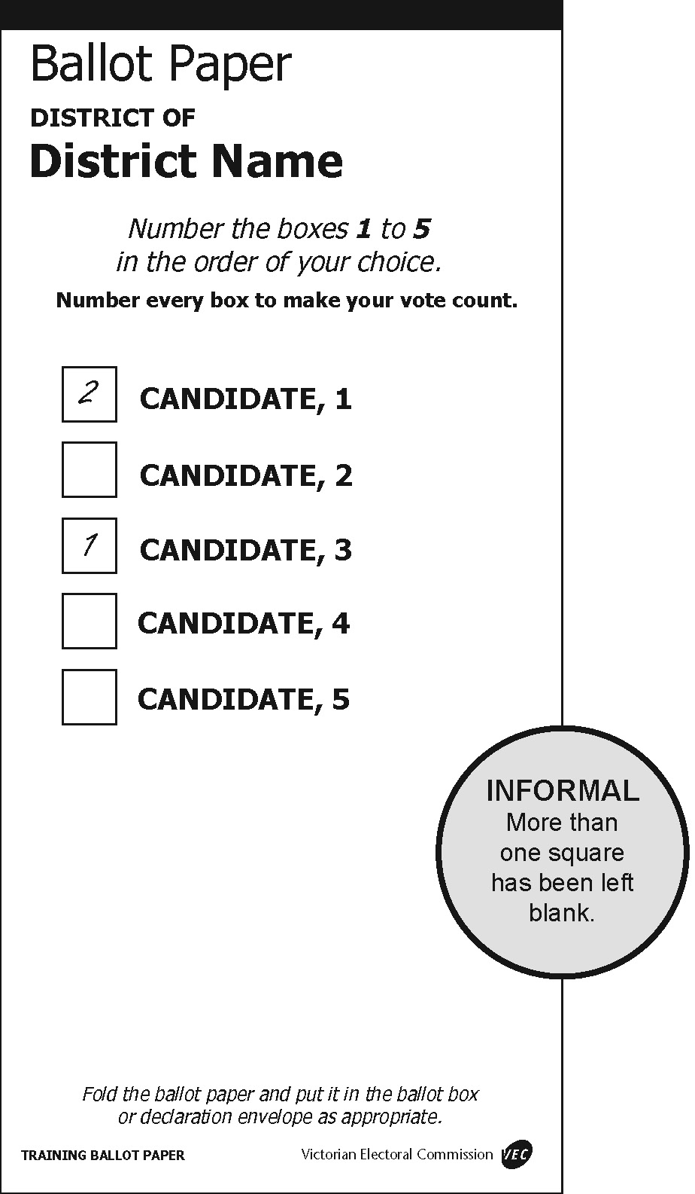
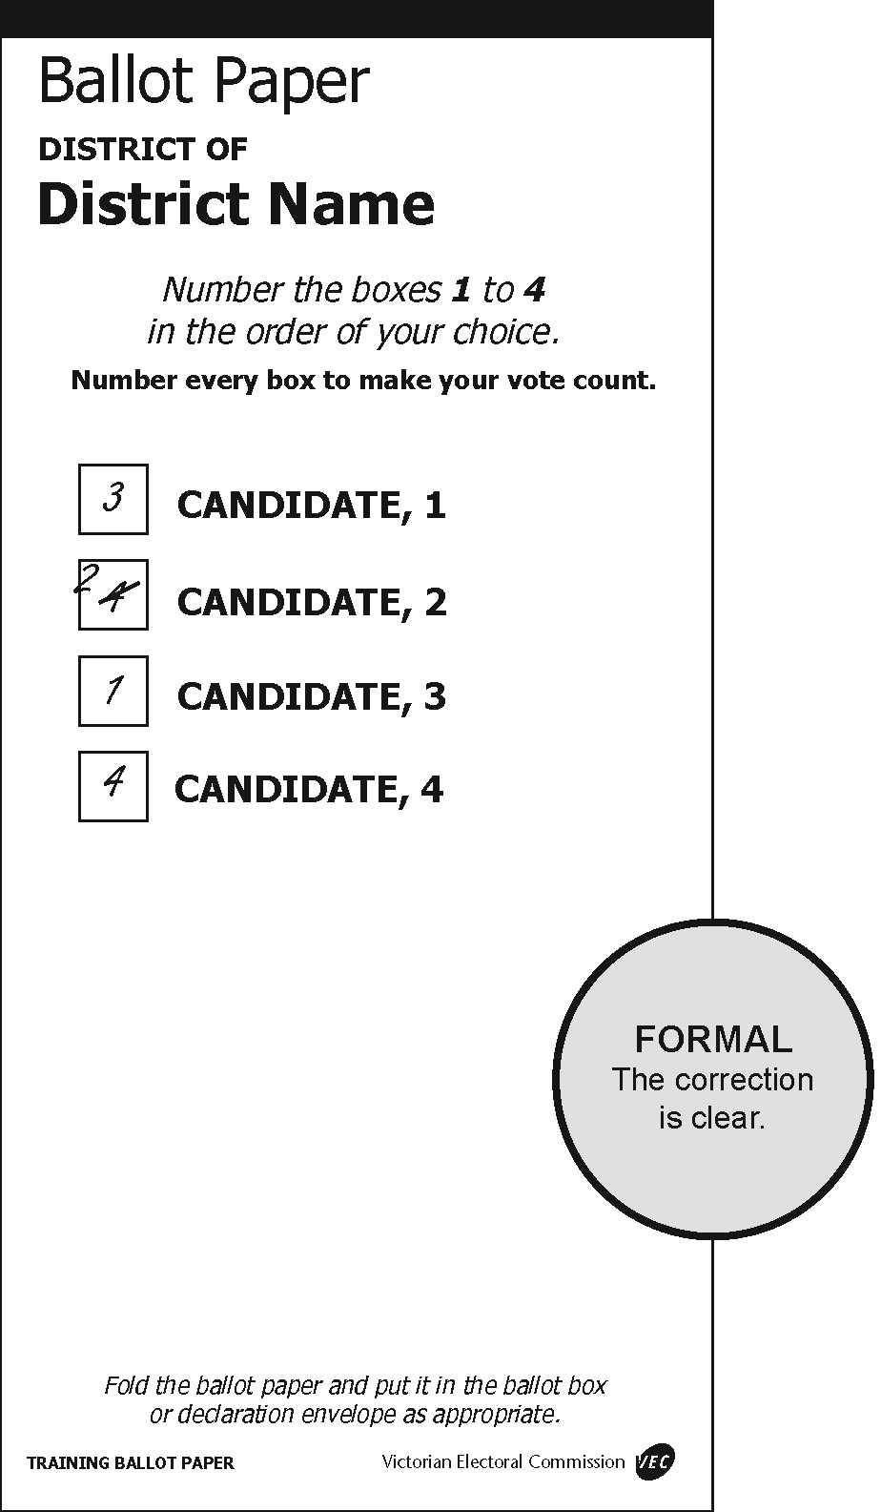 | 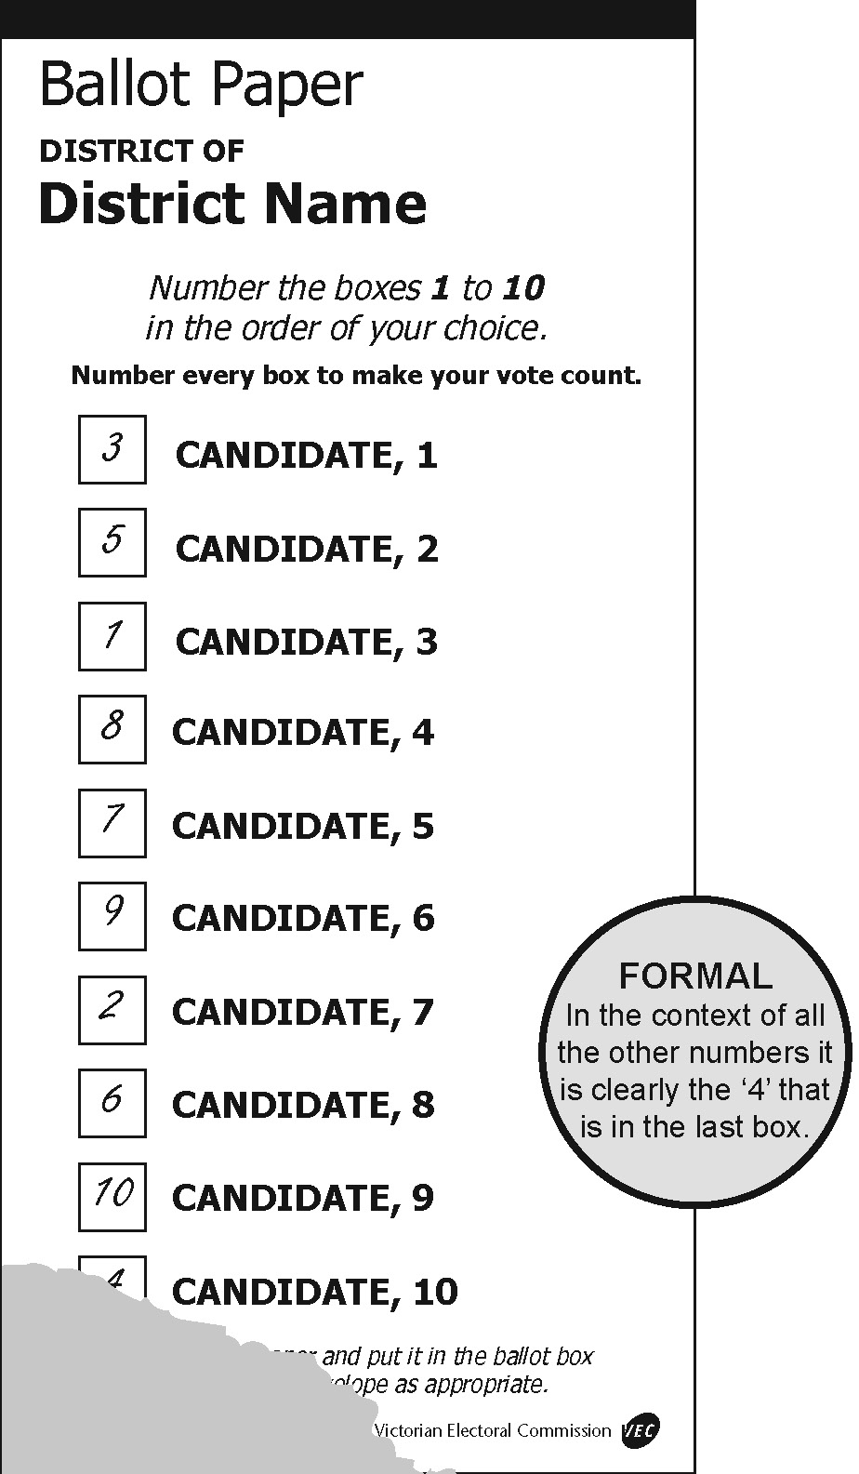
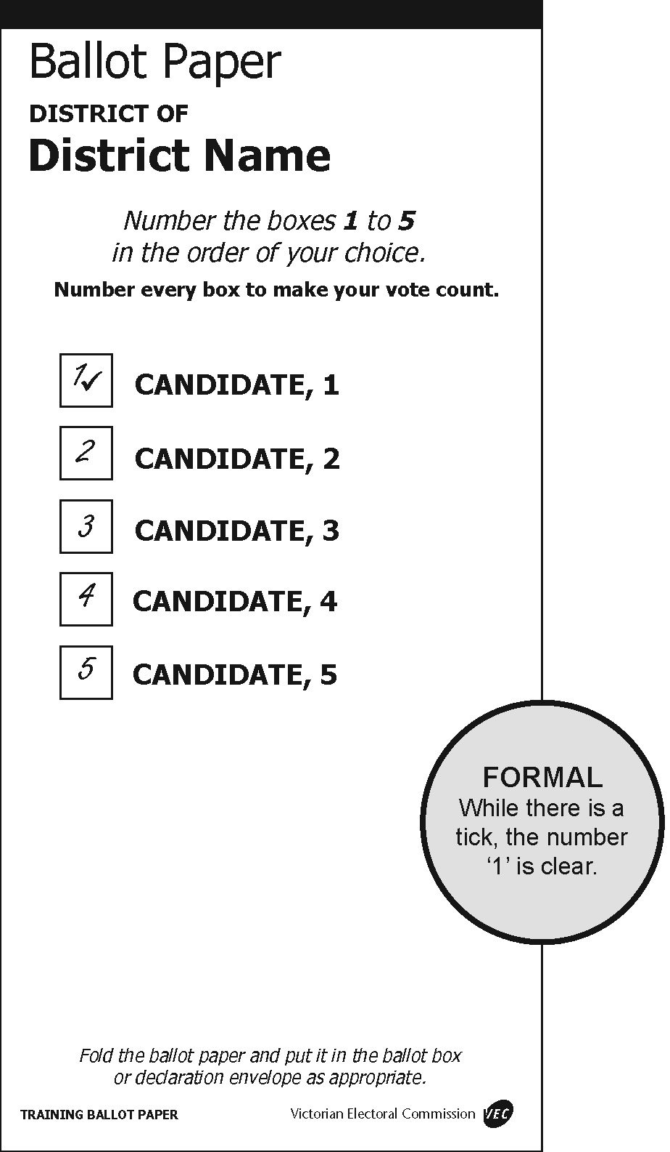 | 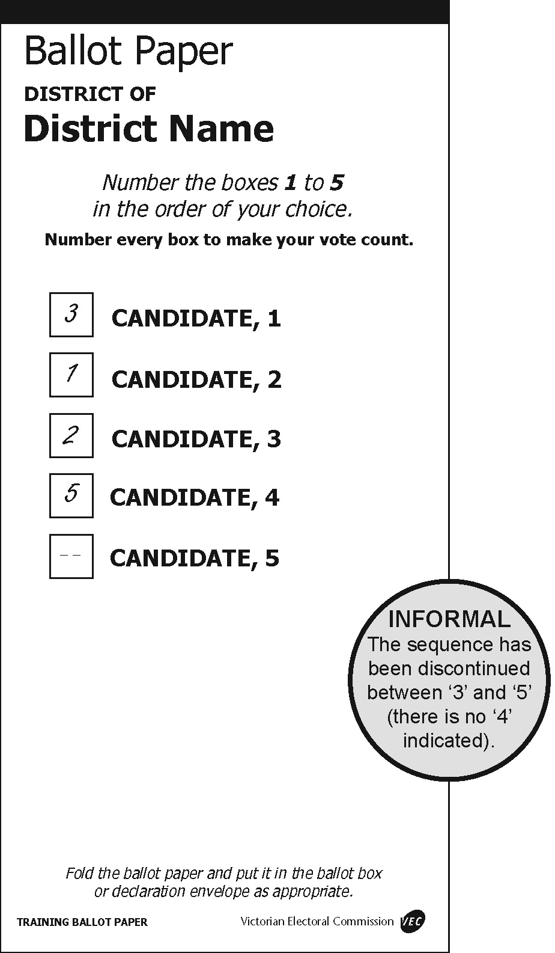
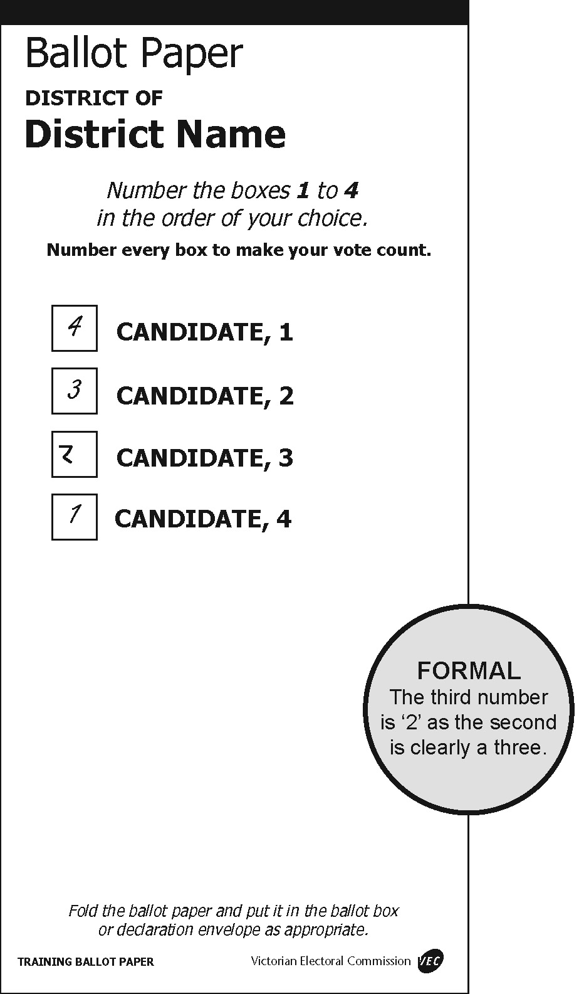 | 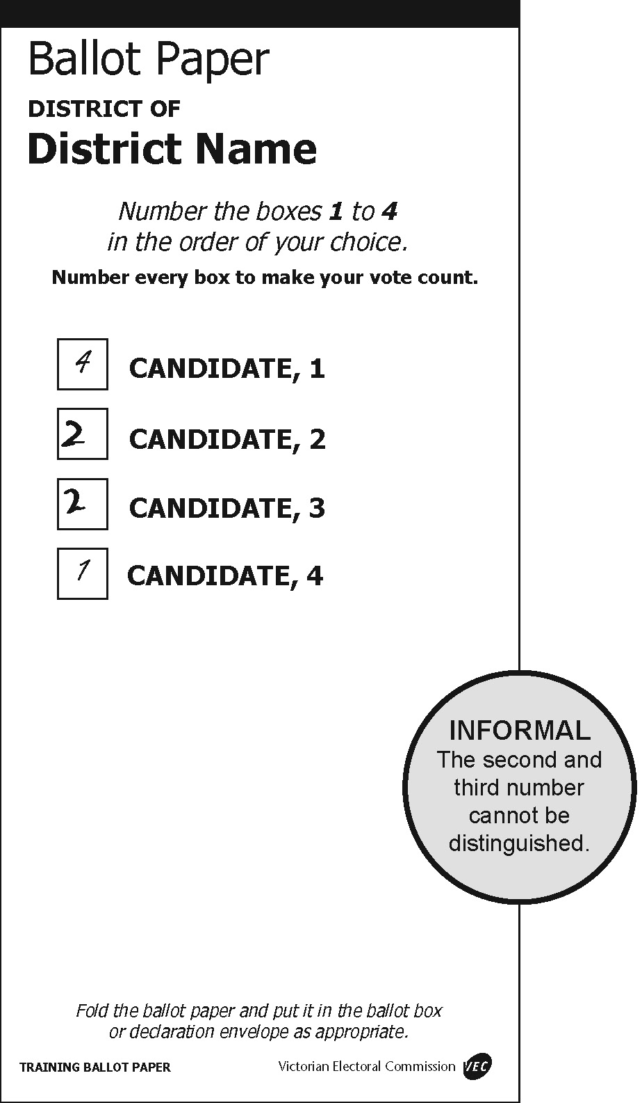

Damaged ballot papers
Election officials from time to time may come across ballot papers that have been torn or cut. Where ballot papers are cut or torn during processing by an election official, and the different parts can be identified beyond doubt as having originated from the same ballot paper, officials will tape the pieces and count as one ballot paper.
Where an official can determine an elector had access to all candidate and party information on the ballot paper when recording their preferences, such a ballot paper can be ruled ‘formal’ if all formality requirements have otherwise been met. If from the intact part the official can determine that the elector had access to the names of all candidates and their affiliations, then look at the formality requirements.
In situations where the ballot paper has been torn across one of the boxes for recording preferences, the ballot paper may still be deemed formal if the preference recorded in the box can be determined. See the following examples for illustrations of these principles.
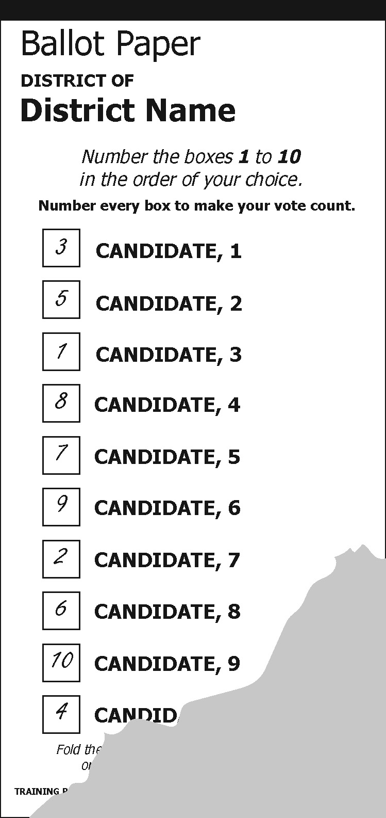 | 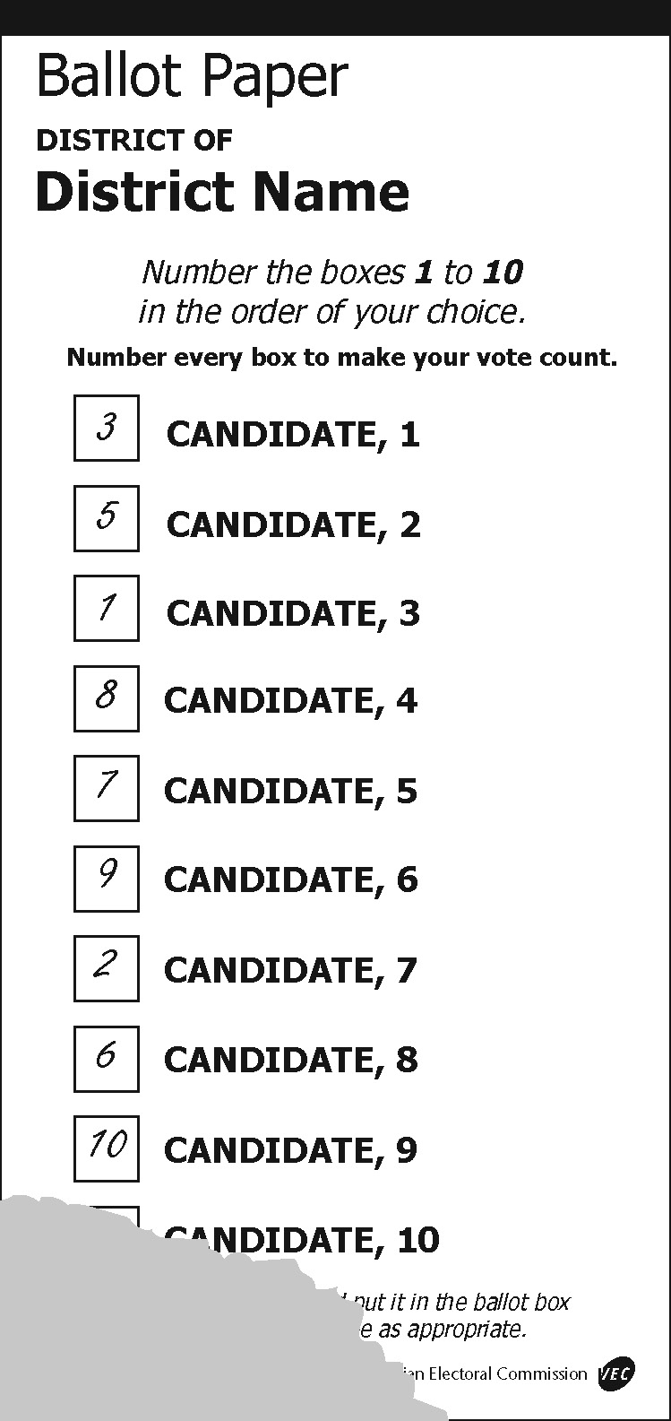 | 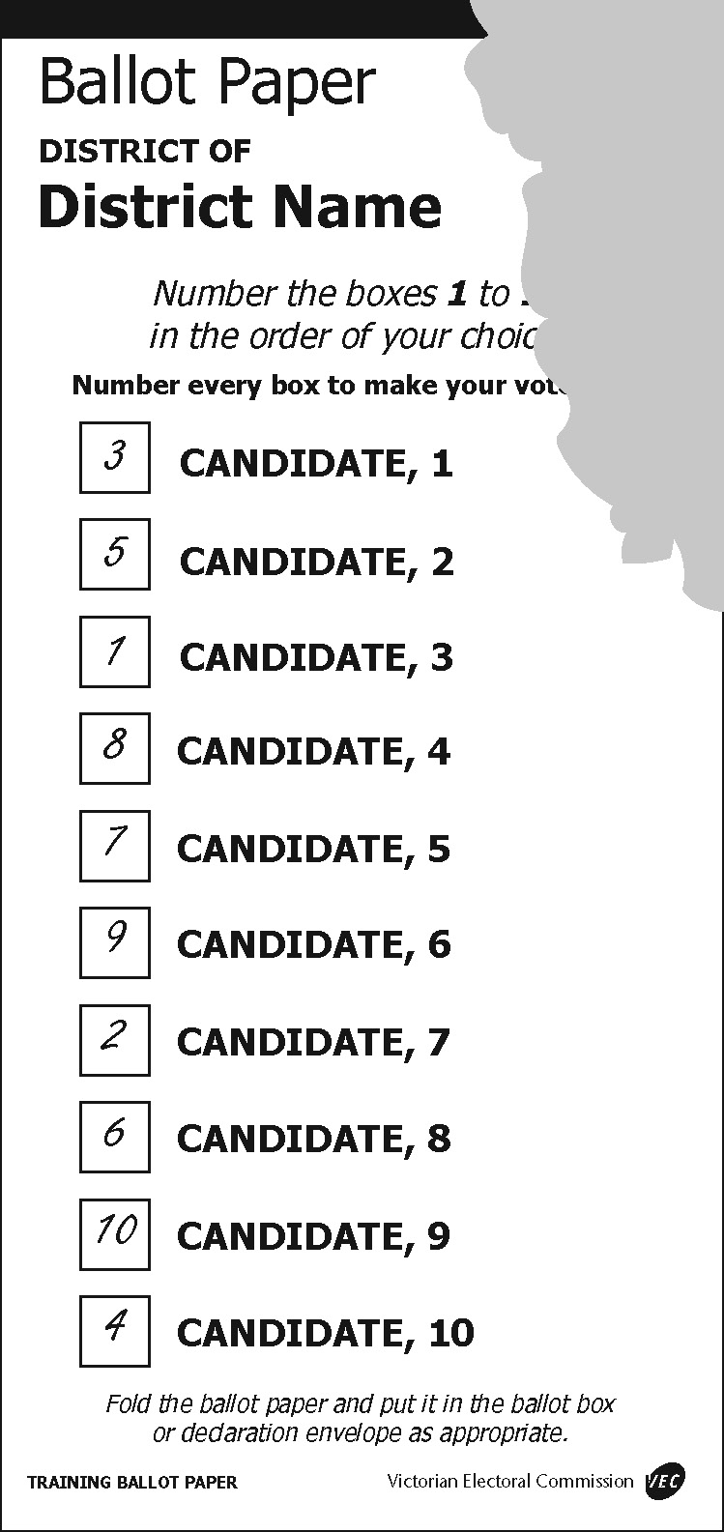
Formal: All the preferences are discernable. | Informal: The number 4 is missing and the official cannot be sure that it existed. | Formal: As long as the paper can be identified as being printed by the VEC the removal of the official’s initials does not make the ballot paper informal.

Region votes
A Region vote can be made in one of two ways:
- by showing a preference in one of the squares above-the-line on the ballot paper
- by showing a number 1 and continuing preferences up to at least 5 opposite candidates’ names below-the-line on the ballot paper.
Formality above-the-line
Ballot papers are formal if:
- the number one appears by itself in a single square
- a single tick, cross, or mark (of any kind) or “yes” (or similar) appears in a single square and the voter’s intention is clear
- more than one preference, commencing with the number 1, appear (the preferences after number 1 are ignored)
- more than one preference appears, but one is the number 1 and any other marks are crossed out as mistaken attempts to mark a preference.
The number one, a tick, cross, mark, or more than one preference must be placed above-the-line for the ballot paper to be formal as an above-the-line ballot paper.
Formality below-the-line
Ballot papers are formal if at least the numbers 1 to 5 appear in sequential order.
Alterations made to numbers or numbers placed outside the boxes do not make a ballot paper informal, providing the elector’s intention is clear.
Informality above-the-line
Ballot papers marked only above-the-line are informal if:
- the number 1 appears more than once
- the number 1 and a tick appear in different boxes
- the number 1 and a cross appear in different boxes
- a tick and a cross appear in different boxes
- a tick or a cross and a mark appear in different boxes
- a tick appears more than once in different boxes
- a cross appears more than once in different boxes
- a mark appears more than once in different boxes
- a single number other than the number 1 appears above-the-line (elector’s intention unclear)
- the elector’s intention to record a single preference above-the-line is not clear.
Informality below-the-line
Ballot papers marked only below-the-line are informal if:
- the number 1 does not appear against any candidate’s name (a tick or a cross is not acceptable as an indicator of preference below-the-line on a Region ballot paper)
- any of the numbers 1 to 5 are repeated against two or more candidates’ names
- any of the numbers between 1 and 5 are missing.
As long as the numbers 1 to 5 are sequential, mistakes in numbering outside this range do not make the ballot paper informal
Ballot papers marked both above- and below-the-line
Where an elector has marked both above and below-the-line, the ballot paper is treated as follows:
- when both above and below are formal, below-the-line is used for counting
- when only one part is formal, the formal part is used for counting
- when both above and below are informal, the ballot paper is informal.
Other Region formality rules
Other general formality rules are:
- amendments are acceptable providing the elector’s intention is clear
- poorly formed numbers must be considered in the context of the whole ballot paper and are acceptable if they can reasonably be construed as numbers comprising part of the sequence
- unconventional but recognisable numbers such as continental 1s and 7s are acceptable. Roman numerals are also acceptable if all numbers are clearly represented in this format. Other ‘non-English’ characters are not acceptable. Numbers may be written one, two, etc., but only in English
- a ballot paper that has not been initialled by an election official is not excluded for that reason alone provided it is printed on VEC official security paper.
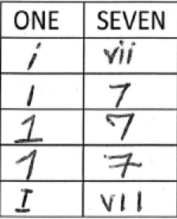
Examples of recognisable numbering.

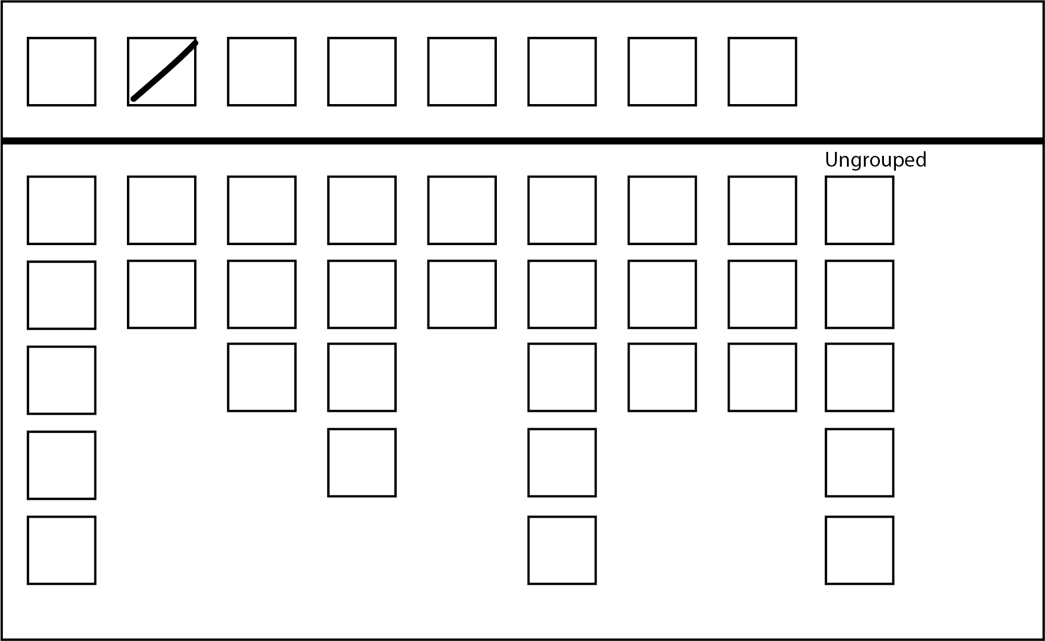
Formal: The elector has made a mark in one box above-the-line.
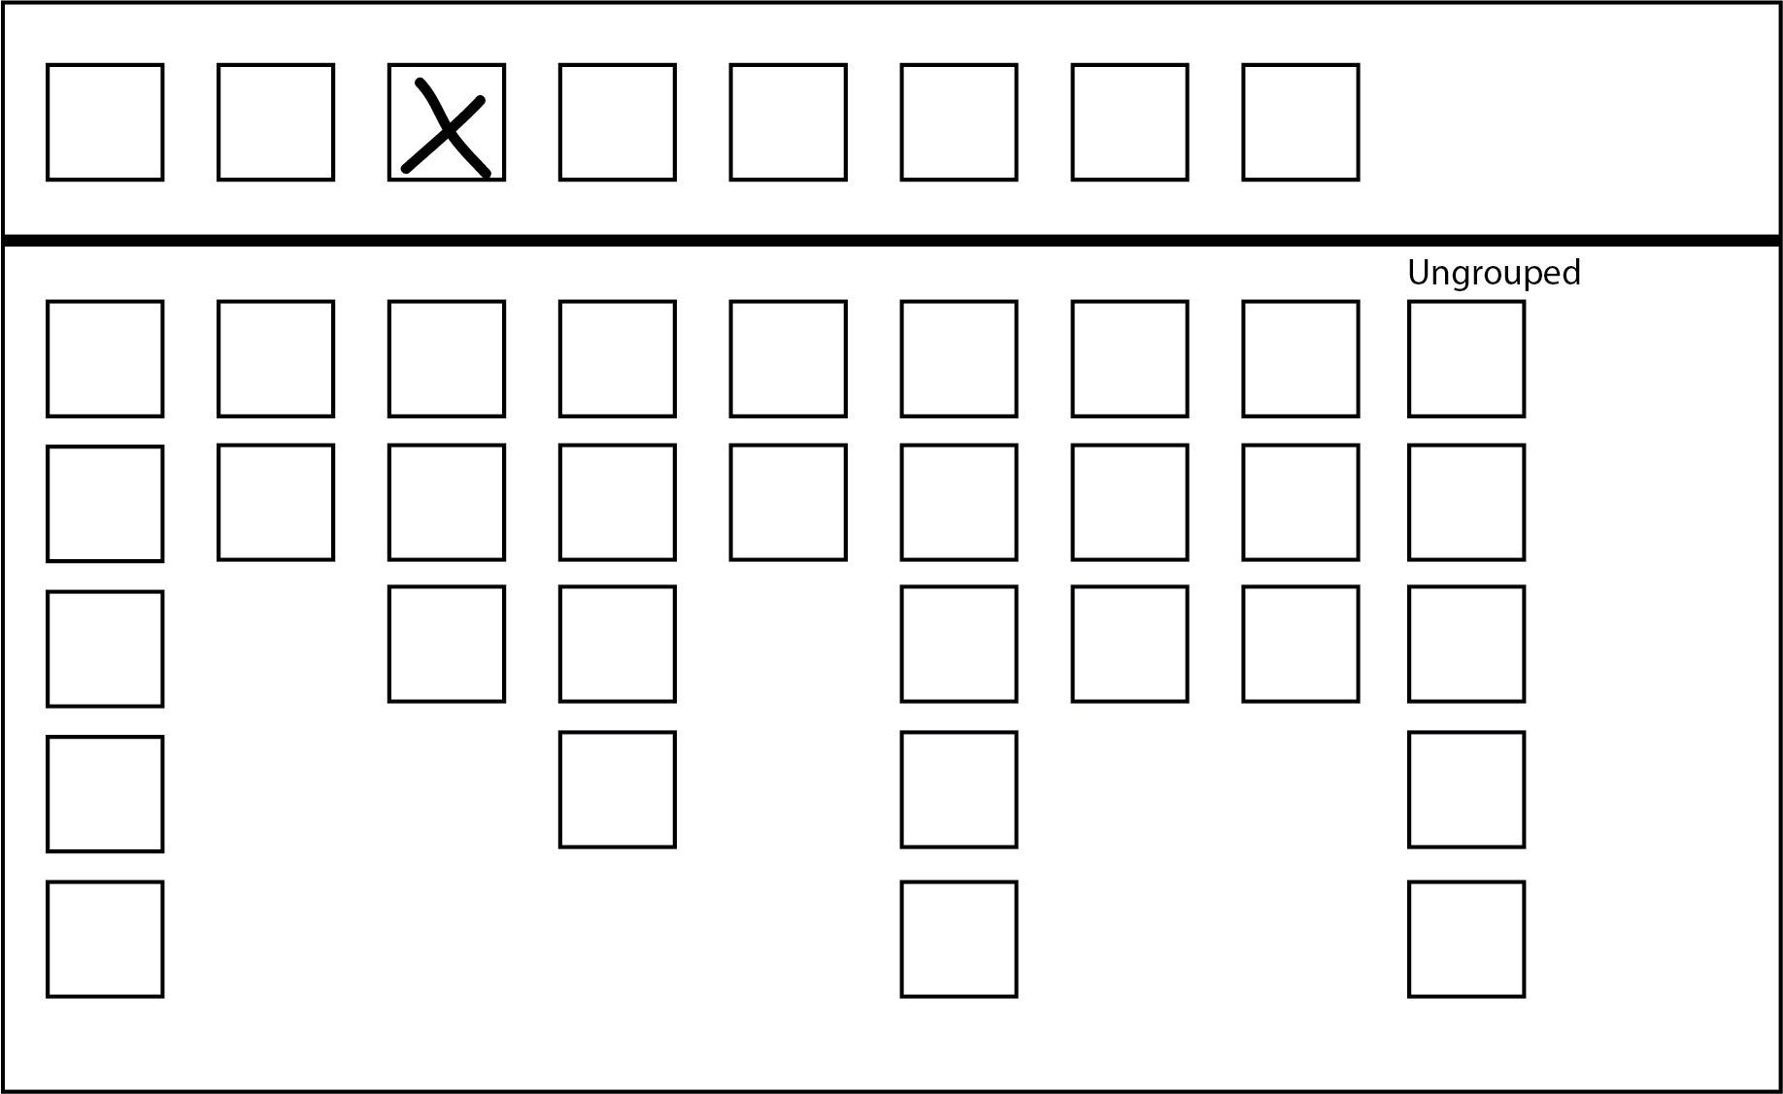
Formal: A number 1, a tick, or a cross appears by itself above-the-line.

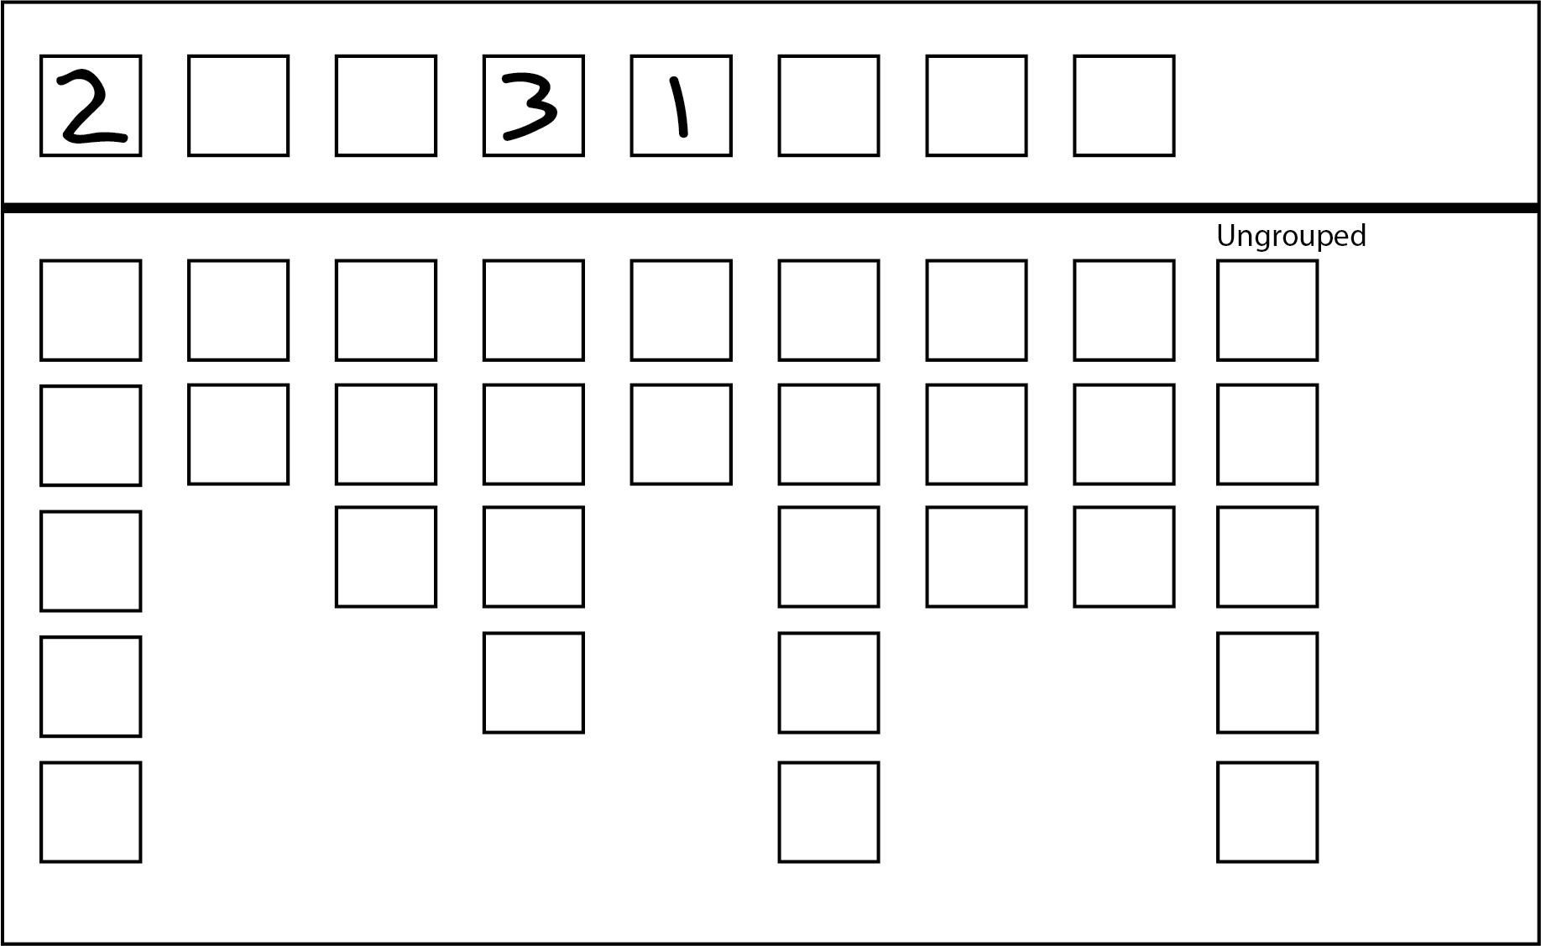
Formal: A first preference appears above-the-line. The numbers after 1 are ignored.
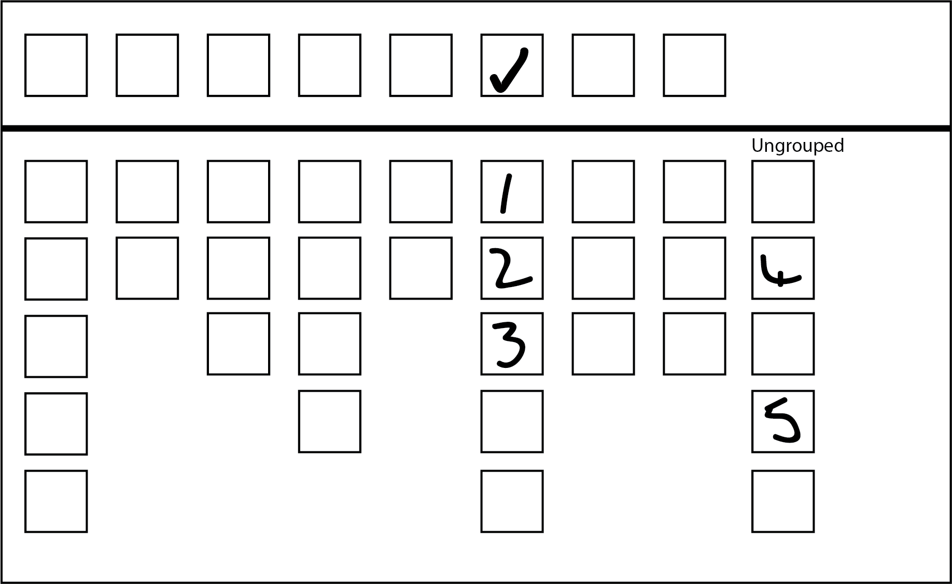
Formal: Both above and below-the-line are formal – use below-the-line for the count.

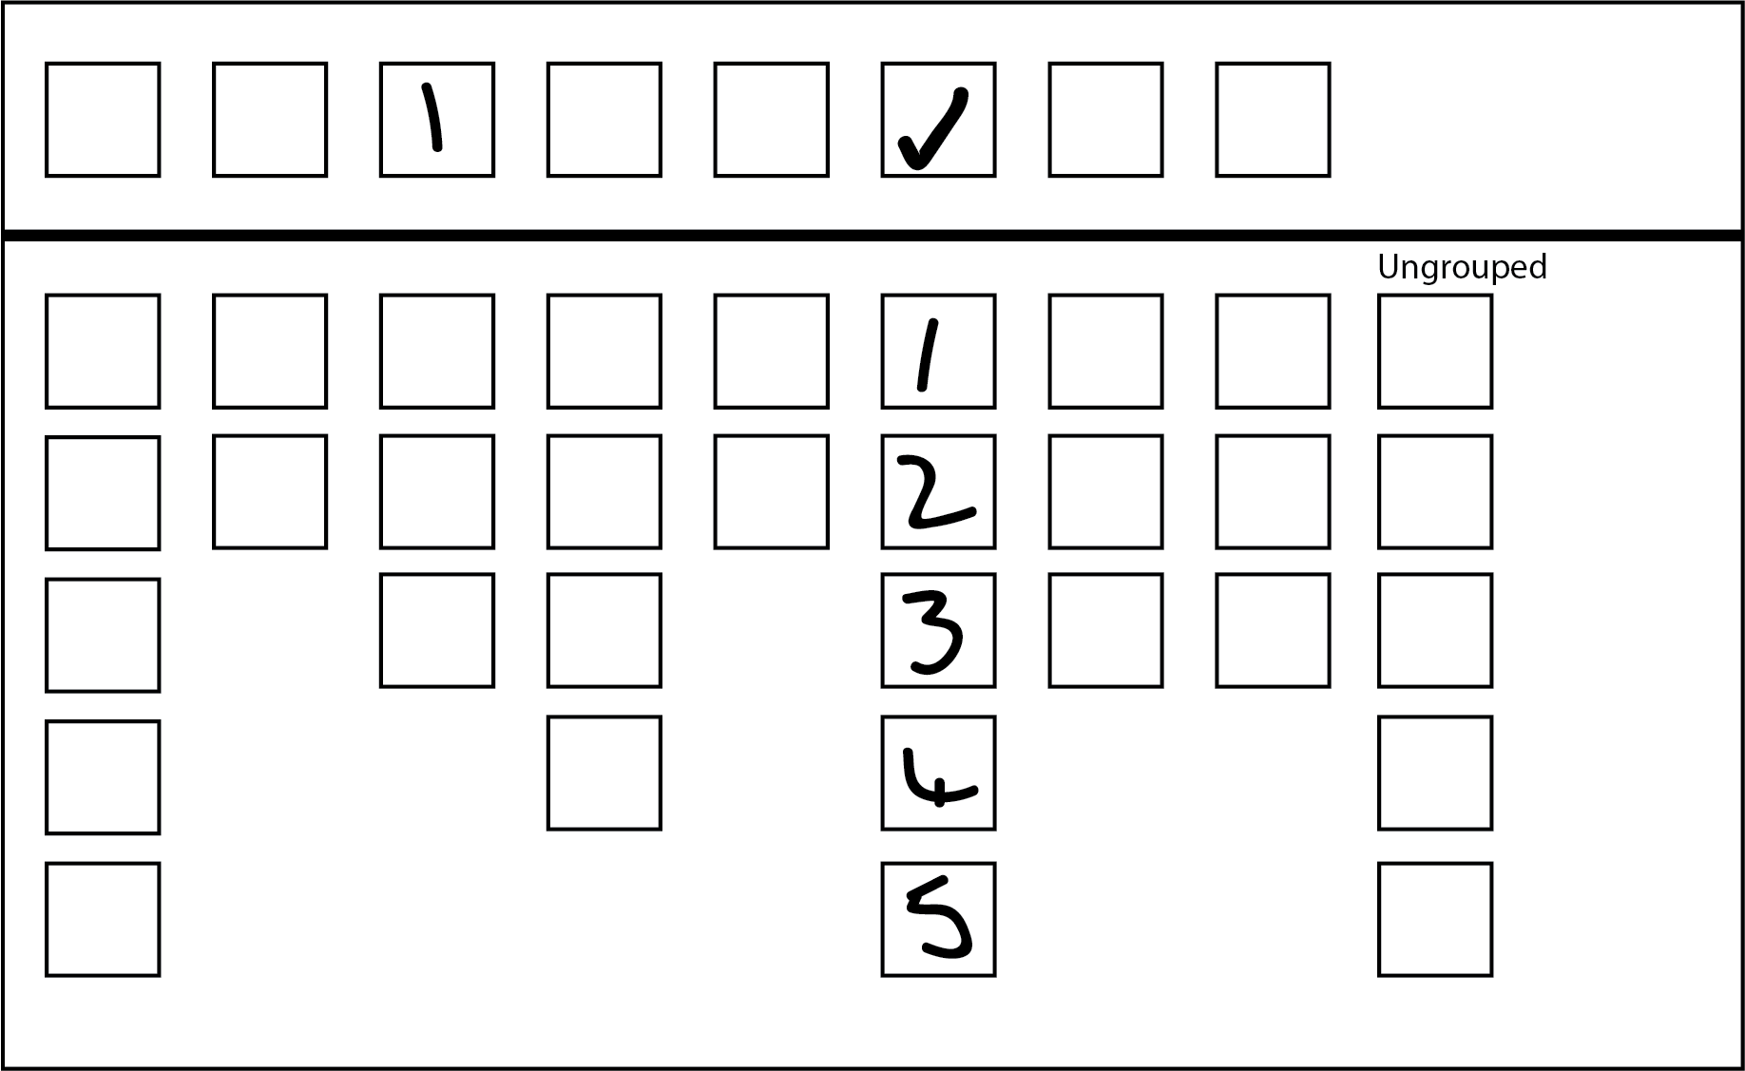
Formal: The below-the-line section is formal. At least the numbers 1 to 5 appear.
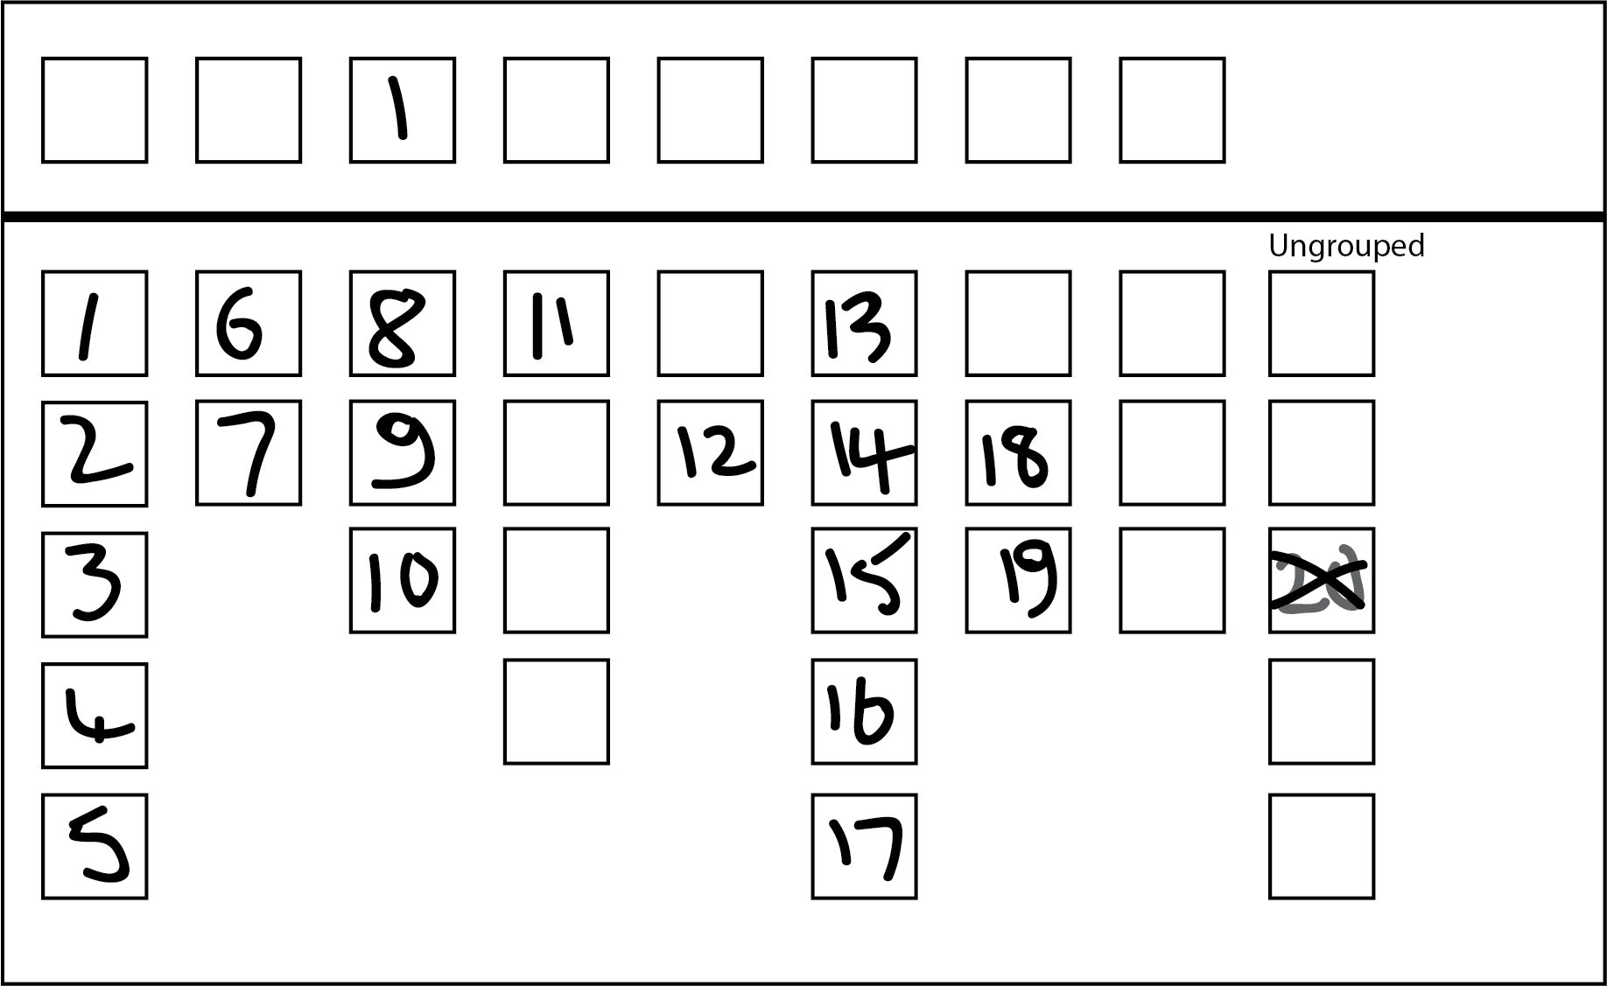
Formal: The above-the-line section is formal and the below-the-line section is formal – both a 1 and a cross appear. A cross is not an indicator of preference below-the-line so it is ignored. Use below-the-line for the count.

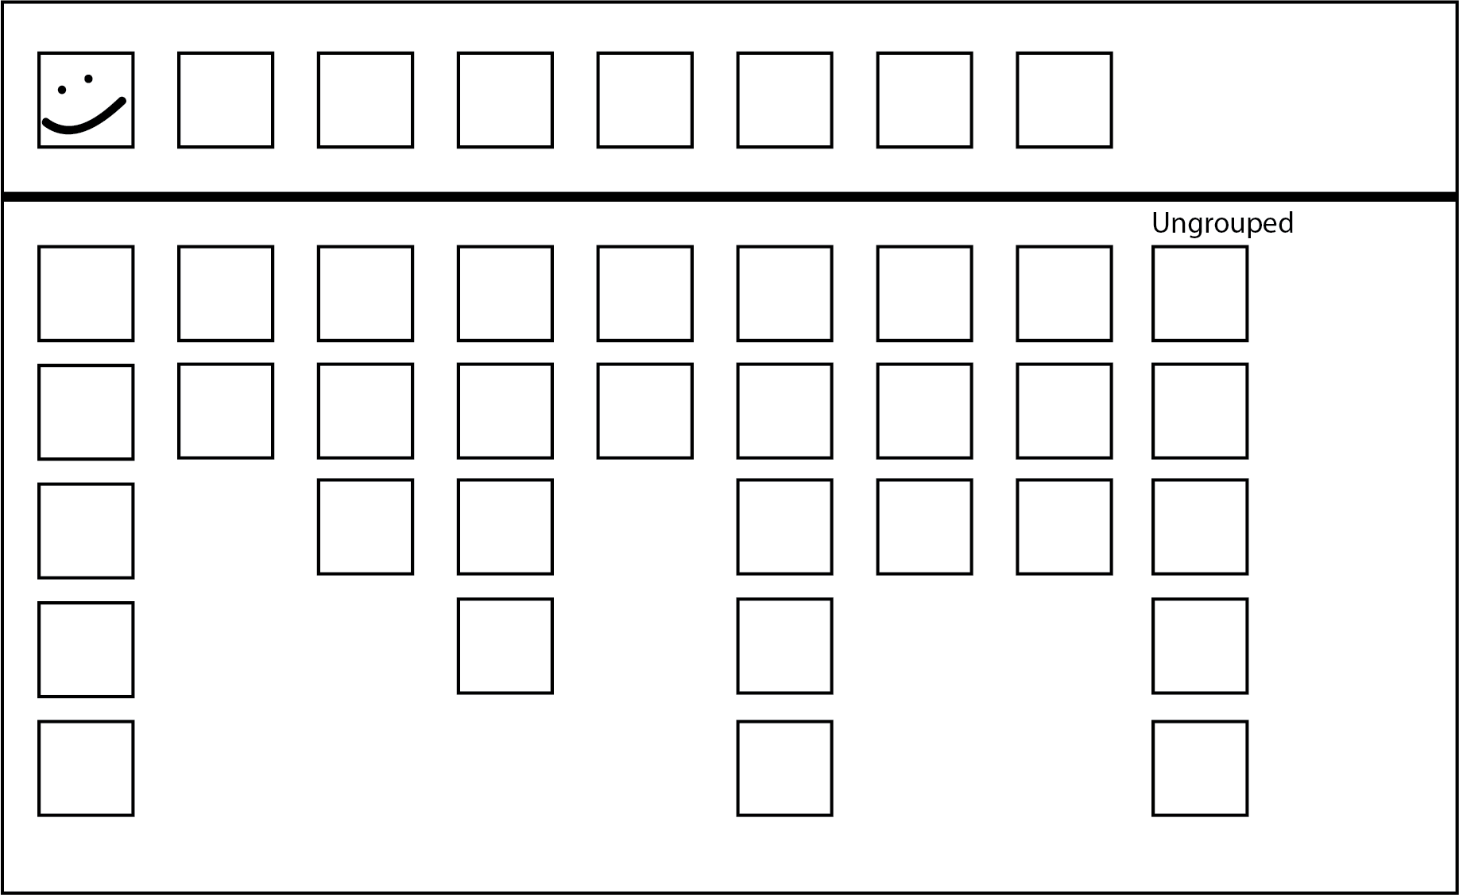
Formal: The elector has made a mark in a single box above-the-line
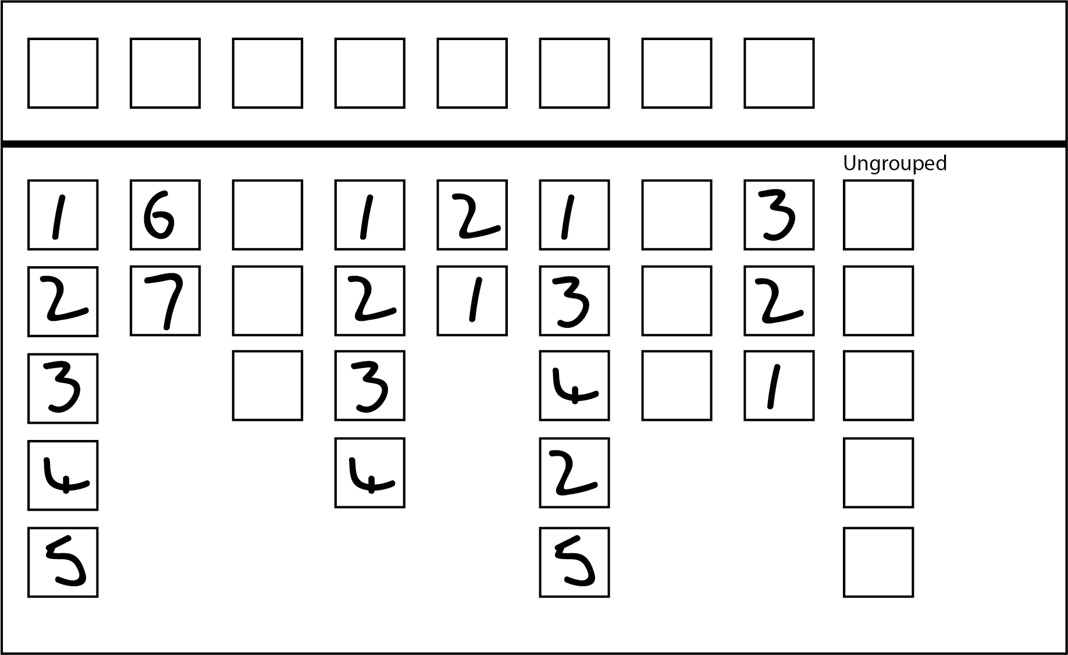
Informal: The numbers 1 to 5 appear more than once below-the-line.

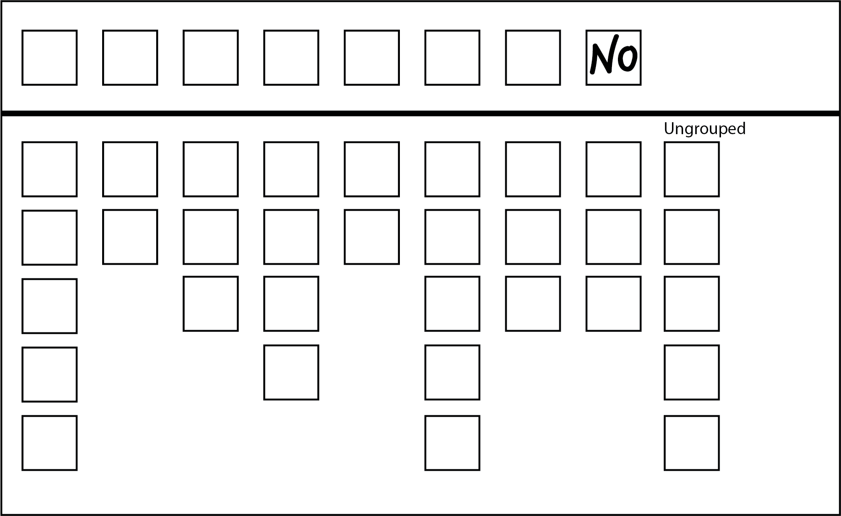
Informal: Elector’s intention is not clear.
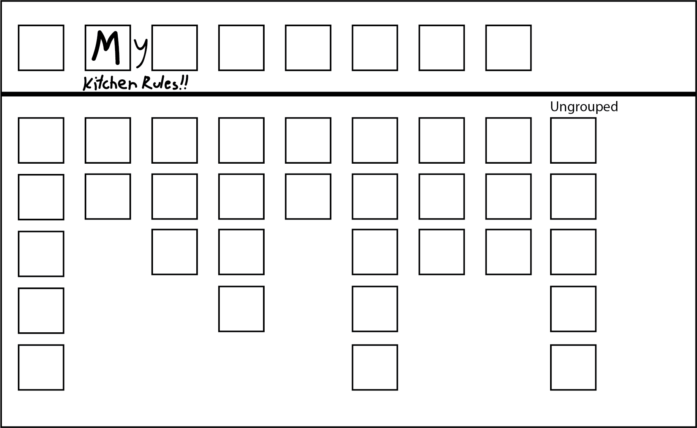
Formal: A single mark appears above-the-line. Marks outside the box are ignored.

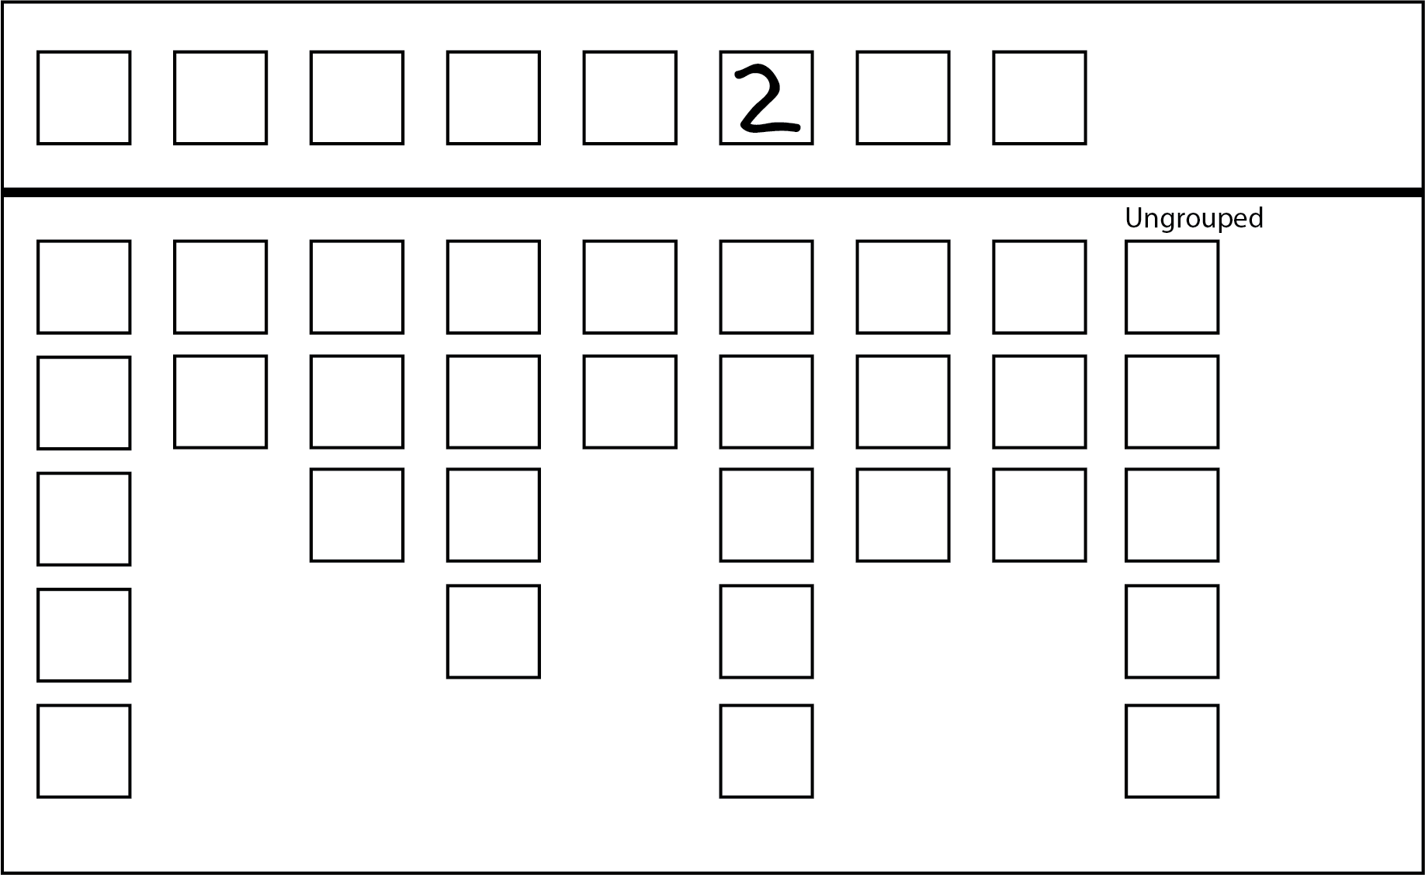
Informal: Single number other than 1 appears above-the-line. Elector’s intention unclear.
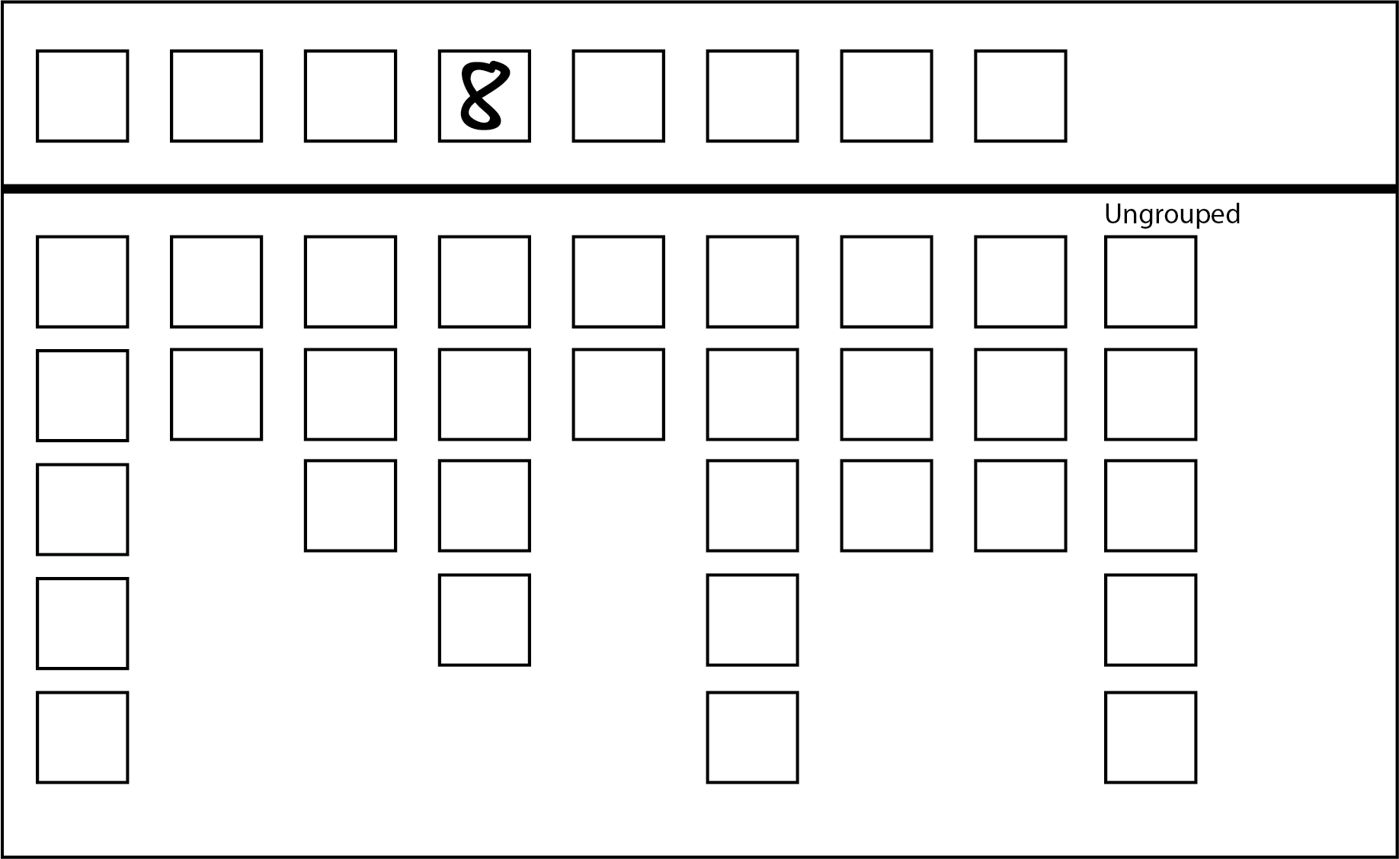
Informal: Single number other than 1 appears above-the-line. Elector’s intention unclear.

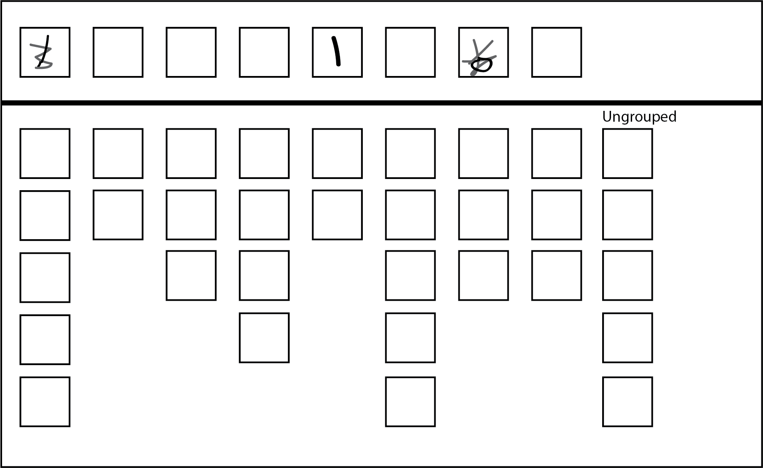
Formal: The elector’s intention is clear.

Damaged ballot papers
Election officials from time to time may come across ballot papers that have been torn or cut. Where ballot papers are cut or torn during processing by an election official, and the different parts can be identified beyond doubt as having originated from the same ballot paper, officials will tape the pieces and count as one ballot paper.
Where an official can determine an elector had access to all candidate and party information on the ballot paper when recording their preferences, such a ballot paper can be ruled ‘formal’ if all formality requirements have otherwise been met. If from the intact part the official can determine that the elector had access to the names of all candidates, their affiliations and, in the case of the Legislative Council (Region ballot papers) their locality, then look at the formality requirements.
In situations where the ballot paper has been torn across one of the boxes for recording preferences, the ballot paper may still be deemed formal if the preference recorded in the box can be determined. See the following examples for illustrations of these principles.
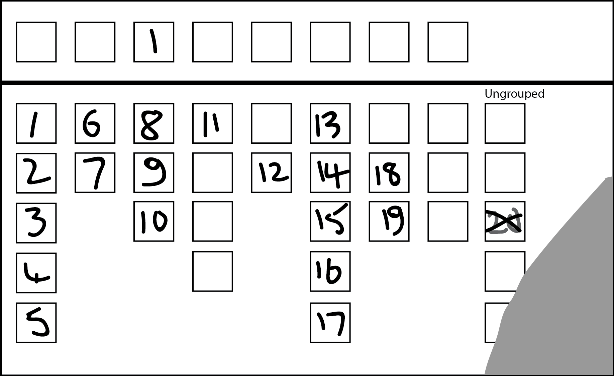
Formal: formal below-the-line. All the squares below are visible, even though the paper is damaged

6. The Count
Scrutineers are entitled to observe all proceedings at any count, whether conducted at a voting centre, the election office, Region recheck centre, or the central count centre.
Scrutineers may challenge the formality of ballot papers at a voting centre by referring them to the Voting Centre Manager for decision.
At other count venues, scrutineers may challenge the admission or rejection of electors' declarations and the formality of ballot papers by referring them to the delegated official in charge of the activity.
The count of ballot papers must proceed smoothly and efficiently and scrutineers should not communicate unnecessarily with anyone.
Scrutineers must not handle:
- ballot papers;
- declaration envelopes; or
- other election material.
Scrutineers are entitled to observe all the markings on ballot papers but they must not delay proceedings, except where it is necessary in the performance of their duties.
The Election Manager must inform scrutineers of any adjournment in proceedings and advise the location and time the activity will be continued.
Scrutineers attending the extraction and sorting of postal and early votes, prior to the close of voting must conform to strict security requirements as all activities prior to the close of voting will take place within a restricted zone. Scrutineers will be required to check-in any mobile telephones, apple watches or other recording devices into secure storage at the extraction and sorting location. Paper and writing implements will also not be allowed within the restricted zone. There will also be restrictions in entry to and leaving the restricted zone during these activities. Election Managers or election officials will fully brief scrutineers prior to the commencement of the extraction and sort.

Postal Votes
Postal vote declarations will be verified against postal vote applications at the Central Processing Centre located at the Royal Melbourne Showgrounds, Ascot Vale, from the Monday prior to election day. Election Managers will advise candidates of arrangements. Election staff will allow any scrutineers present to compare the elector’s identification on the hard copy or imaged postal vote application against the elector’s identification on the returned postal vote declaration envelope. The elector’s identification will be checked by comparing the elector’s signature or verification question and answer on the postal vote application and returned declaration.
Postal ballot papers are to be admitted to the count if the:
- declaration has been completed by the same elector who completed the application;
- declaration has been correctly completed;
- elector is enrolled for the District and/or Region; and
- vote was made before the close of voting on election day.
Note: Declarations returned by GPVs will not have an application for verification purposes.
The extraction and sorting of ballot papers will commence from 8.00 am on election day at the Showgrounds. Candidates will be provided with a schedule of anticipated commencement times for each District.
The count of postal votes will commence at 6.00 pm on election day at the Showgrounds. The VEC will aim to complete the count of all postal votes returned up to 6.00 pm on the Friday before election day on election night.
Further counting of postal votes will take place at the Showgrounds following election day.

Election Day
On election day, scrutineers intending to be present at a voting centre for the count of ballot papers must report to the Voting Centre Manager during the day and be inside the voting centre by 6.00 pm when the doors of the voting centre are locked.
At each voting centre, the counting of votes begins after voting closes.
District ballot papers are:
- sorted to candidates according to the first preference votes marked and to informals; then
- counted and the result for the voting centre telephoned to the Election Manager. The return of the number of first preference votes cast for each candidate may be signed by scrutineers.
The two-candidate-preferred count commences after the count of first preference votes for the District and is conducted simultaneously with the count of Region ballot papers.
The purpose of the two-candidate-preferred count is to provide an indication of the likely outcome of the election should a preference distribution be necessary.
The preferences received by the two selected candidates from other candidates in this count, are added to the first preference votes already received. This gives the total two-candidate-preferred result for the voting centre.
Region ballot papers are:
- sorted into ‘above the line’ and ‘below the line’ bundles;
- sorted to votes for each group marked ‘above the line’;
- sorted to first preference votes for each group and ungrouped candidate marked ‘below the line’; and
- sorted to informals.
At the completion of the counts, the ballot papers are placed in sealed boxes and delivered to the Election Manager. Scrutineers may witness and sign the recording of security seal numbers.

Early Vote Sort and Count
Home District early votes will be sorted and counted in Election Offices or standalone early voting centres. Election staff will commence the extraction and sorting of home District early votes from 4.00 pm on election day.
Counting of home District early votes will commence at 6.00 pm. It is intended that most, if not all home District votes in the hands of the Election Manager will be counted on election night. There will be no counting of home District Region votes on election night.
Some counting of early votes may take place in stand-alone early voting centres. Candidates will be advised where this is the case.
The extraction and sorting of votes taken by telephone will commence at the VEC from 4.00 pm on election night. Restricted zone provisions will apply with this early processing. These votes will be counted at the centralised count centre at the Showgrounds during the week following election day.
Early votes for other Districts and mobile votes cast at mobile voting centres within the District will be sorted to their respective Districts and Regions in election offices after 6.00 pm on election night.
Scrutineers may request to view the Early Voting Journals containing the reconciliation of ballot papers for each early/mobile voting centre.

Early Region and Mobile Voting Counts
Early own District Region ballot papers and mobile votes cast at mobile voting centres, will be counted from Monday 26 November 2018.
Scrutineers may request to view the Early Voting Journals and Mobile Voting Journals containing the reconciliation of ballot papers for each early voting centre and mobile voting team.

Provisional Votes
Checking of provisional votes will take place at the VEC after election day to confirm the elector’s entitlement to enrol and vote before being admitted for counting.
Provisional vote counts will take place during the week following election day.

Exchange
Commencing on election night and continuing into the Sunday after election day a Team Leader will oversee the sort and packaging of completed ballot material for other electorates. This material is collected from election offices on the Monday following election day and distributed to their appropriate electorates on Tuesday.

Absent, Interstate, Overseas, and Remaining Early Votes
Absent, interstate and overseas ballot papers are counted at the election office after election day. Early votes cast by electors at early voting centres outside their own District and telephone assisted early votes will also be counted at the election office after election day.
The Election Manager will advise candidates of the time and dates of these activities.

District Counts
All District primary counts will take place in voting centres after close of voting on election day and at the election office on and after election day. Results of primary counts are entered into the VEC’s election management system and progressively published on vec.vic.gov.au
Two-candidate-preferred counts are conducted following each primary count. The two-candidate-preferred count involves sorting formal ballot papers to two selected candidates to give an early indication of the election result. Election officials sort each formal ballot paper to the selected candidate that has the highest preference (lowest number).
District rechecks will take place in election offices from the Monday after election day. This process involves rechecking each District ballot paper for correct counting and sorting. Rechecked results are entered progressively into the VEC’s election management system and are published on the VEC’s website. It is not uncommon for minor variations in sorting and counting to be identified during the rechecking process. Election Managers can provide candidates and scrutineers with consolidated reports of rechecked results.
District preference distributions will be conducted where no candidate has an absolute majority (more than 50%) of votes after first preference counts and rechecks have been completed. Before a preference distribution takes place, the Election Manager will amalgamate all first preference ballot papers for each candidate from the rechecked parcels of votes. The total ballot papers will be confirmed after amalgamation to ensure that it matches the total ballot papers from all rechecked Voting Centre/Vote Type. During a preference distribution, the candidate with the lowest number of first preference votes is excluded and their ballot papers distributed to the remaining candidates according to the next available preference on each ballot paper.
The process of excluding candidates with the lowest number of first preference votes and distributing their ballot papers to the remaining candidates continues until one candidate achieves an absolute majority and is elected.
The proposed timetable for Lower House counts is included in Chapter 9: Lower House (District) Counting Timetable. Further information about the Lower House count can be found in the VEC booklet The Lower House Count at vec.vic.gov.au/state-publications

Region Primary Counts
All primary counts for the Region will be completed in voting centres and District election offices. Primary counts involve checking ballot papers for formality and sorting to each candidate or group according to the first preference on the ballot paper.
Two types of first preference results are recorded:
- number of first preference votes for each group marked above the line; and
- number of first preference votes for each group and ungrouped candidate marked below the line.
The number of informal ballot papers is also recorded.
Region ballot papers are not amalgamated but remain in the Voting Centre/Vote Type they originated from through the counting and rechecking process.

Region Rechecks
Once primary counts are completed, Region ballot papers are rechecked. Rechecks will take place in District election offices for the three country regions and at the central count centre at the Royal Melbourne Showgrounds for the five metropolitan regions.
The recheck process is summarised as follows:
Formality recheck and sort to first preferences
Each parcel of ballot papers is rechecked for formality and correct sorting to formal above the line and informal. Formal below-the-line ballot papers will not be rechecked at this stage as they will be double data entered at the computer count centre however incorrectly sorted above-the-line or informal ballot papers may be added to below-the-line ballot papers at the recheck.
Check count
Each parcel is rechecked for correct counting.
Recheck figures are recorded in the VEC’s Election Management System. These results will be posted progressively on the VEC’s website.
Once rechecking is complete, ballot papers marked below-the-line are parcelled and dispatched either to the VEC’s central count centre at the Showgrounds or to one of three regional computer count centres.

Region Preference Distributions
At each count centre, data entry operators will enter preferences recorded on ballot papers that are formal below the line into the VEC’s computer count system. A second data entry process will take place to verify the first data entry process. The proposed timetable for data entry is included in Chapter 10: Upper House (Region) Counting Timetable.
During data entry, reports will be generated and displayed at the count centre showing the progressive first preference results for each candidate. Copies are also made available to scrutineers on request.
Scrutineers may also request that a particular batch or batch range be scrutinised further. This may be done via a computer terminal or a report can be generated that shows the preferences recorded for each ballot paper for a defined batch or batch range. This allows scrutineers to verify the accuracy of data entry by comparing the preferences shown on each ballot paper in a batch against the preferences recorded for the corresponding batch on the computer.
Once data entry has been completed, first preference votes for formal ballot papers marked above the line, and informal ballot paper totals for each parcel of votes are incorporated in the VECs’ computer count system at each count centre.
Once verification of all ballot papers is completed for each Region, the final reconciliation and calculation of the result using the VEC’s computer count application will take place. The VEC expects that Region results will be determined by Wednesday 12 December 2018.
Further information about Upper House counts can be found in the VEC booklet The Upper House Count available at vec.vic.gov.au/state-publications

7. Recount of Votes
A recount of votes must be conducted if directed by the Electoral Commissioner and may be conducted at the Election Manager’s discretion or at the request of a candidate.
A scrutineer may:
- attend any recount conducted by the Election Manager; and
- request the Election Manager at a recount to reserve any ballot paper for decision by the Electoral Commissioner.
However, if the number of such ballot papers cannot affect the result of the recount, the Election Manager decides on the ballot papers.

8. Complaints
Issues may arise during the election whereby a scrutineer wishes to make a complaint to someone in authority.

At the Election Office or other count centres
During the count at the election office, scrutineers must direct their complaints to the Election Manager.

At the Voting Centre
On election day, at the voting centre, scrutineers must direct their complaints to the Voting Centre Manager. The Voting Centre Manager may contact the Election Manager for confirmation on how to proceed.

Resolution
If the complaint is of a minor nature the Election Manager or Voting Centre Manager will bring the issue to the attention of the person responsible and try to resolve the issue.
If the issue cannot be resolved, or if the complaint is other than a minor issue, it must be lodged in writing before the Election Manager or VEC will take any action. The VEC will respond in writing to written complaints directly on behalf of the Election Manager.

9. Lower House (District) Counting Timetable
Date | Notes | Early Votes  Primary, 2CP and Recheck | Ordinary Votes  Primary, 2CP and Recheck | Absent Votes  Primary, 2CP and Recheck | Postal Votes  Primary, 2CP and Recheck | Marked as Voted (MAV) and Provisional Votes  Primary, 2CP and Recheck | Preference Distributions and Recounts | 2PP where required
Saturday 24 November | Election Day | 4.00 – 6.00 pm: Sort own District votes.  6.00 pm: Primary and 2CP count of own District votes. Sort other Districts. | Primary and 2CP count in voting centres | Commence sort/package of Absent votes for inclusion in dec exchange | 8.00 am: Extract and sort all admitted votes at Postal Vote Count Centre (PVCC).  6.00 pm: Primary and 2CP count. | Commence sort/package of MAV and Provisional votes for inclusion in dec exchange
Sunday 25 November | Preparation for dec exchange | Complete sort/package for dec exchange |  | Complete sort/package for dec exchange | Election offices package postal votes for dispatch to PVCC | Complete sort/package for dec exchange
Monday 26 November | Dec exchange collected | Correct any incorrect 2CPs.  Commence rechecks. | Correct any incorrect 2CPs.  Commence rechecks. |  | Correct any incorrect 2CPs.  Extraction and primary, 2CP and recheck counts for close seats only (at PVCC). | Provisional vote checking commences at VEC (close seats prioritised)
Tuesday 27 November | Dec exchange received | Complete 2CP corrections.  Continue Primary, 2CP and recheck counts. | Complete 2CP corrections.  Continue rechecks. | Commence marking absent votes off election roll | Complete 2CP corrections.  Commence rechecks. Continue counts for close seats only. | Commence primary, 2CP and recheck counts of admitted provisional votes
Wednesday 28 November |  | Continue Primary, 2CP and recheck counts | Complete rechecks | Commence primary, 2CP and recheck counts. | Continue rechecks.  Continue counts for close seats.
Thursday 29 November |  | Complete Primary, 2CP and recheck counts. |  | Complete primary, 2CP and recheck counts | Continue rechecks.  Continue counts for close seats. | Primary, 2CP and recheck all MAV votes.
Friday 30 November | Last day to accept postal votes into count (6.00 pm) |  |  |  | Complete rechecks.  Continue counts for close seats. | Complete checking at VEC.  Complete primary, 2CP and recheck counts of admitted provisional votes.
Saturday 1 December |  | Complete primary, 2CP and recheck counts of votes returned from interstate/ overseas (at PVCC) |  |  | Conduct primary, 2CP and recheck counts of remaining postal votes
Sunday 2 December
Monday 3 December |  | PVCC dispatches early votes to Districts requiring preference distributions |  |  | PVCC dispatches postal votes to Districts requiring preference distributions |  | Commence amalgamation (where preference distribution is required)
Tuesday 4 December |  |  |  |  |  |  | Commence preference distributions.  Commence recounts (where required)
Wednesday 5 December |  |  |  |  |  |  | Complete preference distributions.  Continue recounts (where required). | Commence 2PP counts
Thursday 6 December |  |  |  |  |  |  | Continue recounts (where required)
Friday 7 December |  |  |  |  |  |  | Complete any recounts
Saturday 8 December
Sunday 9 December
Monday 10 December |  |  |  |  |  |  |  | All 2PP counts completed
Tuesday 11 December
Wednesday 12 December
Thursday 13 December
Friday 14 December
Saturday 15 December | Last Day for Return of Writs
Notes:
This is a proposed timeline only. Timings are subject to change and close seats will have their timelines expedited where possible
Activities will occur at the election office unless stated otherwise
All primary counts will be followed by a 2CP distribution, and then a recheck of all ballot papers
2CP results will not be adjusted after rechecks are conducted. Therefore, there may be some minor variations between 2CP and recheck totals
District declarations will commence from Friday 30 November 2018

10. Upper House (Region) Counting Timetable
Date / Venue | Notes | Early Voting Centres, Voting Centres  and Election Offices |  |  | Postal Vote Count Centre (PVCC) | Metro Region Recheck Centre (MRRC) | Country Region Election Offices | Metro Region Computer Count Centre (MCCC) | Country Region Computer Count Centres (RCCC)
Date / Venue | Notes | Early Votes  Primary | Ordinary Votes  Primary | Absent, Marked as Voted (MAV) & Provisional Votes  Primary | Postal Votes  Primary and Recheck | Rechecks – all vote types (ex. Postal) | Rechecks – all vote types (ex. Postal) | BTL Data Entry and loading of ATL votes – 5 Metro Regions | BTL Data Entry and loading of ATL votes – 1 Region each
Saturday 24 November | Election Day | Sort own and other Region papers | Primary count in Voting Centres | Commence sort/package for dec exchange | 8.00 am: Extract and sort admitted votes
Sunday 25 November | Preparation for dec exchange | Complete sort/ package for dec exchange |  | Complete sort/ package for dec exchange | Primary count all extracted papers
Monday 26 November | Dec exchange collected | Commence Primary count | Metro offices dispatch to MRRC |  |  | Receive Ordinary Votes. Start rechecks
Tuesday 27 November | Dec exchange received | Commence further Primary counts |  |  | Commence rechecks (all Regions) | Ordinary Vote rechecks continue | Commence Ordinary Vote rechecks
Wednesday 28 November |  | Complete further Primary counts |  | Commence Primary counts of Absent votes | Continue rechecks (all Regions) | Ordinary Vote rechecks continue | Ordinary Vote rechecks continue
Thursday 29 November |  |  |  | Commence Primary count of Prov and MAV votes, and complete Absent count | Complete rechecks (all Regions) of all papers counted on Sunday | Ordinary Vote rechecks continue | Complete Ordinary Vote rechecks
Friday 30 November | Last day to accept postal votes into count (6.00 pm) | Metro election offices dispatch votes to MRRC |  | Complete Primary count of Provisional votes.  Metro election offices dispatch votes to MRRC |  | Ordinary Vote rechecks continue.  Receive other vote types. | Commence rechecks of all other vote types | Commence first round of BTL data entry
Saturday 1 December |  |  |  |  | Extract and sort all other postal votes (plus any early votes from interstate / overseas) | Complete Ordinary vote rechecks. Commence rechecks of all other vote types
Sunday 2 December |  |  |  |  | Primary count and recheck | Rechecks of all other vote types continue
Monday 3 December |  |  |  |  | Transfer BTL votes for 5 Metro regions to MCCC | Rechecks of all other vote types continue | Rechecks of all other vote types continue | Continue first round of BTL data entry.
Tuesday 4 December |  |  |  |  |  | Rechecks of all other vote types continue | Rechecks of all other vote types continue | Continue first round of BTL data entry
Wednesday 5 December |  |  |  |  | Dispatch all BTL votes to RCCC | Rechecks of all other vote types continue | Complete rechecks & dispatch BTLs to RCCC | Continue first round of BTL data entry | Receive BTL votes from country offices
Thursday 6 December |  |  |  |  |  | Complete rechecks of all other vote types |  | Complete first round of BTL data entry | Commence first round BTL data entry
Friday 7 December |  |  |  |  |  |  |  | Commence second round of BTL data entry | Complete first round of BTL data entry
Saturday 8 December |  |  |  |  |  |  |  | Continue second round of BTL data entry | Commence second round BTL data entry
Sunday 9 December |  |  |  |  |  |  |  | Complete second round of BTL data entry | Complete second round BTL data entry
Monday 10 December |  |  |  |  |  |  |  | Entry of ATL votes | Entry of ATL votes
Tuesday 11 December |  |  |  |  |  |  |  | Calculate results (all Regions)  Commence declarations
Wednesday 12 December |  |  |  |  |  |  |  | Any recounts commence
Thursday 13 December |  |  |  |  |  |  |  | Any recounts are completed
Friday 14 December
Saturday 15 December | Last Day for Return of Writs
Notes:
This is a proposed timeline only. Timings are subject to change
BTL = below-the-line / ATL = above-the-line
Metro Regions Recheck Centre is in the same building as the Metro Regions Computer Count Centre (so papers are not dispatched from one to other)

This page is intentionally left blank

This page is intentionally left blank

This page is intentionally left blank



