

© State of Victoria (Victorian Electoral Commission)
August 2018
Version 1.0

This work, Candidate Handbook - District, is licensed under a Creative Commons Attribution 4.0 licence [http://creativecommons.org/licenses/by/4.0/]. You are free to share this work under that licence, on the condition that you do not change any content and you credit the State of Victoria (Victorian Electoral Commission) as author and comply with the other licence terms. The licence does not apply to any branding, including Government logos.

Introduction
This handbook is intended to assist candidates at Victorian State elections. It explains those aspects of electoral law which relate directly to candidates. However, the handbook is not a substitute for the law. Victoria’s electoral law is set out in the Constitution Act 1975, the Electoral Act 2002 (EA), and the Electoral Regulations 2012 (ER).
Copies are available at legislation.vic.gov.au
Candidates are reminded that, while the Victorian Electoral Commission (VEC) will assist them by providing information, it does not provide legal advice. Candidates must satisfy themselves as to their legal position, including, where appropriate, obtaining the advice of their own legal advisers. It is the responsibility of individual candidates to ensure that they comply with Victoria’s electoral law.
Candidate Kit
This handbook is part of a comprehensive Candidate Kit produced by the VEC. Candidates may request the full kit from their Election Manager or from the VEC. Each kit will contain:
- a Nomination of an Independent Candidate for the Legislative Assembly (by six electors) P301 form;
- an Electoral Roll Confidentiality Agreement P312;
- a Postal Vote Application Details Confidentiality Agreement P381;
- two How-to-vote card Declarations P305 (one is a spare for use if first how-to-vote card is rejected);
- Funding and Disclosure – Information for candidates
- a list of voting centres in the District including early voting centres;
- estimated votes at each election day voting centre;
- Election Manager contact details;
- a map of the District;
- a Scrutineer Handbook; and
- one Appointment of Scrutineer P380 form.
Independent candidates are encouraged to make an appointment with the Election Manager early in the election period to discuss election arrangements.
The VEC will provide specific nomination kits for registered political parties.
Information session
An information session for candidates not endorsed by registered political parties will be held at 2.00 pm on Sunday 28 October 2018 at the Victorian Electoral Commission, Level 11, 530 Collins Street, Melbourne. It is strongly recommended that candidates attend this session.
Registered political party briefings will be held prior to the commencement of the election period.

VEC Website
The VEC website is located at vec.vic.gov.au
The site contains information about Victorian electoral processes, including new laws governing political funding and disclosure, profiles of electorates, and previous election results. There are also provisions for electors to update their enrolment.
At the time of the State election, the website will include important information about voting, the location of voting centres, and where to vote for those electors who are interstate or overseas. An online postal vote application facility will also be available.
Candidates’ details will be posted on the website following their nomination and election results will be posted on election night and in the weeks that follow.
As soon as practicable after registration, copies of registered how-to-vote cards and group voting tickets will also be displayed on the VEC’s website.
Further useful information for candidates can be found at vec.vic.gov.au/state-publications and vec.vic.gov.au/CandidatesAndParties

Contents
Glossary of terms 1
1. Election Writs 5
Issue of Writ 5
Declaration of the Election and the Return of the Writ 5
2. Timeline for the State Election 2018 6
3. Constitution and Legal Qualifications for Candidates 7
Eligibility for Nomination 7
Multiple Nominations 8
4. Nomination Procedures 9
Complete a Nomination Form Online (Independent Candidates) 9
Nomination Forms 9
Deposit Required 10
When and Where to Nominate 10
Nomination Form 10
Retirement of a Candidate 11
Death of a Candidate 11
Uncontested Elections 12
Candidate Contact Details Publicly Available 12
Candidate Details Provided to Parliamentary Services 12
Nomination Forms not Available for Inspection 12
List of Nominations on Display 12
Correct Pronunciation of Candidate Names 12
5. Electoral Rolls for Candidates 14
6. The Ballot Paper 15
Order of Names on the Ballot Paper 15
Political Party Names and Logos on Ballot Papers 15
Additional Descriptions 15
7. Electoral Advertising 16
Provisions in effect at all times 16
Provisions in effect during the election period 17
8. How-to-vote Cards 19
How-to-vote Cards at Election Day Voting Centres 19
How-to-vote Cards at Early Voting Centres 19
How-to-vote Cards at Mobile Voting Centres 19
Registration 20
Use of Photographs and Quotes on How-to-vote Cards 22
Decision on How-to-vote Card Applications 22
Last Day Submissions 22
Review of Decision 22
Inspection of Cards 23
Alterations to Registered How-to-vote Cards to Correct an Error 23
Printing more than one Registered Card on a Leaflet 23
Combined How-to-vote Cards 23
Multiple How-to-vote Cards 23
9. Postal Voting 24
10. Early Voting Centres 26
11. Election Day Voting Centres 27
12. Mobile Voting Centres 29
13. Assistance to Vote 30
14. Canvassing at Voting Centres 31
The Six Metre Rule 31
Exhibition of Notices or Signs (100 metre rule) 31
Handing Out How-To-Vote Cards (400 metre rule) 31
Party/Candidate Workers 32
Protocol for Party/Candidate Workers 32
Identifying the Designated Entrance 33
Identifying the boundaries 33
15. Count of Ballot Papers 34
Postal Votes 34
Election Day Votes 34
Early Vote Sort and Count 34
Early Region and Mobile Voting counts 35
Provisional Votes 35
Exchange 35
Absent, Interstate, Overseas, and Remaining Early Votes 35
Counting Process 35
Declarations 36
16. Determination of Election Result 37
17. Scrutineers 39
Role of Scrutineers 39
Appointment of Scrutineers by Candidates 39
Scrutineer Responsibilities 40
Scrutineer Handbook 40
18. Formality of Ballot Papers 41
District vote formality 41
Damaged ballot papers 45
19. Election Offences before and on Election Day 46
Postal Voting 46
Bribery 46
Interference with Political Liberty 46
Conduct near Voting Centres 46
Exhibition of notice or sign 47
Secrecy of Vote 47
Prohibition of Public Dissemination of Exit Poll Results 47
Prohibition of Use of Public Address System 47
Distribution of Printed Electoral Material 47
Advocating a Vote Contrary to Directions on the Ballot Paper 48
False Statements 48
Compulsory Voting 48
Voting Offences 48
Injunctions 48
20. Recounts, Tied, and Disputed Elections 49
Recounts 49
Tied Elections 49
Disputed Elections 50
21. Parliamentary Induction for Successful Candidates 51
22. Privacy 52
23. Complaints 53
24. POLITICAL DONATIONS, FUNDING AND EXPENDITURE 55
Overview 55
Donations 55
Annual returns 55
Public funding 56
Administrative expenditure funding 58
Policy development funding 59
Offences 59
Statement of Expenditure Attachment – A 60
Statement of Expenditure Attachment – B 61
Appendix 1: How-to-vote Card Checklist 62
Appendix 2: How-to-vote Card Sample Templates 63
District Card 63
Region Card 65
Combined District/Region Card (RPP’s ONLY) 67
Appendix 3: Lower-House Counting Timetable 69

Glossary of terms
Absent Vote | A vote issued to electors who attend a voting centre outside their District on election day.
Authorised Period | The period on election day prior to the close of voting that allows for the extraction and sorting of votes. For early votes this is the period of two hours prior to the close of voting and for postal votes, 10 hours prior.
Candidate | A person who is nominated under section 69 of the Electoral Act 2002 to stand for election to Parliament.
Canvassing | Soliciting of votes at an election for a candidate or political party.
Central Count Centre | A venue established for entering below-the-line preferences from Region ballot papers into the Victorian Electoral Commission’s (VEC’s) computer count application and calculating Region results.
Close of Roll | The last day to enrol or update enrolment details prior to an election. The roll closes at 8.00 pm seven days after the date of the issue of the writ.
Declaration Vote | A vote on a ballot paper marked under the following sections in the Electoral Act 2002:  - 106 – Postal;  - 108 – Provisional Enrolment/Vote;  - 109 – Absent;  - 110 – Marked as Voted.
Designated Entrance to Voting Centre | An entrance to or entrances to the grounds in which the voting centre is located or to the voting centre itself as designated by the Commission.
District | An electorate for the Legislative Assembly. There are 88 Districts, each electing one member. There are 11 Districts in a Region.
Early Vote | A vote cast by an elector during the early voting period before election day.
Early Voting Centres | Types of early voting centres:  - static early voting centres where an eligible elector can vote up to  6.00 pm on the day before election day (either in Victoria, interstate, or overseas); or  - mobile voting centres where voting facilities are provided to patients/residents in a hospital, aged care facility, homelessness agency, or a prison. Mobile voting centres operate for a scheduled period of time.  The Electoral Commissioner appoints early and mobile voting centres for each election.
Election | Means:  - a general election;  - a by-election;  - a supplementary election; or  - a re-election.
Election Day | The day named as the election day on the Writ for an election  (Saturday 24 November 2018).
Election Manager | A senior election official appointed by the Electoral Commissioner to conduct an election for an electorate.
Election Office | The location from where the Election Manager conducts the election for a District.
Election Official | An authorised person appointed by the Election Manager to assist the Voting Centre Manager with voting and counting at an election day voting centre.
Election Period | In relation to an election, means the period that starts on the day on which the writ is issued for the election and ends at 6.00 pm on election day.
Elector | A person whose name appears on the electoral roll for the election.
Electoral Commissioner | A person appointed by the Governor-in-Council to be responsible for the administration of electoral law in Victoria. The Electoral Commissioner is the Chief Executive Officer of the VEC with the power to appoint Election Managers, voting centres, and early voting centres.
Electoral Expenditure | Electoral expenditure [as defined in s.206 EA] incurred in relation to an election within the period of 12 months immediately before election day.
How-to-vote Card | Any electoral material that:  - is or includes a representation or partial representation or purported representation or purported partial representation of a ballot paper for use in an election; or  - lists the names of any or all of the candidates for an election with a number indicating an order of voting preference against the names of any or all of those candidates.
Independent Candidate | A candidate not endorsed by a political party registered with the VEC.
Ordinary Vote | A vote issued to an elector who attends an election day voting centre in the District for which they are enrolled.
Party/Candidate Worker | A person who assists a candidate on election day, usually by distributing ‘how-to vote’ material.
Penalty Unit | A unit used to define the amount payable for fines for many offences recorded in Victoria’s Acts and Regulations. The dollar amount of a penalty unit is released on 1 July every year.
Political Expenditure | Expenditure for the dominant purpose of directing how a person should vote, by promoting or opposing the election of any candidate, registered political party or elected member.
Provisional vote | A vote issued to a person who claims to be entitled to vote at an election and the name of that person is not on or cannot be found on, the electoral roll.
Publish | To publish by any means, including by publication on the internet.
Recheck | The standard procedure undertaken by an Election Manager when ballot papers are re-examined for formality and correct sorting. Should not be confused with the term ‘recount’.
Recount | A re-examination and count of all formal and informal ballot papers before the declaration of an election.
Region | An electorate for the Legislative Council. There are eight Regions, each electing five members and comprising of 11 Districts.
Registered Political Parties (RPPs) | The VEC maintains a Register of Political Parties. To be eligible for registration, parties must have at least 500 members who are Victorian electors and not members of another registered political party.  Registration entitles a registered political party to have the registered party details, including a registered logo, placed next to its candidate(s) names on District ballot paper(s) or above the group name above the line on Region ballot paper(s).
Restricted Area | The area established under s.110J (6) of the Act that allows early and postal vote extraction and sorting to take place prior to the close of voting to ensure the security and secrecy of the process.
Scrutineer | A person appointed by a candidate to observe certain procedures on the candidate’s behalf at an election.
Silent Elector | An elector whose address details are not included on the roll because of a request made under section 31 of the Electoral Act 2002. Their address is listed on the roll as “Address Suppressed”. Such a person has declared that the inclusion of his or her address details on the roll will place that person’s or family’s safety at risk.
Telephone Assisted Voting | A secure voting facility provided by the VEC to enable electors who would not otherwise be able to vote without assistance, because they are blind or have low-vision or a motor impairment.
Victorian Electoral Commission (VEC) | The Commission responsible for the conduct of state Parliamentary elections. In addition, it is responsible for the conduct of local government elections.  The VEC is established under section 6 of the Electoral Act 2002.
Voting centre | A venue appointed by the VEC for voting at an election as:  - an early voting centre;  - a mobile voting centre; or  - an election day voting centre.
Writ for Election | An order to the Electoral Commissioner that an election be held. The writ specifies key election dates.

1. Election Writs
Reference - Electoral Act 2002 - sections 61 to 64, 121.

Issue of Writ
Writs are issued by the Governor for State elections and the Speaker of the Legislative Assembly for by-elections for the Legislative Assembly, and are addressed to the Victorian Electoral Commission. The Electoral Commissioner then advises each Election Manager of the key election dates and directs each one to make the appropriate election arrangements. [EA ss. 61, 64]
For the state general election, the writ specifies the critical election dates:
- close of rolls for the election, which is 8.00 pm, seven days after the date of the issue of the writ [EA s. 63(2),(3),(4)];
- close of nominations, which must be 10 days after the issue of the writ.
[EA s. 63(5)]; and
- election day.

Declaration of the Election and the Return of the Writ
Each Election Manager, as soon as convenient after the result of the election is known, publicly declares the result of the election and announces the name of the candidate(s) elected. After such a statement has been received from every Election Manager, the Electoral Commissioner endorses on the writ the name of each candidate elected, and returns the writ to whoever issued it—the Governor or the Speaker of the Legislative Assembly. [EA s. 121]
The date fixed for the return of the writ must be within 21 days after Election Day. [EA s. 61(4)]

2. Timeline for the State Election 2018
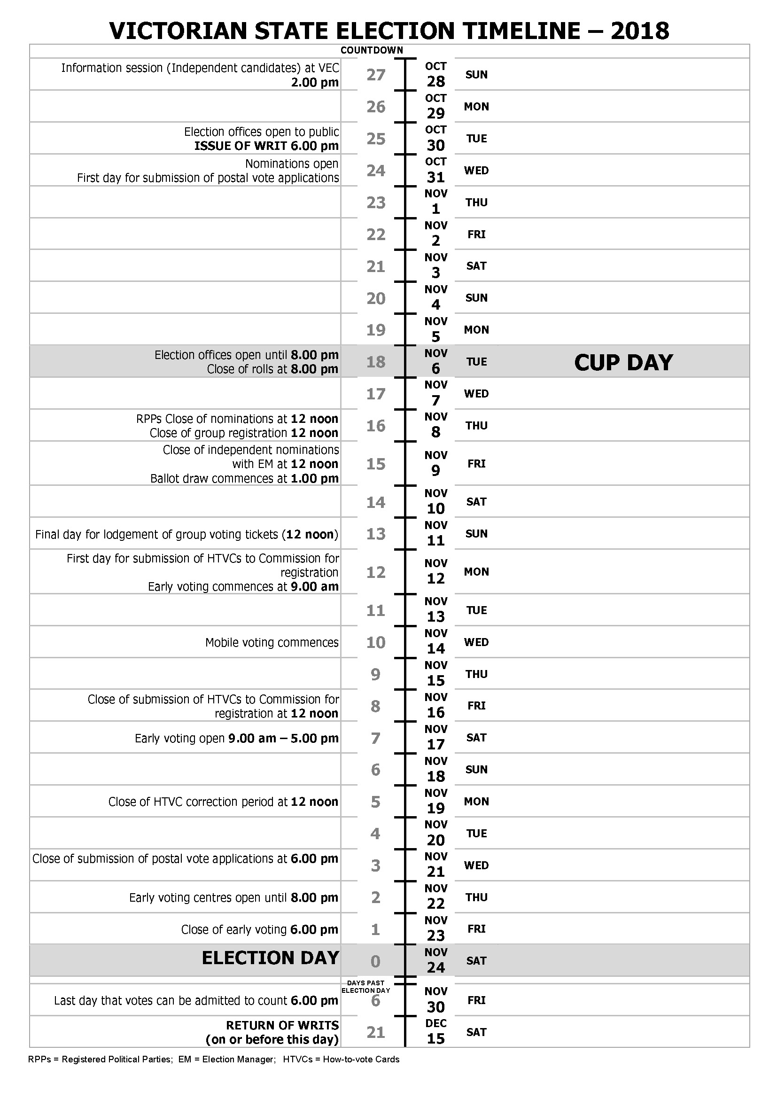
RPPs = Registered Political Parties; EM = Election Manager; HTVCs = How-to-vote Cards

3. Constitution and Legal Qualifications for Candidates
Reference - Constitution Act 1975 - sections 44 to 61A.

Eligibility for Nomination
A candidate for either House must be enrolled as an elector. Therefore, he or she must be:
- at least 18 years old;
- a Victorian resident; and
- an Australian citizen; or
- a British subject who was on either a Victorian or Commonwealth electoral roll at any time between 26 October 1983 and 25 January 1984 inclusive. [Constitution Act 1975 ss. 44(1), 48(1)]
The Constitution Act 1975 [s. 44] disqualifies the following persons from being elected to either House:
- a person not enrolled as an elector in Victoria;
- an elector who is a judge of a court of Victoria;
- an elector who has been convicted or found guilty of an indictable offence, which is punishable upon first conviction by imprisonment for life, or for a term of five years or more. This offence must have been committed by him or her when 18 years or over, under the law of Victoria, or under the law of any other part of the British Commonwealth of Nations;
- an elector who is an undischarged bankrupt; or
- a person who is a member of either House of Parliament of the Commonwealth.
A person who holds an office of profit under the Crown, including an employee in the Victorian or Commonwealth Public Service, is not disqualified from standing for election to State Parliament by reason only of holding an office of profit under the Crown. The election to State Parliament of such a person automatically terminates his or her tenure of the office in question. [Constitution Act 1975 (s.61)]
A person who is a municipal councillor [Local Government Act 1989 s. 28A], or employed in the Victorian or Commonwealth Public Service is eligible to stand for election, but will cease to be qualified for the previous position as soon as they become a Member of Parliament.
Certain contractors with the Crown cannot sit in State Parliament. [Constitution Act 1975 (ss.54-58)]
The qualifications to be a member of either House of the Victorian Parliament are the same. However, a member of either House cannot be elected to or sit as a member of the other House. [Constitution Act 1975 (ss.29, 36)]
Intending candidates must be enrolled before the close of roll.

Multiple Nominations
An elector cannot nominate as a candidate for more than one election to be held on the same day. [EA s. 69(6)] If this occurs, all of his or her nominations as a candidate are declared void and the deposits paid in respect of the nominations are forfeited. [EA s. 69(7)]

4. Nomination Procedures
Reference - Electoral Act 2002 - sections 68 to 69.

Complete a Nomination Form Online (Independent Candidates)
The VEC encourages independent candidates to complete their nomination form online using the VEC’s Candidate Helper at vec.vic.gov.au
The online Candidate Helper will guide intending candidates through each part of the Nomination Form P301. This is an easy process and will allow candidates to check and change details before final submission. It is especially important that any contact details provided for publication are correct, as once they are displayed on the VEC’s website, changes may take some time. Once the candidate is satisfied that the details are correct, the online form can be printed. The form will print in two parts and will include a barcode.
Part 1 of the Nomination Form P301 requires six electors who are on the roll for the District the candidate is standing, to complete and sign the nominators section of the form. It is suggested that additional names are added in case any nominators are not on the roll. Please ensure details are printed clearly.
Note: Candidates have not nominated at this stage. They must deliver the barcoded Nomination Form and the nomination deposit to the Election Manager for processing.
Significant time will be saved at the election office for candidates who submit a pre-populated form that was completed online. These candidates will not have to wait while the data is manually entered into the VEC’s Election Management System (EMS).
At the election office, the Election Manager will check the form and if all details are complete and in accordance with legislation it will be accepted. The barcoded Nomination Form is scanned and all information is loaded into EMS. If a hand-completed Nomination Form P301 is submitted, candidates must be prepared to wait while the details are entered manually.
Once the nomination details are loaded into EMS, a report is printed for the candidate to check and sign confirming all details are correct. The accuracy of nomination details is the responsibility of the candidate.

Nomination Forms
Intending candidates must nominate on the prescribed form. For candidates not using the online facility and who are not endorsed by a registered political party, the Nomination Form P301 is available in the Candidate Kit, from any Election Manager, or can be downloaded from the VEC website.
Independent candidates are encouraged to make an appointment with the Election Manager in the District they are nominating for early in the election period to discuss election arrangements.
Candidates from registered political parties can only be nominated by the registered officer of the party and such nominations must be made with the VEC.
The VEC will provide specific nomination kits for registered political parties.

Deposit Required
Each nomination for the Legislative Assembly must be accompanied by a deposit of $350. The deposit must be in cash or cheque drawn on account of a bank, building society, or credit union (bank cheque). [EA s. 69(4)]
Cheques should be made payable to the “Victorian Electoral Commission”. Personal cheques or money orders cannot be accepted.
The nomination deposit will be returned to the candidate, or someone authorised by the candidate, if the candidate:
- is elected;
- receives at least 4% of the first preference votes in the electorate;
- retires before the close of nominations;
- dies before 6.00 pm on election day; or
- is a candidate in a failed election.
All other candidates forfeit their deposits. [EA s. 180]

When and Where to Nominate
Nominations can only be lodged after the issue of the writ. It is advisable to nominate early in the nomination period to ensure there is sufficient time to resolve any issues that may arise.
For candidates not endorsed by a registered political party, a completed Nomination Form must be lodged by 12 noon on Friday 9 November 2018 with the Election Manager. [EA s. 69(3)] It is the candidate’s responsibility to ensure that his or her nomination is received by the Election Manager before the deadline.
Registered political parties must nominate their endorsed candidates directly with the VEC after the issue of the writ and before 12 noon on Thursday 8 November 2018. [EA s. 69(2)]
An emailed Nomination Form will not be accepted.
Late nominations cannot be accepted.

Nomination Form
The Nomination Form completed by the candidate must include:
- the candidate’s full name and residential address as it appears on the roll;
- postal address (if different to residential address)
- contact details for publication;
- a statement specifying the form in which their given name(s) are to appear on the ballot paper. A given name may be replaced by:
- an initial or a commonly accepted variation or abbreviation of that name; or
- a commonly used other name by which the candidate is usually identified. In this case a candidate will be required to produce evidence to the satisfaction of the Election Manager that it is a name by which the candidate is usually identified;
- in the case of a candidate not endorsed by a registered political party, the full name, signatures, enrolment addresses, and dates of birth of at least six people entitled to vote for the District for which the candidate is nominating;
- in the case of a candidate endorsed by a registered political party, the signature of the registered officer of the party and the form in which the party’s name is to appear on the ballot paper;
- the consent of the nominated candidate; and
- a declaration signed by the candidate that the candidate is qualified under the Constitution Act 1975 to be elected. [EA s. 69(2),(3),ER Form F]
When specifying the way their name is to appear on the ballot paper candidates must:
- print their FAMILY NAME and INITIALS in capitals, e.g. SMITH, T. E. (ensure the format of initial(s) includes a full stop and, if more than one initial, a space is between each letter, e.g. T. E.);
- print their given name(s) in title case, e.g. John P. or Joan Anne; and
- clearly specify on the form if their family name has any lower case letters or accents, e.g. MacALISTER, van LEW, or GLASÉ.
No affiliations or titles (e.g. Dr, Prof.) may appear on a ballot paper beside the name of any candidate.

Retirement of a Candidate
A candidate who is not endorsed by a registered political party may withdraw their nomination by lodging with the Election Manager a notice of retirement, at any time up to the close of nominations.
A candidate endorsed by a registered political party may withdraw their candidate’s nomination by lodging with the Electoral Commissioner a notice of retirement at any time before 12 noon on the day before the close of nominations.
The nomination is then cancelled and the deposit refunded. [EA s. 71]

Death of a Candidate
If a nominated candidate dies before the close of nominations, the nomination period is extended by a day. [EA s. 63(6)]
If a candidate dies between the close of nominations and 6.00 pm on election day, or if the successful candidate dies after 6.00 pm on election day and before being declared elected, the election fails and the deposits lodged on nomination are returned. [EA ss. 72(1), 180(1)] A new writ is issued for another election in that District. [EA s. 72(2)(c)] The supplementary election is held using the roll prepared for the original election. [EA s. 72(4)(a)]

Uncontested Elections
If, by the close of nominations only one candidate has nominated at an election, the Election Manager declares that candidate elected on nomination day. [EA s. 121(1)]

Candidate Contact Details Publicly Available
Candidates should note that candidate contact details for publication, as specified by the candidate on the Nomination Form, automatically become publicly available once quality assurance processes have been completed.
The VEC will publish candidate contact details on its website, and will provide the media with candidate contact details.

Candidate Details Provided to Parliamentary Services
The VEC will provide the name, postal address, phone number, and email address of candidates to Parliamentary Services so that contact with successful candidates can be made immediately after the declaration of the result. Refer to Chapter 21: Parliamentary Induction for Successful Candidates for more information.

Nomination Forms not Available for Inspection
A candidate’s Nomination Form is not available for inspection. [EA s. 69(8)]

List of Nominations on Display
A summary of nominations, including the contact person’s details for each candidate, will be updated at the end of each business day and displayed at the election office [EA s. 68] and on the VEC’s website.

Correct Pronunciation of Candidate Names
The VEC’s telephone assisted voting service enables eligible electors to cast their vote via telephone. The VEC will establish a call centre to manage this process. Telephone operators will be required to read out all the candidate names as they appear on the relevant District and Region ballot papers.
If candidates have a preferred way for their name to be pronounced, they will be able to call a message bank service to advise the VEC of the preferred pronunciation. The message bank service number will be included on the VEC website.
The service will operate from 9.00 am on Wednesday 31 October to 4.00 pm on Friday 9 November 2018.
Candidates should not call this service until their nomination has been finalised by the Election Manager or the VEC, and their name appears as a candidate on the VEC website. The service will request the following information:
- candidate name;
- electorate for which the candidate is nominating;
- a contact phone number; and
- the pronunciation of the candidate name as it will appear on the ballot paper (surname first, then given name(s)).
VEC staff may contact candidates using the service should further clarity be required.

5. Electoral Rolls for Candidates
An electronic copy of the roll for the District a candidate has nominated for will be made available via the VEC’s secure data exchange portal. This is the only way the roll will be supplied.
All candidates requiring a copy of the roll must sign the Electoral Roll Confidentiality Agreement P312 taking full personal responsibility for the confidentiality of the data, and provide an email address for receipt of instructions to access the roll. The form cannot be signed by a candidate’s representative. An emailed signature is acceptable on this declaration. This form is to be lodged with the Election Manager at the time of nomination.
Once the P312 has been signed and the candidate’s nomination finalised, the roll for the District for which the candidate has nominated will be provided as soon as possible after the close of roll and completion of processing (expected to be Saturday 10 November 2018). Candidates will be sent an email containing instructions on how to create an account and download an electronic copy of the roll from the VEC’s secure data exchange portal (dex.vec.vic.gov.au).
The roll will contain the name and address of electors entitled to vote in the election. The roll will not contain any silent electors [EA s. 33(6),(7)] nor address details of itinerant or overseas electors. The roll will comprise two comma separated files, one in name order and one in street order. These can be opened in Excel, then used to look up names, for a mail merge, or as a basis for street walks (street order).
Candidates may only use roll information for a purpose in connection with the election for which it was provided and for monitoring the accuracy of information contained on the roll. [EA s. 36]
PENALTY: 600 penalty units for an individual and 3000 penalty units for a body corporate or registered political party
There are very sound reasons why candidates must treat the roll with absolute privacy. The roll contains electors’ personal information. Electors are required by law to provide their personal information to the VEC for the purpose of enrolment. If electors believe their personal information is being misused then they will be reluctant to maintain their enrolment.
Enrolment information is protected information under Victoria’s electoral law and candidates must not disclose protected information other than for a permitted purpose in connection with the candidate’s campaign.
A candidate may use the roll information to send electors campaign material. A candidate may provide the roll to a mailhouse for the purpose of direct mailing electors with campaign material. However, the candidate remains responsible for ensuring that the mailhouse does not disclose the information for another purpose.
Once the election is over, a person who was a candidate in an election may not use the roll for any other purpose, nor supply it to any other party.
Enrolment information must not be used for a commercial purpose.
[EA ss. 36, 37]
PENALTY: 600 penalty units for an individual and 3000 penalty units for a body corporate or registered political party

6. The Ballot Paper
Reference - Electoral Act 2002 - section 74.

Order of Names on the Ballot Paper
Candidates’ names will appear on the ballot paper in the form specified by the candidate on the Nomination Form. The order of names on the ballot paper is determined by a computerised single randomised draw. The Election Manager will conduct the draw at the election office as soon as practicable after nominations close. This is anticipated to commence from 1.00 pm. Candidates will be advised of the time for the draw for position on the ballot paper. Candidates and any persons may attend the draw.
Following the draw for position on the ballot paper the Election Manager will provide candidates with a report called Sample How-to-vote Card. This report shows all candidates’ names as they appear on the ballot paper and the details required for registration of a how-to-vote card.

Political Party Names and Logos on Ballot Papers
Only a registered political party is allowed to have its registered party name or abbreviation and registered logo printed on the ballot paper adjacent to the name of the candidate or group endorsed by the party. [EA s. 74(4) & (5)].
Parties, however constituted, that are not registered with the VEC, are not entitled to have a party name, abbreviation or logo printed on ballot papers.
The form of the party’s name is specified by the party on the Nomination Form. [ER Form F]

Additional Descriptions
Where the similarity in the names of two or more candidates is likely to cause confusion, the names of these candidates may include other additional descriptions to distinguish them from one another, as determined by the VEC. [EA s. 74(2)]

7. Electoral Advertising
Reference - Electoral Act 2002 - sections 83 to 86.

Provisions in effect at all times
The following provisions operate all times.
Electoral Material and Electoral Matter
Electoral material is an electoral advertisement, handbill, pamphlet, or notice that contains electoral matter. [EA s. 3]
Electoral matter means matter which is intended or likely to affect voting in an election. [EA s. 4]
Without limiting the generality of the definition of electoral matter, matter is taken to be intended or likely to affect voting in an election if it contains an express or implicit reference to, or comment on:
- the election;
- the Government;
- the Opposition;
- a previous Government or a previous Opposition of the State, Commonwealth, or any other State or Territory;
- a member or former member of the Parliament of the State or of the Commonwealth, or any other State or Territory;
- a political party, a branch or division of a political party, or a candidate in the election; or
- an issue submitted to, or otherwise before the electors in connection with the election.
Electoral Material (including online) must be Authorised
Electoral material may not be printed, published, or distributed unless:
- the name and street address (not a post office box) of the person who authorised the electoral material appears; and
- in the case of electoral material that is printed or published otherwise than in a newspaper, the name and place of business of the printer or publisher appears. [EA s. 83 (1)(b)] Note that ‘to publish’ includes publication on the internet.
PENALTY: 10 penalty units for an individual and 50 penalty units for a body corporate
A person who makes copies for distribution of electoral material that is published on the internet is deemed to be the printer of those copies. [EA s. 83(2)]
Authorisation is not required for a car sticker, an item of clothing, lapel button, lapel badge, fridge magnet, pen, pencil, balloon, or a letter or card which bears the name and address of the sender, and does not include a representation of a ballot paper for an election or how-to-vote card registered under section 70 or 80 of the Act or an article included in a prescribed class of articles. [EA s. 83(3)]
Social media, blogs and email communication containing electoral matter or content must also be authorised. In particular, candidates and others involved in campaigning must ensure that: all website/webpages are authorised; election related postings to Facebook, Twitter, blogs etc. are authorised or link directly to an authorisation statement; advertisements including sponsored links carry or directly link to an authorisation statement; and care is taken not to defame, threaten or harass any person.
If unclear, candidates should seek their own legal advice in this area or just authorise.
Headings of Electoral Advertisements
Newspaper proprietors must ensure that all paid paragraphs or articles containing electoral matter that appear in their newspapers are headed by the word ‘Advertisement’. [EA s. 85]
PENALTY: Five penalty units for an individual and 25 penalty units for a body corporate
Local Laws
Candidates should check with their local council to see if there are any local laws that may apply to the distribution and display of advertising material within the municipality, with VicRoads for provisions covering the display of material on highways and with Public Transport Victoria (ptv.vic.gov.au/about-ptv/victorias-public-transport-network/fundraising-and-campaigning-activity-on-the-public-transport-network/) in relation to the distribution and display of material on public transport facilities.

Provisions in effect during the election period
The following provisions operate only during an election period, that is in the period between the issue of the writ and 6.00 pm on election day.
Identification of Authors
During an election period, all articles, reports, or letters containing electoral matter which are printed, published, or distributed in a newspaper, circular, or pamphlet must include the name and address of the author at the end (‘Address’ does not include a post office box number).
However, letters in a newspaper simply have to include the author’s name and the suburb or locality in which the author’s address is located.
The identification requirement does not apply to a newspaper leading article or an article that is solely a report of a meeting. [EA s. 86]
PENALTY: Five penalty units for an individual and 25 penalty units for a body corporate

Misleading or Deceptive Material
During an election period it is illegal to print, publish, distribute, permit, or authorise:
- anything that is likely to mislead or deceive an elector in relation to the casting of their vote; or
- electoral material containing a representation of a ballot paper that is likely to induce an elector to vote otherwise than in accordance with the directions on the ballot paper. [EA s. 84 (1) and (2)]
PENALTY: 60 penalty units or six months imprisonment for an individual and 300 penalty units for a body corporate
Refer to Chapter 23: Complaints for more information concerning misleading or deceptive material.
Matter Broadcast or Televised
The broadcast on radio or television of all political and election matter (including election advertisements), must comply with the requirements set out in Schedule 2 of the Broadcasting Services Act 1992 (Commonwealth).
The VEC is not in a position to offer any advice regarding the operation of Commonwealth legislation. Any enquiries concerning the operation of the above Commonwealth Act should be directed to:
Australian Communications and Media Authority
PO Box 13112 Law Courts, Melbourne Vic 8010
Tel: (03) 9963 6800
acma.gov.au

8. How-to-vote Cards
Reference - Electoral Act 2002 - sections 77 – 82A, 156, 157 and the Electoral Regulations 2012 (Regulations 17 – 19).

How-to-vote Cards at Election Day Voting Centres
Registered how-to-vote cards are the only form of printed electoral material permitted to be distributed within 400 metres of a voting centre on election day. [EA s. 156(1)]
PENALTY: 60 penalty units or six months imprisonment
This restriction does not apply to posters, bunting and similar material, material in campaign offices, or the normal distribution of newspapers. [EA s. 156(4)]
On election day an Election Manager or election official is empowered to require a person reasonably suspected of distributing unregistered how-to-vote cards to produce their how-to-vote cards for inspection and to hand over all unregistered cards. [EA s. 157] Failure to comply is an offence.
PENALTY: 10 penalty units

How-to-vote Cards at Early Voting Centres
How-to-vote cards distributed at early voting centres are not required to be registered. They are required to contain the name and street address of the person authorising the card and the name and place of business of the printer. [EA s. 83(1)]
PENALTY: 10 penalty units for an individual and 50 penalty units for a body corporate
They must not contain material that is likely to mislead or deceive an elector in relation to the casting of the vote of the elector. [EA s. 84]
PENALTY: 60 penalty units or six months imprisonment for an individual and 300 penalty units for a body corporate

How-to-vote Cards at Mobile Voting Centres
How-to-vote cards carried by election officials at mobile voting centres must be registered.
It is for the party, candidate, or other person to provide printed copies of registered how-to-vote cards to Election Managers for inclusion in material carried by mobile voting teams. The VEC will not facilitate distribution to Election Managers.
When registered how-to-vote cards have been provided, the Election Manager will enclose the how-to-vote cards in several folders in the same order as candidates or group names appear on the ballot paper.
Mobile voting teams will advise electors that how-to-vote cards have been supplied and provide electors with a folder of cards if so requested.[EA s. 65(4)]

Registration
All cards are registered by the Victorian Electoral Commission (VEC). Any person may lodge cards for registration with the Election Manager appointed within the electorate that the card relates to [EA s. 77]. How-to-vote cards specific to registered political parties (RPPs) must be lodged directly with the VEC for registration.
Applicants are encouraged to discuss drafts of their cards with the VEC or their Election Manager before submitting their card(s) for registration. Once formally submitted, the VEC will advise the applicant of their decision by 12 noon on the next day. If a card does not meet the criteria for registration it will be rejected and the applicant will need to resubmit an amended card and a new application. The registration process commences again.
Applications to register how-to-vote cards must be submitted between the first working day after the close of nominations and 12 noon on the sixth working day before election day. Refer to Chapter 2: Timeline for the State Election 2018.
Each card submitted to the Election Manager for registration must be a single card for a District election or for a Region election. Sample how-to-vote card templates are in Appendix 2. Additional provisions apply for registered political parties.
Applicants should submit an electronic copy of the how-to-vote card on a USB key or by email in PDF format. This copy must be in print ready format as changes or errors introduced during the formatting and printing process could change the registration status of the card. Applicants must also provide two hard copies of the card in print ready format at the time of lodgement.
The final print version that is submitted must include the following endorsement on one printed side of the card:
Authorised by: <name and street address of authoriser, not PO Box>
Printed by: <name and place of business>
Registered by the Victorian Electoral Commission
Cards must not be handed out until confirmation is received from the VEC that the card has been registered. Do not have cards printed until registration is approved.
A How-to-vote Card Checklist (Appendix 1) and sample cards (Appendix 2) will assist in the preparation of how-to-vote cards.
Check each item as it applies to the card, paying particular attention to the spelling of candidates’ names. The Election Manager and the VEC will also check each item when the card is submitted.
The applicant must make a declaration on the prescribed form concerning his or her identity and the party, organisation, or person on whose behalf the card will be distributed. If the card includes a section in a language other than English, the applicant must also submit a translation of that section and sign a declaration that the translation is fair. [EA s. 148]
Indictable Offence
PENALTY for false declaration: 600 penalty units or five years imprisonment
A How-to-vote Card Declaration is included in the Candidate Kit. The completed form must be provided by the applicant along with the copies of any how-to-vote cards being submitted for registration. A new completed declaration is required if an applicant lodges additional cards at other times during the how-to-vote card registration period.
To be registered a card must:
- clearly identify the person, political party, organisation, or group on whose behalf the card is to be distributed;
- contain an indication of the order of voting preference for all candidates listed on the card or contain a statement that a number must be placed against the name of each candidate;
- have the size of any logo, emblem, or insignia belonging to the person, political party, organisation, or group on whose behalf the card is to be distributed appearing on the how-to-vote card at not less than the relevant prescribed size of 4 square centimetres (4 cm²). Keep in mind this criteria if printing a card at a different size to when it was registered;
- contains on at least one printed side the name and street address (not a post office box) of the person authorising the card and the name and place of business of the printer;
- not be likely to mislead or deceive an elector in casting their vote. For example, a card for a District election that contains empty boxes may induce the elector to cast an informal vote, and as such would not be registered;
- not be likely to induce an elector to mark their vote otherwise than in accordance with the directions on the ballot paper;
- not contain offensive or obscene material; and
- contain the prescribed endorsement i.e. Registered by the Victorian Electoral Commission. [EA s. 79, Electoral Regulations 2012, regulation 18,]
Applicants are encouraged to use the Sample How-to-vote Card supplied by the Election Manager, which has the correct spelling of candidate names with their order on the ballot paper and the correct wording for authorisation and registration.
A list of candidate names in ballot paper order will also be available on the VEC website.
Note: ‘Registered by the Victorian Electoral Commission’ must not be included on how-to-vote cards that have not completed the registration process but are to be distributed prior to election day. Refer to How-to-vote Card Checklist (Appendix 1)

Use of Photographs and Quotes on How-to-vote Cards
If intending to include photographs on the how-to-vote card that include people other than the candidate, photographs that clearly identify members of a particular organisation, or quotes from people other than the applicant, it is strongly advised to ensure permission has been gained from the people or organisations concerned to use the image and/or quote(s) in the context of a how-to-vote card.
There have been instances where people or organisations have objected to the use of photographs or quotes on how-to-vote cards because it has promoted a view that the person or organisation is supporting that candidate.
While the use of photographs or quotes in most cases would not prevent registration of the card, applicants are reminded to ensure proper protocols are followed to avoid disputes that could consume time away from their election campaign.
The VEC will not accept any responsibility to advise candidates on potentially contentious photographs or quotes, and the VEC has little authority to regulate the use of photographs or quotes unless they are offensive or obscene.

Decision on How-to-vote Card Applications
Before 12 noon on the next day after receiving a how-to-vote card the VEC will inform the applicant that they are:
- registering the how-to-vote card; or
- refusing to register the how-to-vote card.

Last Day Submissions
Applicants are advised not to leave submission of their card(s) for registration until the last minute. If applicants submit their application on the last day (Friday 16 November 2018), the VEC will not advise applicants of its decision until the next day. If a card does not meet the requirements for registration, it will be too late for the applicant to resubmit a card for registration and they will not be able to:
- distribute their card within 400 metres of voting centres on election day;
- have their card displayed on the web; or
- have their card included with how-to-vote cards carried by mobile voting teams visiting mobile voting centres.

Review of Decision
Any person may apply to the Victorian Civil and Administrative Tribunal for a review of the VEC’s decision on a how-to-vote card no later than 12 noon on the next working day after the VEC has advised the applicant of that decision.
The Victorian Civil and Administrative Tribunal must make a decision no later than 5.00 pm on the next working day after receiving the application.
[EA s. 82A]

Inspection of Cards
As soon as practicable after registration, registered how-to-vote cards will be displayed on the VEC’s website, vec.vic.gov.au [EA s. 82]. Any person has the right to inspect a card at the office of the VEC, once it has been registered.
[EA s. 82]

Alterations to Registered How-to-vote Cards to Correct an Error
If an alteration is required on a registered how-to-vote card to correct an error, the person who applied for the registration must submit an amended version to the VEC for registration no later than 12 noon on the fifth working day before election day. Refer to Chapter 2: Timeline for the State Election 2018
Before 12 noon on the next day after receiving the amended card, the VEC will inform the applicant that they are:
- registering the amended how-to-vote card; or
- refusing to register the amended how-to-vote card.

Printing more than one Registered Card on a Leaflet
Applicants may wish to print more than one registered single how-to-vote card on the same leaflet. This is usually the case where an applicant separately registers single how-to-vote cards for a District election and Region election or where applicants wish to distribute their card at a joint voting centre.
More than one single registered how-to-vote card can be printed on the same leaflet. In such cases, each single registered card must be reproduced exactly as they were registered and each card must include its own authorisation and registration statement. No changes can be made to the registered single how-to-vote cards and no additional material can be introduced.
This should not be confused with combined registered how-to-vote cards available to Registered Political Parties.

Combined How-to-vote Cards
Registered political parties may submit a combined how-to-vote card to the VEC for registration, that is, a how-to-vote card submitted with respect to one or more electoral Districts or Regions for which the registered political party submitting the how-to-vote card has endorsed a candidate. [EA s. 78(3)(c)]

Multiple How-to-vote Cards
Registered political parties may submit a multiple how-to-vote card to the VEC for registration, that is, a how-to-vote card submitted with respect to no less than every District or Region for which the registered political party submitting the how-to-vote card has endorsed a candidate. [EA s. 78(3)(b)]

9. Postal Voting
During the State election, the VEC will establish a centralised postal vote processing centre. The centralised processing centre will minimise any delays in electors receiving their postal voting papers and will also process and count completed postal vote declarations.
Electors can obtain an application for a postal vote from:
- any post office;
- election offices;
- any of the interstate and overseas early voting centres; or
- by telephoning the VEC election hotline number on 131 832
Electors may also submit an online postal vote application. Online applications do not have to be witnessed however; the elector is required to provide a verification question and answer at the time of application. Directions for lodging completed applications either online or in hardcopy with the VEC are included on the application and at vec.vic.gov.au
Candidates are cautioned not to attach or include party badged or campaign material to postal vote applications for distribution to electors. If the VEC receives postal vote applications that are physically attached to, or form part of other written material not produced by the Commission, the application will be rejected.
Postal vote applications cannot be dated prior to the Issue of the Writ and must be received at the VEC no later than 6.00 pm on the Wednesday before election day. Refer to Chapter 2: Timeline for the State Election 2018.
Candidates may appoint scrutineers to observe the preparation of ballot packs at the VEC’s mailhouse and the return of completed postal vote declaration envelopes to the VEC’s central processing centre. Candidates and parties will be provided with venue details including operation times.
An electronic copy of the details of those applicants requesting to vote by post for the District or Region a candidate has nominated for will be made available on request via the VEC’s secure data exchange portal. On request registered political parties will also be provided with similar applicant information.
All candidates and registered political parties requesting a copy of the postal voting application details must sign the Postal Vote Application Confidentiality Agreement P381 taking full personal responsibility for the confidentiality of the data, and provide an email address for its delivery. The form cannot be signed by a candidate’s representative. An emailed signature is acceptable on this declaration. This form is to be lodged with the Election Manager at the time of nomination or for Registered Political Parties with the VEC.
Once the P381 has been signed, postal voting application details for the District for which the candidate has nominated will be provided as soon as practicable after postal voting material has been issued. Candidates will be sent an email containing instructions on how to create an account and download electronic copies of the postal voting details as they become available from the VEC’s secure data exchange portal (dex.vec.vic.gov.au).
The postal voting application details will contain the name and address of electors who applied to vote via post in the election. The information will not contain any silent electors nor address details of itinerant electors [EA s. 104A (3)]. Information of those applicants requesting to vote by post will comprise of one comma separated file, in surname order within District. This can be opened in Excel, and then used to look up names, for a mail merge, or as a basis for street walks (street order). As per legislative requirements there are restrictions as to what data is made available. Independent candidates may only receive data for the electorate in which they are standing, whereas registered political parties will receive data for all electorates.
Candidates must not use information provided for any purpose unless the use is for a purpose in connection with the election. [EA s. 104A (4)]
PENALTY: 600 penalty units for an individual and 3000 penalty units for a body corporate or registered political party
A person must not disclose information provided unless the disclosure is for any purpose in connection with the election. [EA s. 104A (5)]
PENALTY: 600 penalty units for an individual and 3000 penalty units for a body corporate or registered political party

10. Early Voting Centres
The VEC will appoint early voting centres at suitable locations throughout Victoria, interstate, and overseas. Refer to Chapter 14: Canvassing at Voting Centres.
Any elector can vote at an early voting centre.
Early voting centres will operate from 9.00 am on the first working day after the close of nominations to 6.00 pm on the day before election day. Details of all early voting centres and operating hours will be available on the VEC website. Candidates can obtain this information from the Election Manager.
Electors may vote in person at:
- any early voting centre in Victoria (including Melbourne Airport); or
- any of the interstate and overseas early voting centres.
Early voting hours are as follows:
9.00 am to 6.00 pm on Monday 12 November 2018
8.30 am to 6.00 pm from Tuesday 13 November to Friday 23 November 2018
9.00 am to 5.00 pm on Saturday 17 November 2018
8.30 am to 8.00 pm on Thursday 22 November 2018
Note, however, that operating hours for the early voting centre at Melbourne Airport are different. See below:
Melbourne Airport
9.00 am to 10.00 pm on Monday 12 November 2018
5.00 am to 10.00 pm from Tuesday 13 to Thursday 22 November 2018, including Saturday and Sunday.
5.00 am to 6.00 pm on Friday 23 November 2018.
People wishing to vote at an early voting centre who cannot be found on the roll will be entitled to apply to enrol and make a provisional vote, by completing a form and giving a proof of identity. The VEC will check these applications after election day.

11. Election Day Voting Centres
Voting takes place between 8.00 am and 6.00 pm on election day at appointed voting centres within each electorate.
The Election Manager will provide candidates with a list of election day voting centres within the electorate together with voting estimates for each venue. A full list of election day voting centres is also available on the VEC website.
Electors who attend an election day voting centre within their own electorate will complete an ordinary vote. Ordinary voting involves election officials marking the elector’s name off a printed scannable roll, or in some cases, an electronic roll, and issuing the elector with their ballot papers. The elector completes their ballot papers and places them directly into the ballot boxes at the venue. Ordinary votes are counted in voting centres after 6.00 pm on election day.
Joint voting centres are appointed in some electorates where the venue is close to a District boundary. Electors from each District sharing the joint venue will be able to complete an ordinary vote. Estimated elector numbers will be provided to candidates by the relevant Election Manager responsible for each District sharing the joint venue. This is to assist the candidate in estimating the number of how-to-vote cards required as electors from the District the candidate is not standing for may take cards meant for the candidate’s District electors; candidates may need to provide more cards than the estimated number of electors expected from the District they are standing for.
Electors who attend an election day voting centre outside their own District can complete an absent vote. This involves the elector either completing a declaration envelope, stating the address for which they are enrolled or having their named marked on an electronic roll. Their completed ballot papers are either sealed in the declaration envelope, or placed in a ballot box and then sorted and returned to their home District election office after election day. Votes in declaration envelopes are checked against the roll and those that are admitted are counted in the week following election day. Votes marked on the electronic roll are included in the count with absent votes extracted from declaration envelopes.
Where election day voting centres have facilities to enable electronic roll marking, absent electors will not have to complete a written declaration.
Eligible electors who attend an election day voting centre, whose name cannot be found on the roll for any electorate within Victoria, will have the opportunity to enrol and complete a provisional vote for the District where they reside. These electors will be required to provide proof of identity in the form of an Australian Driver Licence, Australian Passport, current Victorian Rates Notice, current electricity account, current Victorian identification (defined as current identification issued to a person by the State or a statutory authority that includes the person’s name, residential address, date of birth, and photograph, e.g. a proof of age card), or any other acceptable form of identification prescribed by the Electoral Regulations 2012.
If they do not have a proof of identity document with them, they can nominate VicRoads, their local Council, or their electricity provider to enable the VEC to verify their identity after election day. The elector will be required to complete a declaration envelope and enclose their completed ballot papers in the envelope. The VEC will check these applications after election day.

12. Mobile Voting Centres
Mobile voting centres are venues (typically hospitals and nursing homes) appointed by the Electoral Commissioner at which a team conducts mobile voting in the period prior to election day. A mobile voting team may move around the venue issuing early votes to patients and residents or establish a static voting area within the venue for a period of time.
Candidates may appoint scrutineers to accompany the mobile voting team.
Election Managers will advise candidates of arrangements for mobile voting and the number of scrutineers permitted.
An itinerary listing mobile voting centres, dates, and times of visits will be prominently displayed in election offices before 4.00 pm on the day preceding any visit. However, should it become necessary to vary the timetable, candidates and the centre administration will be advised.
Candidates should note that scrutineers are not permitted to display election material or distribute how-to-vote cards while accompanying the mobile team.
In addition, party/candidate workers are not permitted to canvass for votes or distribute election material, including how-to-vote cards, within 6 metres (or other distance as determined by the Mobile Voting Centre Manager) of the designated entrance to the voting centre while voting is in progress. Additional restrictions apply regarding the display of notices or signs within 100 metres of the designated entrance to the voting centre. Refer to Chapter 14: Canvassing at Voting Centres.
Candidates may provide printed copies of registered how-to-vote cards to Election Managers, to be included in folders carried by mobile voting teams. Mobile voting teams will advise electors that registered how-to-vote cards have been supplied and provide electors with a folder of the cards if so requested. [EA s. 65(4)]
People wishing to vote who cannot be found on the roll will be entitled to apply to enrol and make a provisional vote, by completing a form and giving a proof of identity. The VEC will check these applications after election day.

13. Assistance to Vote
Electors may be assisted with voting in a number of ways by:
- election officials taking ballot material outside the voting centre when the elector is physically unable to enter the voting centre to vote; or
- being assisted in the marking of their ballot material by an election official, scrutineer, or other person nominated by the elector.
Strict procedures are in place to enable scrutineers, if present, to witness election officials helping electors with their vote. The Voting Centre Manager or the Election Manager will advise scrutineers of the procedures if an elector requests special assistance to vote.
Additionally, telephone assisted voting will be provided at the VEC Head Office telephone early voting centre for electors who otherwise could not vote without assistance because they are blind or have low-vision or a motor impairment.
An elector applying to vote by telephone who cannot be found on the roll will be required to attend a voting centre if they wish to complete a provisional vote.

14. Canvassing at Voting Centres
Candidates are requested to ensure that party/candidate workers are aware of the legislative requirements and protocol as outlined below. This applies at early, mobile and election day voting centres.

The Six Metre Rule
A person is not allowed to canvass for votes, solicit the vote of any elector, induce any elector not to vote, or display any unofficial electoral notice within 6 metres of the designated entrance of, or within the building used as a voting centre. [EA s. 158]
PENALTY: Five penalty units
Party/candidate workers distributing registered how-to-vote cards must be outside this limit.

Exhibition of Notices or Signs (100 metre rule)
During the hours of voting a candidate or registered political party may display up to two notices or signs not exceeding 600 mm x 900 mm within 100 metres of the Designated Entrance of the voting centre. No other notices or signs in relation to the election, other than official notices, may be displayed in this area at this time.
Party/candidate workers need to be aware of the following potential situations:
- Candidate office/location – It is possible that a candidate office or other location controlled by the candidate/party may fall within 100 metres of a Designated Entrance of a voting centre. In such a case any signage displayed at the candidate/party location is subject to the 100-metre restricted zone regarding display of notices or signs.
- Private property – Private residences that fall within 100 metres of the designated entrance of the voting centre are exempt from this requirement. Signage displayed in a private residence is not subject to the 100-metre restricted zone regarding display of notices or signs [see s.158A EA].
An Election Manager or election official may remove, or cause to be removed any notice or sign that is reasonably considered as being in contravention. [EA s158A]
PENALTY: Five penalty units

Handing Out How-To-Vote Cards (400 metre rule)
The only electoral material that may be distributed or made available during the hours of voting within 400 metres of a voting centre on election day are registered how-to-vote cards [EA s. 156]. Cards distributed outside early voting centres do not need to be registered.
PENALTY: 60 penalty units of six months imprisonment.

Party/Candidate Workers
Party/candidate workers may assist electors by handing out how-to-vote cards.
A person must not subject any person who within 100 metres of the designated entrance to the voting centre is handing out how-to-vote cards, or supporting a candidate in an election, to violence or intimidation [EA s152(4)]. A person who contravenes the above section of the Act is guilty of an indictable offence.
PENALTY: 600 penalty units or imprisonment up to five years
Additionally, party/candidate workers must not:
- enter a voting centre to retrieve how-to-vote cards from rubbish bins or voting compartments; or
- canvass within six metres of a designated entrance to a voting centre. The Voting Centre Manager will clearly indicate the six metre distance.
Party/candidate workers may only enter the voting centre:
- to cast their vote; or
- if nominated by an elector who needs assistance to complete the ballot paper.
Party/candidate workers must remove any candidate/party-related ID before entering a voting centre.

Protocol for Party/Candidate Workers
In addition to the legal requirements listed within this handbook, party and candidate workers must abide by the following guidelines in relation to all activities outside early and election day voting centres. Venues used as early and election day voting centres are not the property of the VEC. As such, much good will is relied upon in retaining the venue for subsequent elections.
All party and candidate workers should:
- be attentive to any local restrictions requested by venue owners and the VEC regarding the placement of personnel, notices or signs and ensure that the activities do not interfere with other concurrent activities at the venue;
- ensure the complete removal of any notices or signs (including ties), how-to-vote cards and equipment before leaving the venue at the end of each day; and
- ensure workers and materials do not impede or intimidate people moving in and out of the venue.
A spirit of cooperation is requested from all workers outside voting centres with an equal entitlement to convey their message.
Note that the Voting Centre Manager has the authority to respond to activities that are in breach of the legislation.
Voting Centre Managers will not arbitrate on disputes outside any venue between party/candidate workers.
Voting Centre Managers will request cooperation from all parties in the first instance, but if unsuccessful, the matter will be escalated to the relevant party/candidate administration to resolve, or if necessary, to the Police.

Identifying the Designated Entrance
At the 2018 State election the VEC will identify one Designated Entrance to the building used as a voting centre, unless circumstances apply where further entrances may be designated. An entrance to voting centre grounds (e.g. entrance to school yard within which the building sits) will not be a designated entrance unless there are specific reasons to require it. [158A (5)]
Designated Entrances for each election day voting centre will be identified by Voting Centre Managers. Designated Entrance information will be communicated in advance of election day via a Candidate Bulletin. On election day, Designated Entrances will also be identified via a official sign placed next to the entrance from 7.30 am.

Identifying the boundaries
Voting Centre Managers may make a determination that it is necessary to reduce the 6-metre distance from the Designated Entrance (e.g. due to inclement weather or for safety reasons). If so, this will be noted with the information about the location of the Designated Entrance made available in advance, and the Voting Centre Manager will affix a notice to the Designated Entrance declaring the distance that applies and the reason the distance has been reduced.
Voting centre staff will be able to provide guidance to candidate and party workers regarding the 6-, 100- and 400-metre boundaries on election day. The release of information about designated entrances will enable candidate and party workers to estimate the boundaries for voting centres in advance if they wish. Note, however, that on election day the definitive boundary will be determined by the Voting Centre Manager.


15. Count of Ballot Papers
The proposed timetable for Lower House counts is included in Appendix 3 and a booklet describing counting arrangements for the Lower House will be made available on the VEC website at vec.vic.gov.au/state-publications
Candidates can appoint scrutineers to observe all activities described in this chapter unless otherwise noted.

Postal Votes
Postal vote declarations will be verified against postal vote applications at the Central Processing Centre located at the Showgrounds, Ascot Vale, from the Monday prior to Election Day. Election Managers will advise candidates of arrangements.
The extraction and sorting of ballot papers will commence from 8.00 am on Election Day at the Showgrounds. Candidates will be provided with a schedule of anticipated commencement times for each District. Strict rules will apply for any scrutineers attending this activity.
The count of District ballot papers will commence at 6.00 pm on election day at the Showgrounds. The VEC will aim to complete the count of all District ballot papers extracted from postal vote envelopes returned up to 6.00 pm on the Friday before election day on election night. Region ballot papers extracted from postal vote envelopes will be set aside for counting during the week following election day.
Further counting of postal votes will take place at the Showgrounds following Election Day.

Election Day Votes
Ordinary votes cast on election day at voting centres are counted in voting centres, commencing at 6.00 pm.
First preference and two-candidate-preferred results will be phoned through to election offices and posted on the VEC website.

Early Vote Sort and Count
All home District early votes will be sorted and counted in election offices. Election Managers will commence the extraction and sort of home District early votes from 4.00 pm on election day. Strict rules will apply to scrutineers during the period between 4.00 pm and 6.00 pm.
Counting of home District early votes will commence at 6.00 pm. It is intended that most, if not all home District votes in the hands of the Election Manager will be counted on election night. There will be no counting of home District Region votes on election night.
Some counting of early votes may take place in stand-alone early voting centres. Candidates will be advised where this is the case.
Early votes for other Districts and votes cast at mobile voting centres within the District will be sorted to their respective Districts and Regions in election offices after 6.00 pm on election night.
The extraction and sorting of votes taken by telephone will commence at the VEC from 4.00 pm on election day. The same strict rules will apply for telephone votes as for all other early votes.

Early Region and Mobile Voting counts
Early own District Region ballot papers and mobile votes cast at mobile voting centres, will be counted from Monday 26 November 2018.
Scrutineers may request to view the Early Voting Journals and Mobile Voting Journals containing the reconciliation of ballot papers for each early voting centre and mobile voting team.

Provisional Votes
From the Monday following election day, the Election Manager will forward details of provisional votes to the VEC’s Electoral Enrolment Branch (EEB) for eligibility checking.
Counting of accepted provisional votes will take place during the week following election day.

Exchange
Commencing on Election Night and continuing into the Sunday after election day, the sort and packaging of completed ballot material for the Districts will take place at each election office. This material is collected from election offices on the Monday following election day and distributed to their appropriate electorates on the Tuesday.

Absent, Interstate, Overseas, and Remaining Early Votes
Absent, interstate and overseas ballot papers are counted in election offices from the Tuesday after election day. Early votes cast by electors at early voting centres outside their own electorate and telephone assisted early votes will also be counted from this time. Candidates should check with the Election Manager for the dates and times for these activities.

Counting Process
The counting process can be summarised as follows:
Formality check and sort to first preferences
All ballot papers are checked for formality (see Chapter 18) and sorted to each candidate according to the first preference recorded on each ballot paper. The total first preference votes for each candidate plus informals are recorded and captured in EMS. All results are published on the VEC website.
Two-candidate-preferred count (2CP)
All formal ballot papers are sorted to two selected candidates to give an early indication of the election result. Scrutineers will be informed of the two candidates before the count. Election officials sort the formal ballot papers to each selected candidate according to the candidate that has the highest preference (lowest number).
Recheck
A process where all ballot papers are rechecked for formality and correct sorting. Rechecks will commence in District election offices from Monday 26 November.
Preference distribution
Where no candidate has an absolute majority of first preference votes (i.e. more than 50% after the recheck is complete) a distribution of preferences is conducted to determine the result. A preference distribution involves excluding candidates with the fewest votes and distributing their ballot papers to continuing candidates according to the next available preference. This continues until a candidate achieves an absolute majority. This process is described in detail in Chapter 16: Determination of Election Result.
If a preference distribution is required it will generally be conducted from Tuesday 4 December.

Declarations
Once the result of the election is determined, and it is clear that no outstanding votes can affect the result, the Election Manager will arrange to formally declare the result of the election.
The Election Manager will advise all candidates of the time and location for the declaration. It is expected that the Lower House declaration ceremonies will take place between Friday 30 November and Friday 7 December 2018.

16. Determination of Election Result
The following extracts from the Electoral Act 2002 describe in detail the process for determining a result in electorates with two candidates or more than two candidates.
113. Procedure to ascertain number of votes when 2 candidates only for Assembly election
- This section specifies the procedure to ascertain the number of votes for each candidate at an Assembly election where there are only 2 candidates.
- Immediately after 6.00 p.m. on election day, the election manager and an election official at a voting centre must, subject to the inspection of any scrutineer—
  - open each ballot-box containing ballot papers used for an Assembly election; and
  - count all first preference votes (other than declaration votes) given for each candidate; and
  - certify a list of the number of first preference votes given for each candidate verified by the signature of at least one other election official and the signature of any scrutineer who consents to sign; and
  - in accordance with the directions of the Commission—
- make out an account of the ballot papers; and
- make and seal up in parcels all the ballot material kept or used at the voting centre during the election.
- An election official must transmit the sealed parcels to the election manager.
- The election manager must as soon as practicable—
  - ascertain from the lists made out under this section the number of first preference votes given for each candidate; and
  - add to the first preference votes ascertained under paragraph (a) the first preference votes for each candidate from the allowed declaration votes so as to ascertain the number of first preference votes given for each candidate.
- The candidate who has received the greatest number of first preference votes is to be declared elected by the election manager under section 121.
114. Procedure to ascertain the number of votes where more than 2 candidates for Assembly election
- This section specifies the procedure to ascertain the number of votes for each candidate at an Assembly election where there are more than 2 candidates.
- In this section, absolute majority of votes means a number of votes greater than one-half of the total number of ballot-papers (excluding ballot papers which are required to be rejected under section 112).
- Subsections (2) to (4) of section 113 of the Act are to be followed.
- The candidate who has received the greatest number of first preference votes if that number constitutes an absolute majority of votes is to be declared elected by the election manager under section 121.
- If no candidate has an absolute majority of votes, the election manager must—
  - open all the sealed parcels containing used ballot-papers; and
  - arrange the ballot-papers together with the ballot-papers specified in section 113(4)(b) by placing in a separate parcel all those on which a first preference is indicated for the same candidate; and
  - omit the ballot-papers which require to be rejected; and
  - declare the candidate who has obtained the fewest first preference votes to be a defeated candidate; and
  - distribute the ballot-papers counted to the defeated candidate amongst the non-defeated candidates next in order of the voters' preference.
- After the distribution, the number of votes given to each non-defeated candidate must again be ascertained.
- If no candidate then has an absolute majority of votes, the process of declaring the candidate who has the fewest votes to be defeated and distributing the ballot-papers amongst the non-defeated candidates next in order of the voters' preference is to be repeated and the votes recounted after every redistribution until one candidate has obtained an absolute majority of votes.
- The candidate who obtains an absolute majority of votes is to be declared elected by the election manager under section 121.
- If on any count 2 or more candidates have an equal number of votes and one of them has to be declared defeated, the candidate whose name is drawn by the election manager by lot in a manner determined by the Commission, either manually or by computer, is to be declared defeated.
- If on the final count 2 candidates have received an equal number of votes, section 117 applies.
- If the Commission so directs in writing, the procedure referred to in subsection (5) is to include a scrutiny of preferences (other than first preferences) on such of the ballot-papers as is required by the direction, conducted in the manner specified in the direction.

17. Scrutineers
Reference - Electoral Act 2002 - section 76, and the Scrutineer Handbook (published by the VEC).

Role of Scrutineers
On behalf of candidates, scrutineers may observe any aspect of the electoral process where ballot material is being handled by election officials. Scrutineers have legal rights and obligations under the Electoral Act 2002.

Appointment of Scrutineers by Candidates
The appointment of a scrutineer by a candidate must be by notice in writing. This notice must specify the name and address of the scrutineer, be signed by the candidate, and must be produced for inspection on request by an Election Manager or election official. [EA s. 76(4)]
Appointment forms (Appointment of Scrutineer P380) are available from the Election Manager and the VEC. The forms may be photocopied but the signatures on each appointment form must be original.
Candidates may appoint one scrutineer for each election official handling ballot material at a particular venue for the District or Region for which the candidate is seeking election. [EA s. 76(3)]
Candidates may appoint scrutineers to observe the taking of votes from those electors wishing to vote via telephone assisted voting. Candidates and parties will be provided with venue details, including hours of operation.
Scrutineers attending the extraction and sorting of postal and early votes prior to the close of voting must conform to strict security requirements as all activities prior to the close of voting will take place within a restricted zone. Scrutineers will be required to check any mobile telephones, apple watches or other recording devices into secure storage at the extraction and sorting location. Paper and writing implements will also not be allowed within the restricted zone. There will also be restrictions in entry to and leaving from the restricted zone during these activities. Election Managers or election officials will fully brief scrutineers prior to the commencement of the extraction and sort.
On election day, at a voting centre, scrutineers intending to be present at the count of ballot papers must report to the Voting Centre Manager during the day and be inside the voting centre by 6.00 pm when the doors of the voting centre are locked.
Appointed scrutineers must wear the Scrutineer ID label, provided by the officer in charge at the voting or counting venue, whilst undertaking their duties. At some venues scrutineers will be required to wear an ID vest.

Scrutineer Responsibilities
A scrutineer must not interfere with, or attempt to influence, any elector within the voting centre or communicate with any person in the voting centre except in so far as is necessary in the discharge of his or her functions or handle any ballot papers. [EA s. 76(5)]
PENALTY: 60 penalty units or six months imprisonment

Scrutineer Handbook
Election Managers will provide a Scrutineer Handbook in the Candidate Kit, which outlines the role and responsibilities of scrutineers. Extra handbooks will be available from Election Managers. The handbook can be passed on to the candidate’s scrutineers.

18. Formality of Ballot Papers

District vote formality
District formality rules are:
- each ballot paper must have a number 1 in, adjacent to, or level with one box
- all boxes should be numbered using the full sequence of numbers as indicated on the ballot paper. The only exception is where one box is left blank and would logically have contained the last preference, i.e. with six candidates, the number 6 may be omitted
- more than one box left blank makes the vote informal
- any duplication or omission of a number from the sequence makes the vote informal
- numbers next to, or on the other side of the names, are acceptable providing the elector’s intention is clear
- amendments are acceptable providing the elector’s intention is clear. All other marks are to be ignored
- the number ‘0’ (zero) makes the vote informal. It is outside the range of numbers indicated in the instructions on the ballot paper
- poorly formed numbers must be considered in the context of the whole ballot paper and are acceptable if they can reasonably be construed as numbers comprising part of the sequence
- unconventional but recognisable numbers such as continental 1s and 7s are acceptable. Roman numerals are also acceptable if all numbers are clearly represented in this format. Other ‘non-English’ characters are not acceptable. Numbers may be written one, two, etc., but only in English
- ticks, crosses, As and Bs, etc. are not acceptable as indicators of preference
- a ballot paper that has not been initialled by an election official is not excluded for that reason alone, provided it is printed on VEC official security paper.
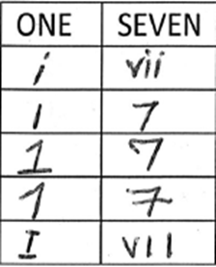
Examples of recognisable numbering.

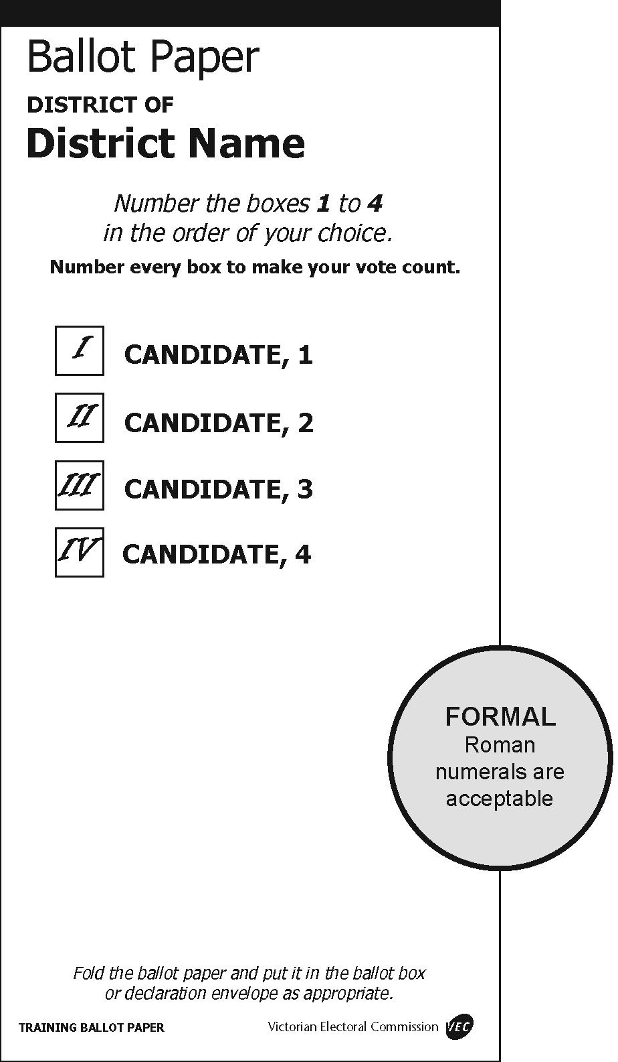 | 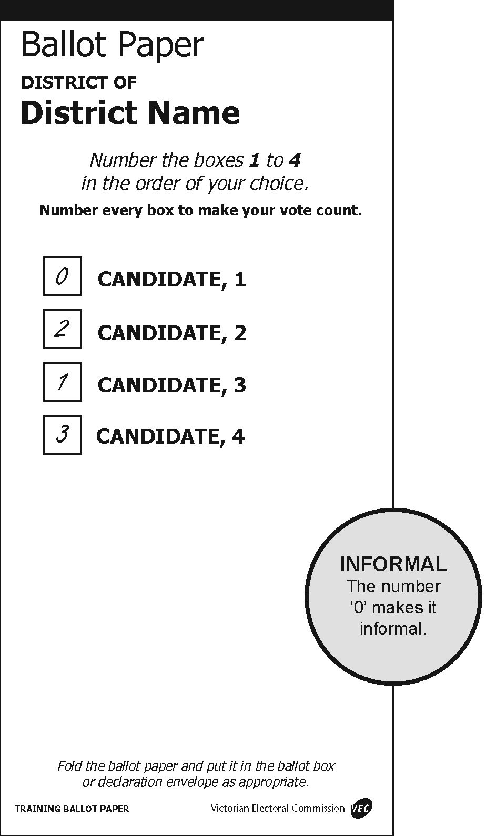
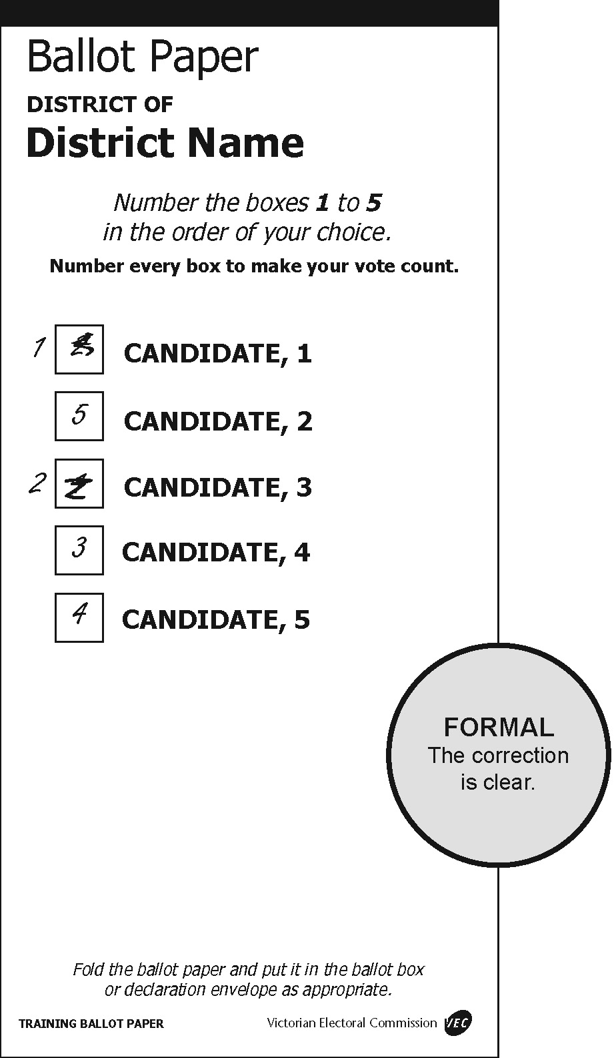 | 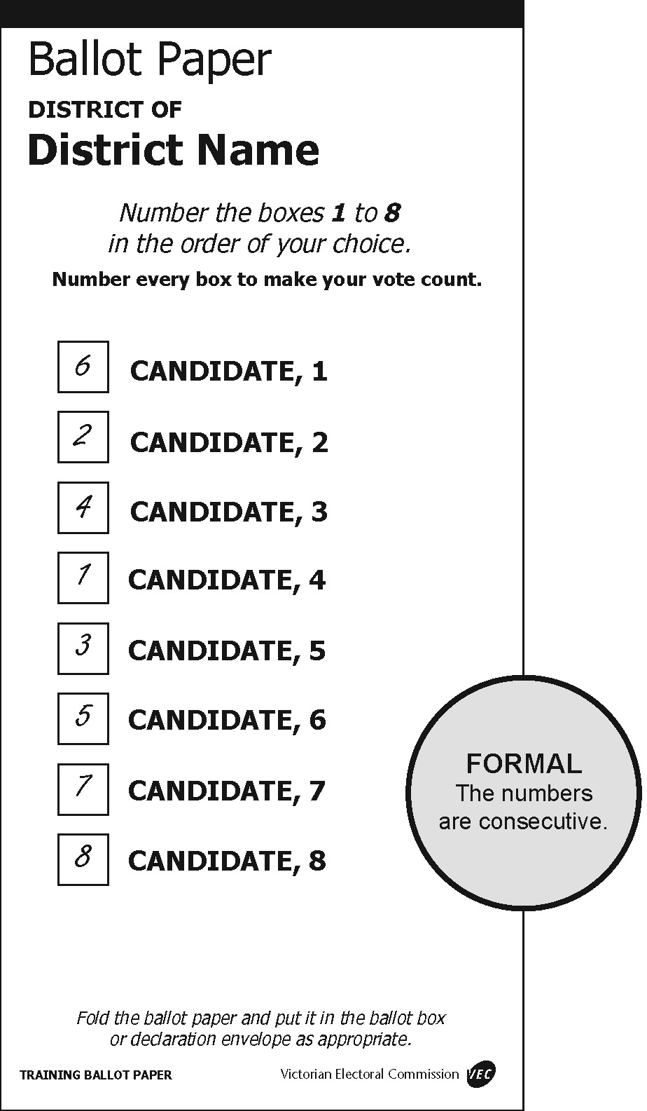
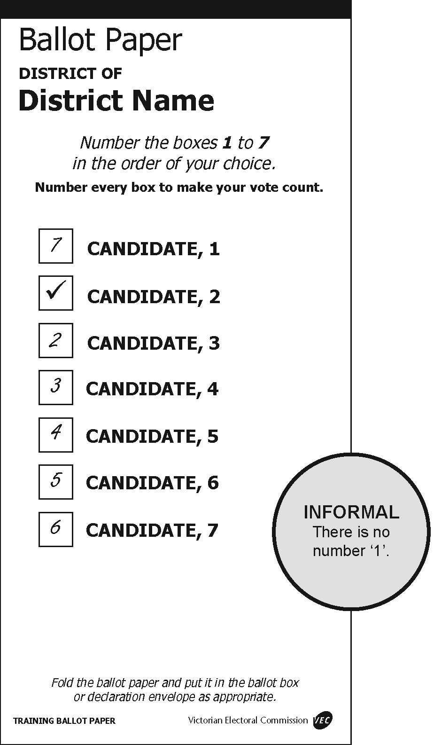 | 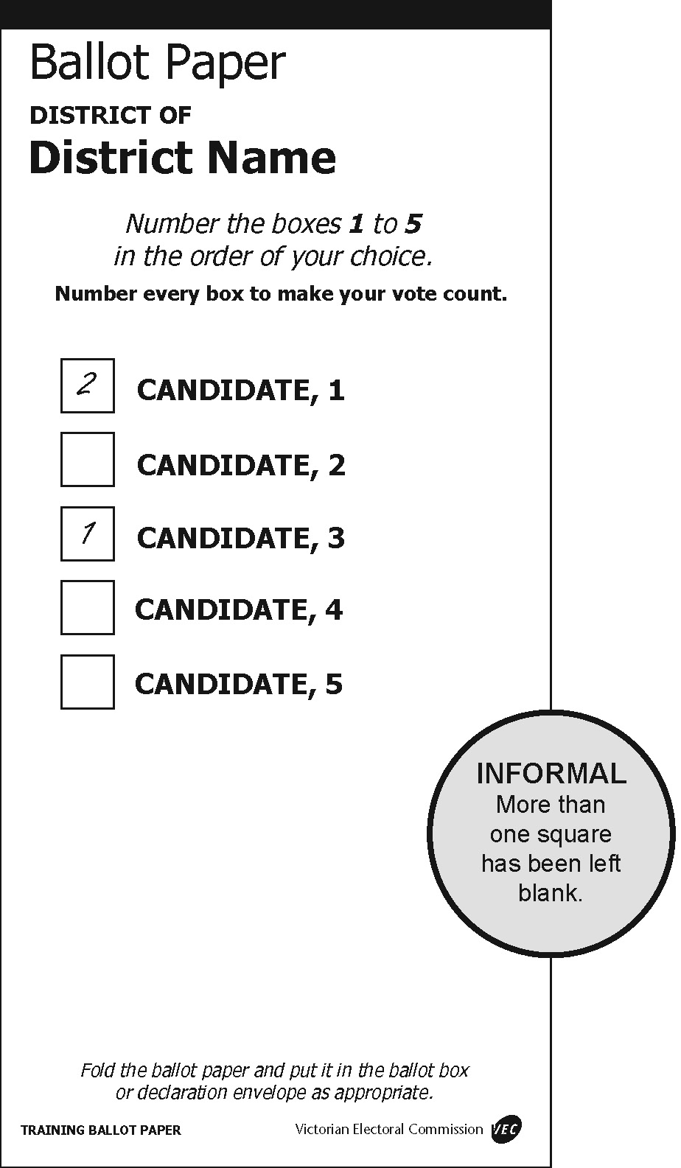
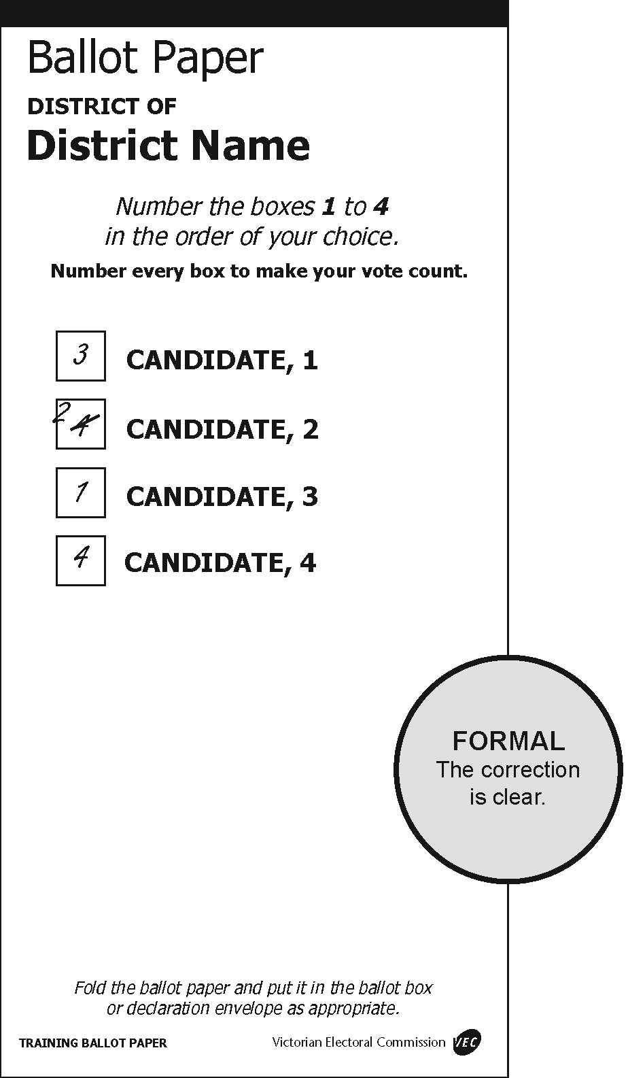 | 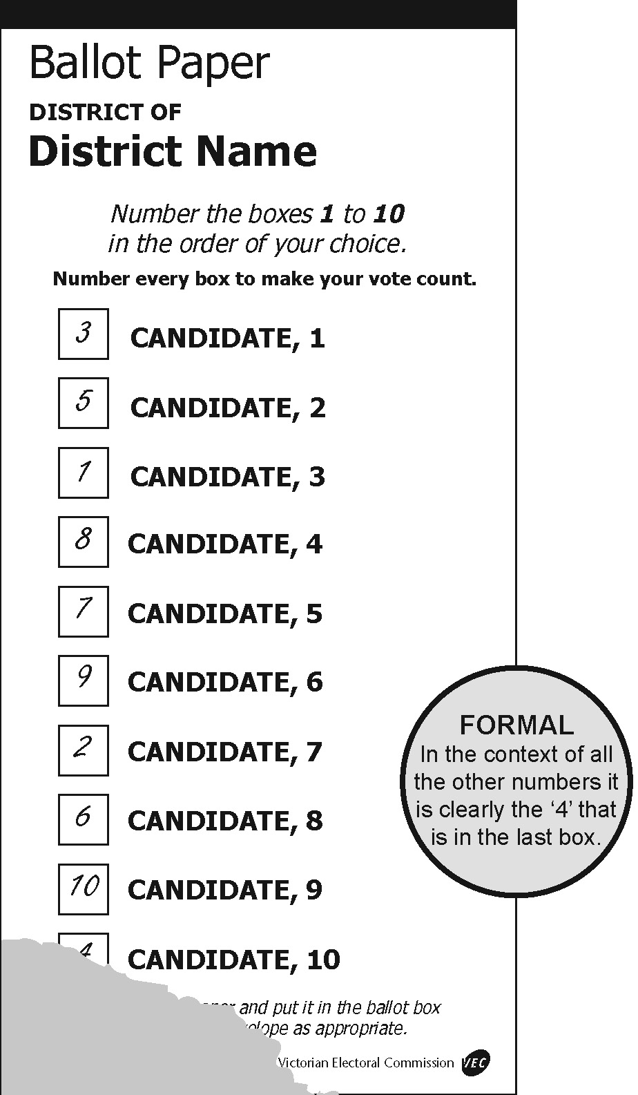
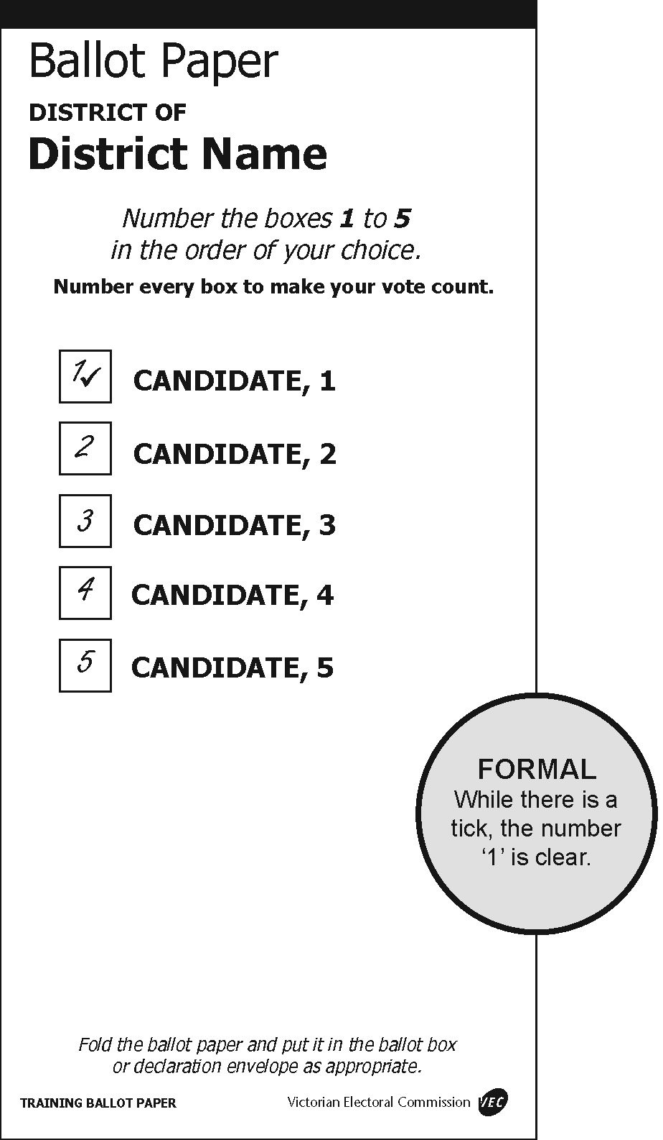 | 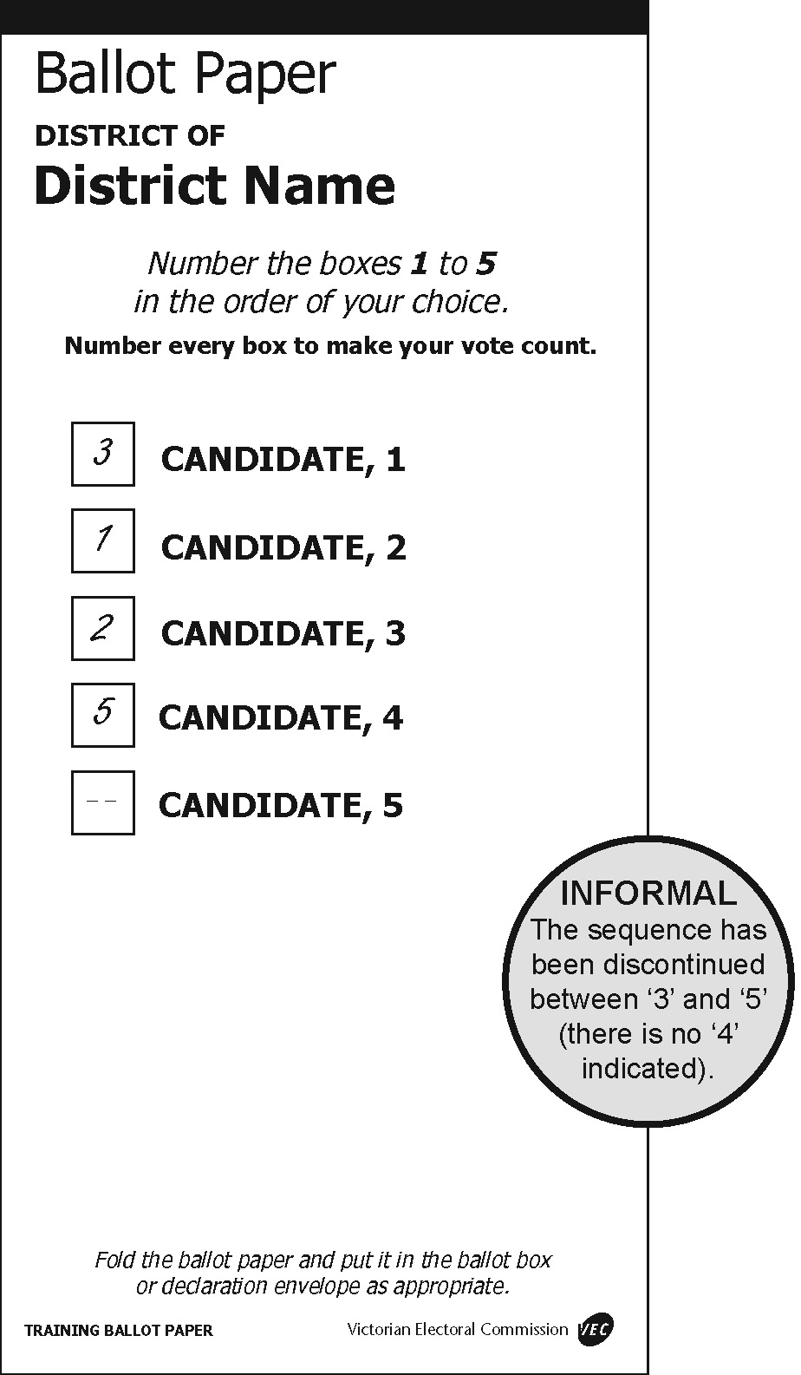
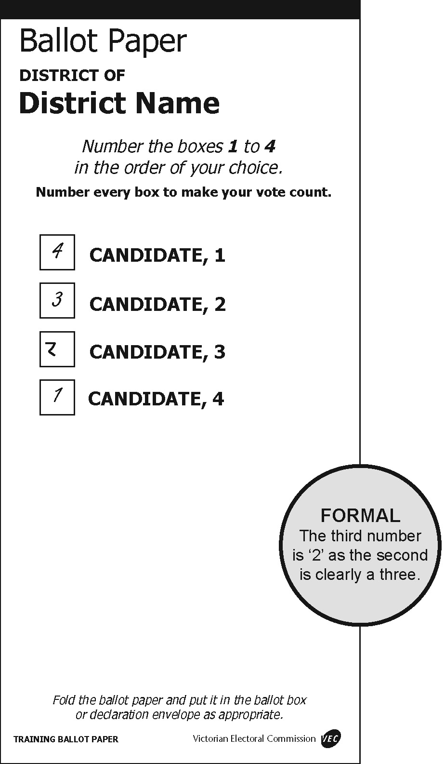 | 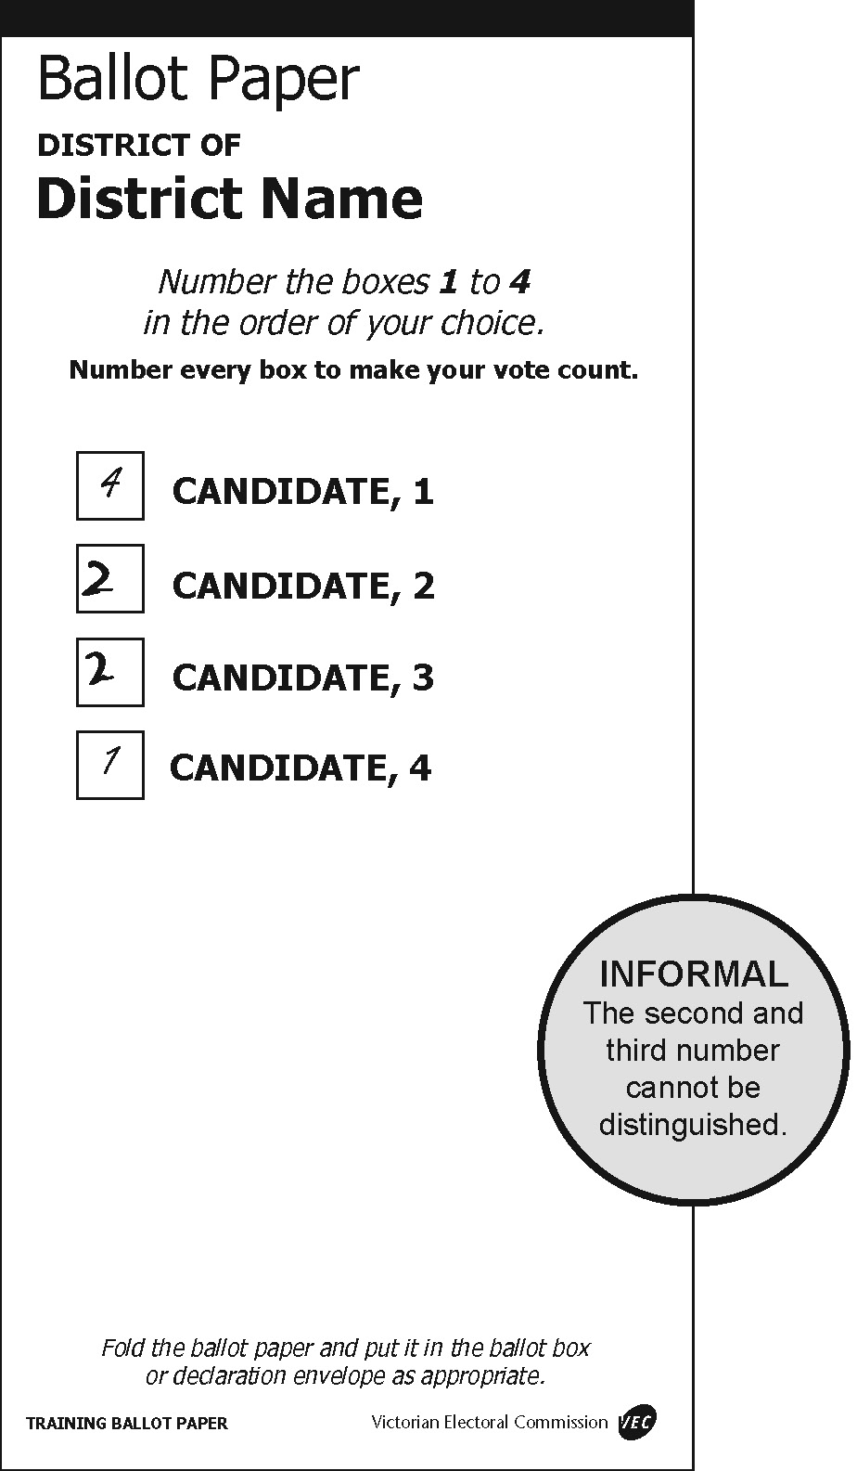

Damaged ballot papers
Election officials from time to time may come across ballot papers that have been torn or cut. Where ballot papers are cut or torn during processing by an election official, and the different parts can be identified beyond doubt as having originated from the same ballot paper, officials will tape the pieces and count as one ballot paper.
Where an official can determine an elector had access to all candidate and party information on the ballot paper when recording their preferences, such a ballot paper can be ruled ‘formal’ if all formality requirements have otherwise been met. If from the intact part the official can determine that the elector had access to the names of all candidates and their affiliations, then look at the formality requirements.
In situations where the ballot paper has been torn across one of the boxes for recording preferences, the ballot paper may still be deemed formal if the preference recorded in the box can be determined. See the following examples for illustrations of these principles.
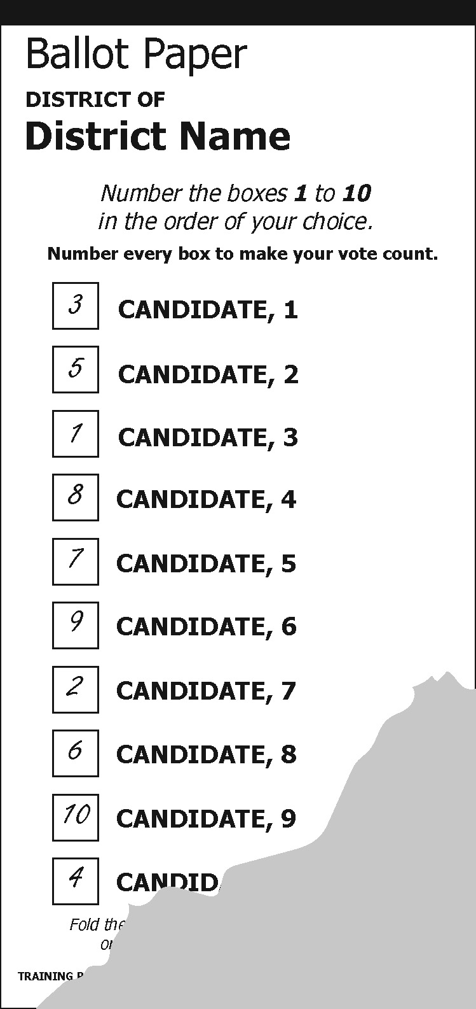 | 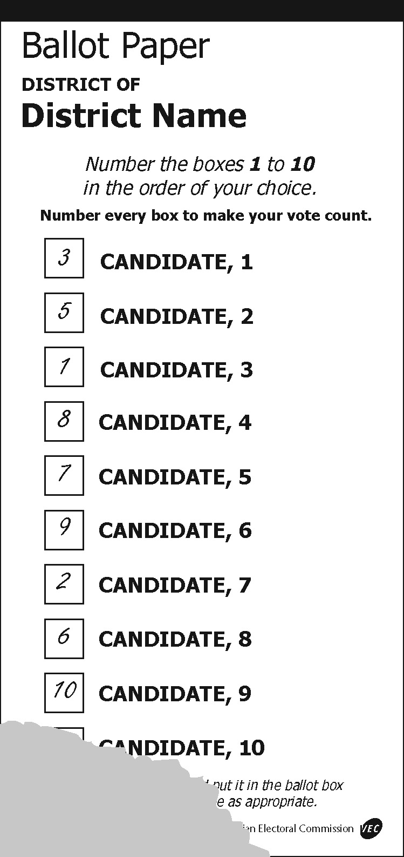 | 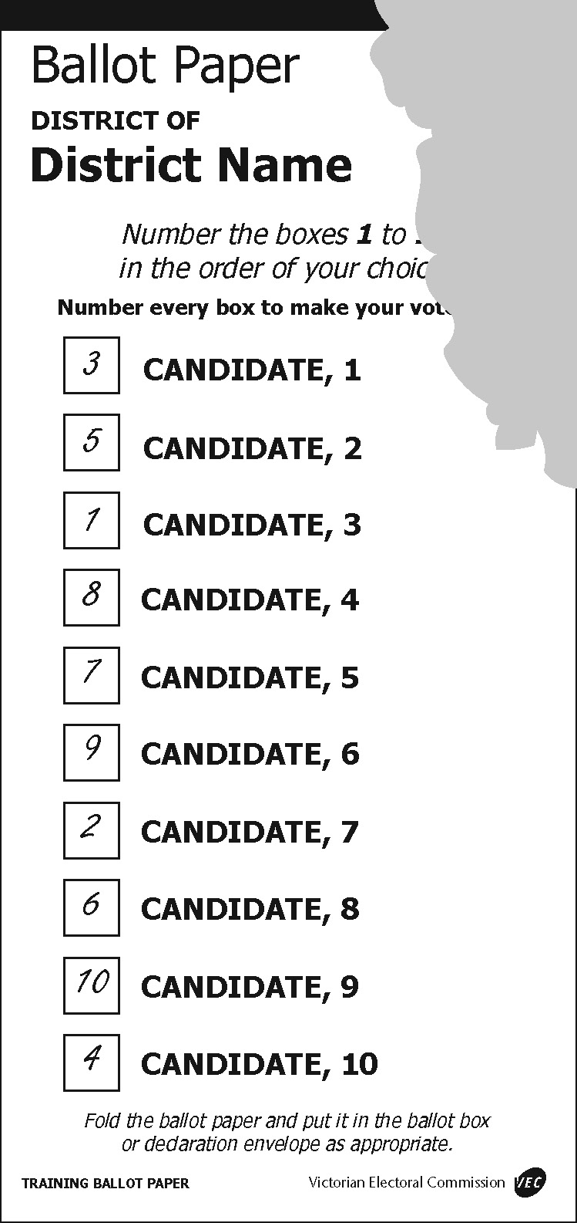
Formal: All the preferences are discernable. | Informal: The number 4 is missing and the official cannot be sure that it existed. | Formal: As long as the paper can be identified as being printed by the VEC the removal of the official’s initials does not make the ballot paper informal.

19. Election Offences before and on Election Day
Reference - Electoral Act 2002 for a detailed description of all electoral offences. The following is a brief list of certain electoral offences.

Postal Voting
No candidate may witness the signature of an elector applying for a postal vote for the electorate which the candidate is contesting. [EA s. 3 (authorised witness)]
An authorised witness must not witness the signature of any elector to an application for a postal vote unless he or she:
- is satisfied as to the identity of the applicant;
- has seen the applicant sign the application; and
- is satisfied that the statements in the application are true. [EA s. 102]
PENALTY: Five penalty units

Bribery
The provisions relating to bribery are set out in section 151 of the Electoral Act 2002.

Interference with Political Liberty
No one shall hinder or interfere with the free exercise or performance of any other person’s political right or duty relevant to an election. [EA s. 152 (1 & 1a)]
Indictable Offence
PENALTY: 600 penalty units or up to five years imprisonment
A person must not, by violence or intimidation, influence the vote of a person at an election. [EA s. 152(2)(3)]
Indictable Offence
PENALTY: 600 penalty units or up to five years imprisonment
A person must not, subject any person who within 100 metres of the entrance of a building used as a voting centre is handing out HTVCs or supporting a candidate at an election, to violence or intimidation. [EA s. 152(4)(5)]
Indictable Offence
PENALTY: 600 penalty units or up to five years imprisonment

Conduct near Voting Centres
The following acts are prohibited within six metres of the designated entrance of, or within, the building used as a voting centre:
- canvassing for or soliciting votes;
- inducing any elector not to vote for any particular candidate, or not to vote at the election;
- exhibiting any notice or sign (other than an official notice) relating to the election;
- conducting an exit poll; or
- if the person is an election official or a scrutineer, wearing any badge or slogan of a candidate or political party. [EA s. 158]
PENALTY: Five penalty units

Exhibition of notice or sign
A person must not exhibit any notice or sign (other than an official notice) in relation to the election except as provided above. [EA s. 158A(2)]
Penalty: Five penalty units

Secrecy of Vote
Except as authorised under the Act, a person who is present when an elector votes must not ascertain or disclose the elector’s vote, attempt to induce the elector to show how the elector intends to vote, communicate with the elector during voting, or look at the elector’s vote. [EA s. 154]
PENALTY: 120 penalty units or one year imprisonment

Prohibition of Public Dissemination of Exit Poll Results
During the hours of voting, no candidate or other person may publicly disseminate, or cause, permit or authorise the public dissemination of the results of an exit poll carried out at an election day voting centre. [EA s. 155]
PENALTY: 60 penalty units or 6 months imprisonment

Prohibition of Use of Public Address System
During the hours of voting, no candidate or other person shall use any loud speaker, public address system, amplifier or other device to disseminate any matter likely to affect the result of the election, or make a public demonstration about an election, within 400 metres of the entrance of, or within the building used as a voting centre. [EA s. 159]
PENALTY: One penalty unit

Distribution of Printed Electoral Material
A person may not distribute printed electoral material other than registered how-to-vote cards within 400 metres of the entrance of, or within the building used as a voting centre on election day. [EA s. 156(1)]
PENALTY: 60 penalty units or six months imprisonment
It is an offence to print, publish, or distribute a how-to-vote card which has not been registered and which contains a representation of the prescribed endorsement. [EA s. 156(2)]
PENALTY: 60 penalty units or six months imprisonment
It is an offence to refuse to comply with a request on election day by an election official to produce how-to-vote cards for inspection or to hand over all unregistered cards. [EA s. 157]
PENALTY: 10 penalty units

Advocating a Vote Contrary to Directions on the Ballot Paper
It is an offence to print, publish, or distribute, or to cause to be printed, published, or distributed a handbill, pamphlet, or notice that contains a representation of a ballot paper that is likely to induce an elector to mark his or her vote otherwise than in accordance with the directions on the ballot paper. [EA s. 84(2)]
PENALTY: 60 penalty units or six months imprisonment for an individual and 300 penalty units for a body corporate

False Statements
It is an offence to provide orally or in writing any false or misleading information under the Act. [EA s. 148]
Indictable Offence
PENALTY: 600 penalty units or five years imprisonment

Compulsory Voting
Voting is compulsory for all electors, including candidates, for the electorate for which they are enrolled. [EA ss. 166, 170]
PENALTY: Half a penalty unit

Voting Offences
A person must not vote in the name of another person, vote more than once, or apply for a ballot paper in the name of another person. [EA s. 150]
Indictable Offence
PENALTY: 600 penalty units or five years imprisonment

Injunctions
If a person has engaged, is engaging, or is proposing to engage in any conduct that would constitute a contravention of the Act or any other law of Victoria in its application to elections, the Supreme Court may, on the application of a candidate or the VEC, grant an injunction restraining the person from engaging in the conduct. [EA s. 176]
Similarly, if a person has refused or failed, is refusing or failing, or is proposing to refuse or fail to do an act or thing and the refusal or failure was, is, or would be, a failure to comply with the Act or any other law of Victoria in its application of elections, the Supreme Court may, on the application of a candidate or the VEC grant an injunction requiring the person to do that act or thing. [EA s. 176]

20. Recounts, Tied, and Disputed Elections

Recounts
A recount may occur if the result of an election is extremely close. Recounts should not be confused with a routine recheck of votes. A recount can only occur prior to the declaration of the result of an election. [EA s. 120]
A recount will involve a full re-examination of all ballot papers and will follow the same process as the original count.
A recount can occur in three ways:
- as a result of a written request received by an Election Manager from a candidate. The letter must detail the reasons for the request for a recount;
- an Election Manager may decide to conduct a recount; or
- the Electoral Commissioner may direct an Election Manager to conduct a recount. [EA s. 120]
The Election Manager is not obliged to conduct a recount automatically on the request of a candidate. In making their decision to conduct a recount, the Election Manager will consider:
- the occurrence of close margins at critical points during the distribution of preferences
- any procedural or system error or failure that may have interrupted or interferred with the counting process
- if scrutineers were given the opportunity to access the counting process to perform their duties.
The Election Manager’s interpretation of what constitutes a close margin is informed by the VECs historical experience at previous recounts. This has shown that limited variation occurs when comparing the final or critical recounted margin to the original count.
The Election Manager conducting a recount may, and at the request of a scrutineer shall, reserve any ballot paper for the decision of the Electoral Commissioner. [EA s. 120(4)] However, if the number of reserved ballot papers cannot alter the outcome of the recount, the Election Manager’s decision is final on these papers. [EA ss. 19(2)(c),120(5)]
Candidates should note that the Election Manager conducting a recount has the same powers as if the recount were the original count, and may reverse any decision to admit or reject a ballot paper. [EA s. 120(3)]
It is most desirable that candidates, particularly a candidate requesting a recount and any other candidate who could possibly win the election as a result of a recount, be represented by scrutineers during the recount.

Tied Elections
If, on the final count, two or more candidates have an equal number of votes, the following provisions apply:
- the Election Manager must declare that the election is tied;
- within 14 days of the declaration that the election is tied, the VEC or a candidate who has the same number of votes as another candidate at the election may petition the Court of Disputed Returns, and the Court of Disputed Returns may declare that one of the candidates is elected, or that a new election must be held; and
- if 14 days after the declaration that the election is tied, the Court of Disputed Returns has not been petitioned, the election is declared absolutely void and a new election must be held. [EA s. 117]

Disputed Elections
The validity of any election may only be disputed by a petition to the Court of Disputed Returns. [EA s. 133]
A candidate, an elector, or the Commission may petition the Court of Disputed Returns. The petition must be filed with the Prothonotary of the Supreme Court within 40 days after the return of the writ.
Procedures for disputing an election are laid down in Division 2 of Part 8 of the Electoral Act 2002. Those contemplating a challenge should consult their own legal advisers.

21. Parliamentary Induction for Successful Candidates
Candidates (including current members) will not be recognised by the Parliament of Victoria as the successful candidate for their electorate until the result has been formally declared by the VEC Election Manager and communicated to the Clerk of the relevant House.
Provision of services to Members of Parliament will not commence until the official VEC advice for each electorate is received by the Clerk of the relevant House and communicated to the Election Coordinator.
Following receipt of official advice, the Parliament of Victoria will provide successful candidates with information on scheduling time for a formal induction program and beginning the process of allocating resources (including electorate office, motor vehicle and salary). The VEC will provide the Parliament with contact details for all candidates as provided on Nomination Forms for this purpose. Personal information will be maintained by the Parliament of Victoria in accordance with the Information Privacy Principles as derived from the Privacy and Data Protection Act 2014.
All successful candidates will be allocated the existing electorate office in their electorate.

22. Privacy
The VEC is subject to the Information Privacy Act 2000 (IPA) and handles all of the personal information it collects and holds in accordance with the Information Privacy Principles (IPPs).
Although a candidate's Nomination Form is not available for public inspection, by nominating for an election a candidate is taken to understand that the VEC is required to disclose certain personal information about the candidate. These disclosures, which are governed by legislation, are as follows:
- once nominations for an election close, the VEC will make each candidate’s name and contact details publicly available by publishing these details on the VEC’s website, releasing them to the media, and by making them available for inspection at election offices. [EA ss. 68, 73] See Chapter 4: Nomination Procedures; and
- candidate’s names will appear on ballot papers and how-to-vote cards and, where appropriate, will appear together with the name and logo on the ballot paper, of the registered political party that has endorsed the candidate. [EA ss. 74, 82] See Chapter 6: The Ballot Paper and
Chapter 8: How-to-vote Cards.
All candidate names, postal addresses, phone, and email details will also be provided to Parliamentary Services to enable contact with successful candidates regarding their introduction into Parliament.
All internal uses of candidate’s personal information by the VEC are either expressly specified by, or necessary to implement, the VEC’s legislative requirements (the Electoral Act 2002). These legislative requirements include processing applications to nominate for an election, to register a how-to-vote card, or for the payment of election expenses, as well as monitoring the distribution of electoral material at or near voting centres on election day.
The personal information about candidates that is collected, used, and disclosed by the VEC is fundamental to the running of an election. The VEC thus accords the highest priority to ensuring that this information is accurate, complete, and up to date.
Under the Freedom of Information Act 1982 (FOI Act), candidates have rights of access and correction in relation to any personal information about them held by the VEC. These rights are subject to the provisions included in the FOI Act.

23. Complaints
Elections in Australia allow for robust debate and expression of opinion. Candidates are free to rebut the opinions expressed by others in the public domain during the campaign. However, candidates may lose considerable time during an election campaign by involving themselves in the complaints process when there has been no breach of the law. At the time of voting, electors can consider all material before them, and who authorised it, when considering where to direct their vote.
If candidates or members of the public believe that there has been a breach of electoral law, complaints should be addressed to the Election Manager or Electoral Commissioner and must be in writing to ensure an evidentiary trail. Complaints lodged with an Election Manager will be forwarded to the Electoral Commissioner for consideration and response.
Complaints should be addressed to
Electoral Commissioner
Victorian Electoral Commission
Level 11, 530 Collins Street
Melbourne Vic 3000
Email: complaints@vec.vic.gov.au
The Electoral Commissioner will write to the person who is the subject of the complaint advising them that a complaint has been received and the nature of the complaint. This will allow the person who is the subject of the complaint to rectify the matter if necessary. The Electoral Commissioner will only divulge who has made the complaint in very rare circumstances.
The VEC will not discuss individual complaints with members of the media under any circumstance, not even to confirm or deny that a complaint has been received. The VEC acts to minimise situations where it may become unintentionally involved in attempts by candidates or members of the public to gain free publicity.
It is important to remember that the Court is the only authority that can determine whether a breach has occurred and is the only authority that can impose penalties following a successful prosecution action. The VEC will only take a matter to court where it is in the public interest and where it considers there is sufficient evidence for a reasonable chance of success.
Misleading or Deceptive Matter (section 84)
A large proportion of the complaints received by the VEC during elections allege the distribution of misleading electoral material. Section 84 of the Electoral Act 2002 provides that electoral material must not mislead or deceive electors in relation to the casting of their vote.
The Courts have interpreted this phrase narrowly. Courts are particularly concerned with material that is likely to mislead or deceive electors in relation to how they mark their ballot paper.
For example, the following statement might fall within the narrow definition of misleading:
The way to vote for Candidate A is as follows:
Candidate A |  | 2
Candidate B |  | 3
Candidate C |  | 1
Candidate D |  | 4
This statement is misleading because if the elector decided to vote for candidate A, then followed the instructions given, they would in fact be voting for candidate C.
In contrast, the following statement is unlikely to fall within the narrow definition of misleading under section 84:
Vote 1 for candidate A, your true local candidate.
If candidate A did not live or work locally, some may consider the statement is false, but it is unlikely to be considered misleading in the legal sense; i.e. in relation to the way electors will complete their ballot papers.

24. POLITICAL DONATIONS, FUNDING AND EXPENDITURE
Reference – Electoral Act 2002 – sections 206 to 222. These sections are relevant for all candidates and registered political parties.

Overview
Recent changes to the Electoral Act 2002 introduced new political funding and disclosure laws for Victoria.
The provisions under these laws come into effect in stages, with some provisions in place now and some starting on 25 November 2018, after the 2018 Victorian State election.
This Handbook contains information regarding laws now in effect. Further details on the laws in effect from 25 November 2018 can be found in the Funding and Disclosure Handbook, available on the VEC website.
The VEC will provide additional information in relation to ongoing obligations to elected candidates and registered political parties after the election.

Donations
Candidates and registered political parties cannot accept political donations unless they are from: an Australian citizen or resident; or a business with a relevant Australian business number. [EA s.217A]
Candidates and registered political parties also cannot accept any political donations of $1,000 or more from an anonymous donor. [EA s.217B]
A political donation is any gift, be it money, a service, a loan, a guarantee or the giving of goods or property. [EA s.206]
From 25 November 2018, additional obligations in relation to political donations will apply, including caps on donations and a requirement for donations of $1,000 or more to be disclosed online.

Annual returns
From 25 November 2018, elected candidates and registered political parties will be required to submit annual returns to the VEC following the end of each financial year. The first annual return will cover the period 25 November 2018 to 30 June 2019, and must be submitted via the VEC website by 20 October 2019.
Candidates and registered political parties will need to ensure they have a system in place for recording donations, including capturing the full name and address of the donor, and the sum of the donations received from that donor. These details will need to be provided in the annual return for elected candidates and registered political parties.
Additional information about annual returns can be found in the Funding and Disclosure Handbook.

Public funding
Public funding is available to State election candidates that receive at least 4% of first preference votes in the election being contested or that are elected. [EA s.211]
For the 2018 State election, registered political parties with eligible candidates and eligible independent candidates are entitled to receive $1.75 per first preference vote. [EA s.211]
Before receiving public funding, registered political parties with eligible candidates and eligible independent candidates must submit an audited Statement of Expenditure (SoE) in relation to the election. This audited statement must be submitted within 20 weeks of the election. [EA s.208] If the statement specifies less than the entitlement has been spent, only the amount spent will be paid. If the statement specifies more than the entitlement has been spent, only the entitlement amount will be paid. [EA s.212]
For candidates endorsed by a registered political party, the SoE is to be prepared and submitted by the Registered Officer. For independent candidates, this SoE is to be prepared and submitted by the candidate themselves [EA s.208]. For registered political parties, the SoE is to be in the form of ‘Public Funding Application – Registered Political Party – Statement of Expenditure’; for independent candidates, the SoE is to be in the form of ‘Public Funding Application – Candidate – Statement of Expenditure’. Both appear as attachments to this Handbook, and editable versions will be made available on the VEC website.
The SoE should include political and electoral expenditure, not including any GST component, paid or incurred within the period of four years immediately before the election. Political expenditure is any expenditure for the main purpose of directing how a person should vote at an election, by promoting or opposing the election of a candidate, registered political party or an elected member. Electoral expenditure is any expenditure in relation to:
  - the broadcasting of an advertisement relating to the election;
  - the publishing in a journal of an advertisement relating to the election;
  - the display at a theatre or other place of entertainment, of an advertisement relating to the election;
  - the production of an advertisement detailed in (a), (b) and (c) above;
  - the production of any material in relation to the election (not being material referred to in (a), (b), or (c) above) that is required under section 83 to include the name and address of the author of the material or of the person authorising the material;
  - the production and distribution of electoral matter that is addressed to particular persons or organisations;
  - fees or salaries paid to consultants or advertising agencies for –
- services provided relating to the election; or
- material relating to the election; or
  - the carrying out of an opinion poll, or other research, relating to the election. [EA s. 206]
The SoE must be lodged with an audit certificate. The certificate must be provided as follows:
- for a registered political party: via a registered company auditor within the meaning of the Corporations Act 2001; and
- for a candidate: via an independent auditor advising that the SoE has been audited in accordance with Australian Accounting Standards as specified in section 334(1) of the Corporations Act 2001. [EA s.209]
The certificate must state that the auditor:
- was given full and free access at all reasonable times to all accounts, records, documents, and papers relating directly or indirectly to any matter required to be specified in the SoE;
- examined the material referred to above for the purpose of giving the certificate;
- received all information and explanations that the auditor requested in respect of any matter required to be specified in the SoE; and
- has no reason to believe that any matter stated in the SoE is not correct. [EA s.209]
The VEC will make public funding payments within 30 days of the receipt of an audited SoE.
Registered political parties with eligible candidates and eligible independent candidates will also receive funding in advance for the 2022 State election at new rates. This amount will be based on results from the 2018 election at a rate of $6 for Legislative Assembly candidates, and $3 for Legislative Council candidates. This amount will be indexed annually and these advance payments will be paid in four instalments over four years. [EA s.211]
Following submission of the SoE for the 2018 State election, registered political parties with eligible candidates and eligible independent candidates will receive both the retrospective payment for the 2018 State election, as well as the first advance payment (40%) for the 2022 State election. This first advance payment will be made within 30 days of receipt of an audited SoE. The remaining 60% of the advance payments for the 2022 election will be paid in three 20% instalments as follows:
- 20% on 30 April two years prior to the next election
- 20% on 30 April one year prior to the next election
- 20% on 30 April in the year of the next election. [EA s.212]

Administrative expenditure funding
Registered political parties with endorsed elected members and independent elected members are eligible to receive administrative expenditure funding for administrative expenses, including expenses incurred in complying with their funding and disclosure obligations. [EA s.207GA]
Independent elected members are eligible to receive up to $200,000 per year. Registered political parties are eligible to receive a tiered amount based on the number of elected members, capped at 45 members. Payments for registered political parties start at $200,000 per year for the first elected member, $70,000 per year for the second elected member, and $35,000 per year for the third to forty-fifth elected members. [EA s.207GA]
Applications for administrative expenditure funding must be made:
- for a new parliamentary term, as soon as practicable after the commencement of the new parliamentary term, but before 31 December of that year
- for the period 1 July to the day of the election during an election year after 2018, by 1 July of that year – for this period, applications for payment can only be made for elected members that intend to recontest the next election
- when the number of elected members of a party increases, or when an independent elected member commences after the commencement of a new parliamentary term, as soon as practicable after the increase or commencement. [EA s.207GB]
Applications for administrative expenditure funding for the period 1 August to 24 November 2018 must be made by election day.
Applications for administrative expenditure funding for the new parliamentary term must be made as soon as practicable after the commencement of the new parliamentary term, but before 31 December 2018.
Any registered political party or independent elected member that receives administrative expenditure funding during a calendar year must provide an audited return in relation to administrative expenses for that year. This audited return must be made within 16 weeks of the end of the calendar year. [EA s.207GC] If the administrative expenditure return specifies the registered political party or independent elected member has spent less on administrative expenses than they received throughout the year, the registered political party or independent elected member must repay the amount. Where applicable, parties may elect to have the next administrative expenditure funding payment reduced.

Policy development funding
Registered political parties that have been registered with the VEC as a registered political party for the full calendar year and did not receive administrative expenditure or public funding in that year are eligible to receive policy development funding.
Eligible registered political parties may receive $1 per first preference vote based on the results of the previous general election, or $25,000, whichever is greater.
Additional information about policy development funding can be found in the Funding and Disclosure Handbook.

Offences
Offences and penalties related to political donations, funding and expenditure are as follows:
If the registered officer of a registered political party gives a statement that contains particulars that are, to the knowledge of the registered officer, false or misleading in a material particular, the registered officer is guilty of an offence.
PENALTY: 120 penalty units [EA s.218]
If a candidate gives a statement that contains particulars that are, to the knowledge of the candidate, false or misleading in a material particular, the candidate is guilty of an offence.
PENALTY: 60 penalty units [EA s.218]
A person who gives to another person who is required to give a statement any information that relates to the statement and that is, to the knowledge of the first mentioned person, false or misleading in a material particular is guilty of an offence.
PENALTY: 10 penalty units
A person who knowingly makes or accepts a political donation that is classed as a prohibited political donation is guilty of an offence.
PENALTY: 300 penalty units or 2 years’ imprisonment or both
If a person is convicted of an offence against the first two above offences, the Court may, in addition to imposing a penalty, order the person to forfeit to the State an amount equal to the amount of any payment obtained by the person under Part 12 of the Electoral Act 2002.
A prosecution in respect of an alleged offence may be started at any time within three years after the alleged offence was committed.

Statement of Expenditure Attachment – A
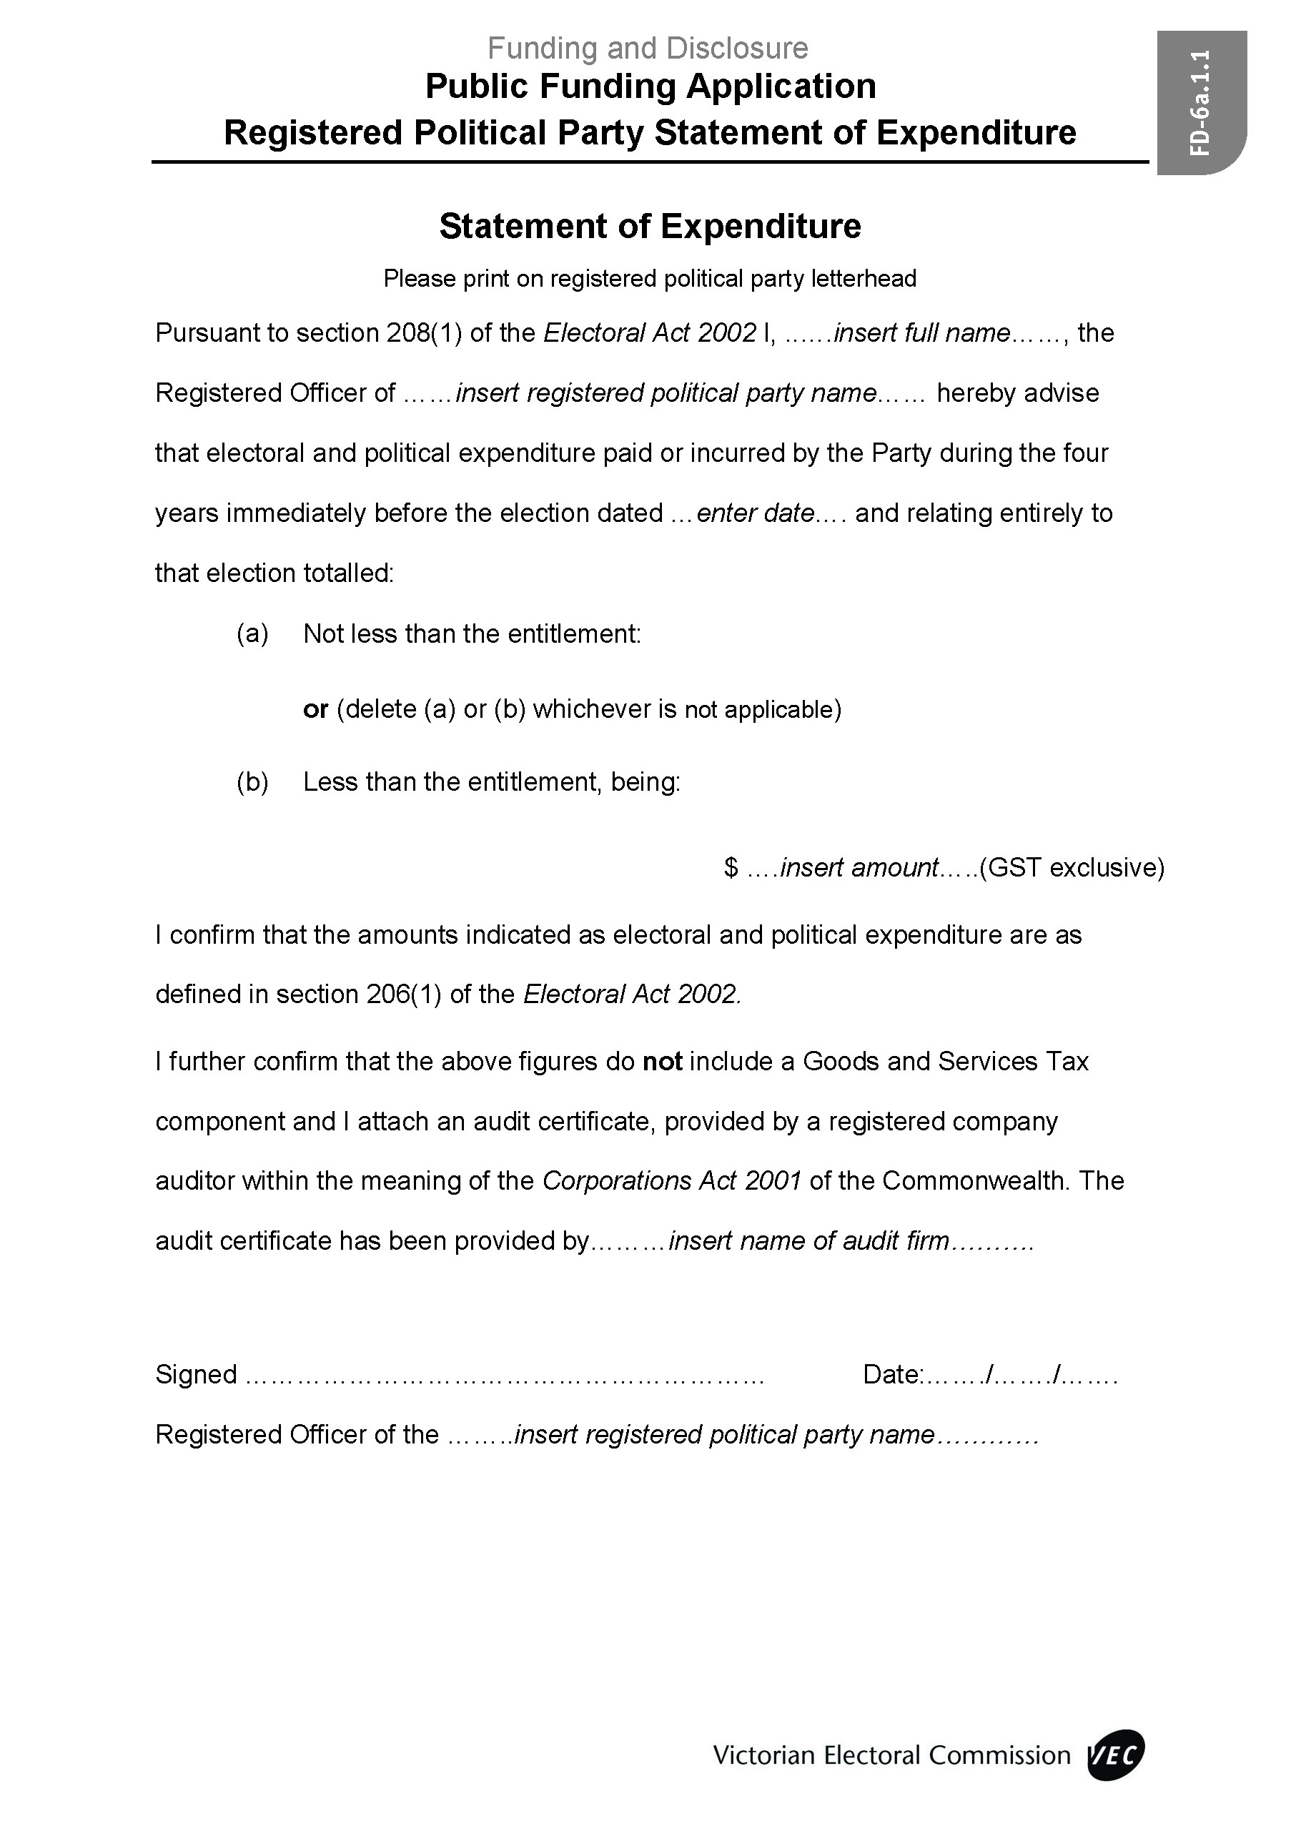

Statement of Expenditure Attachment – B
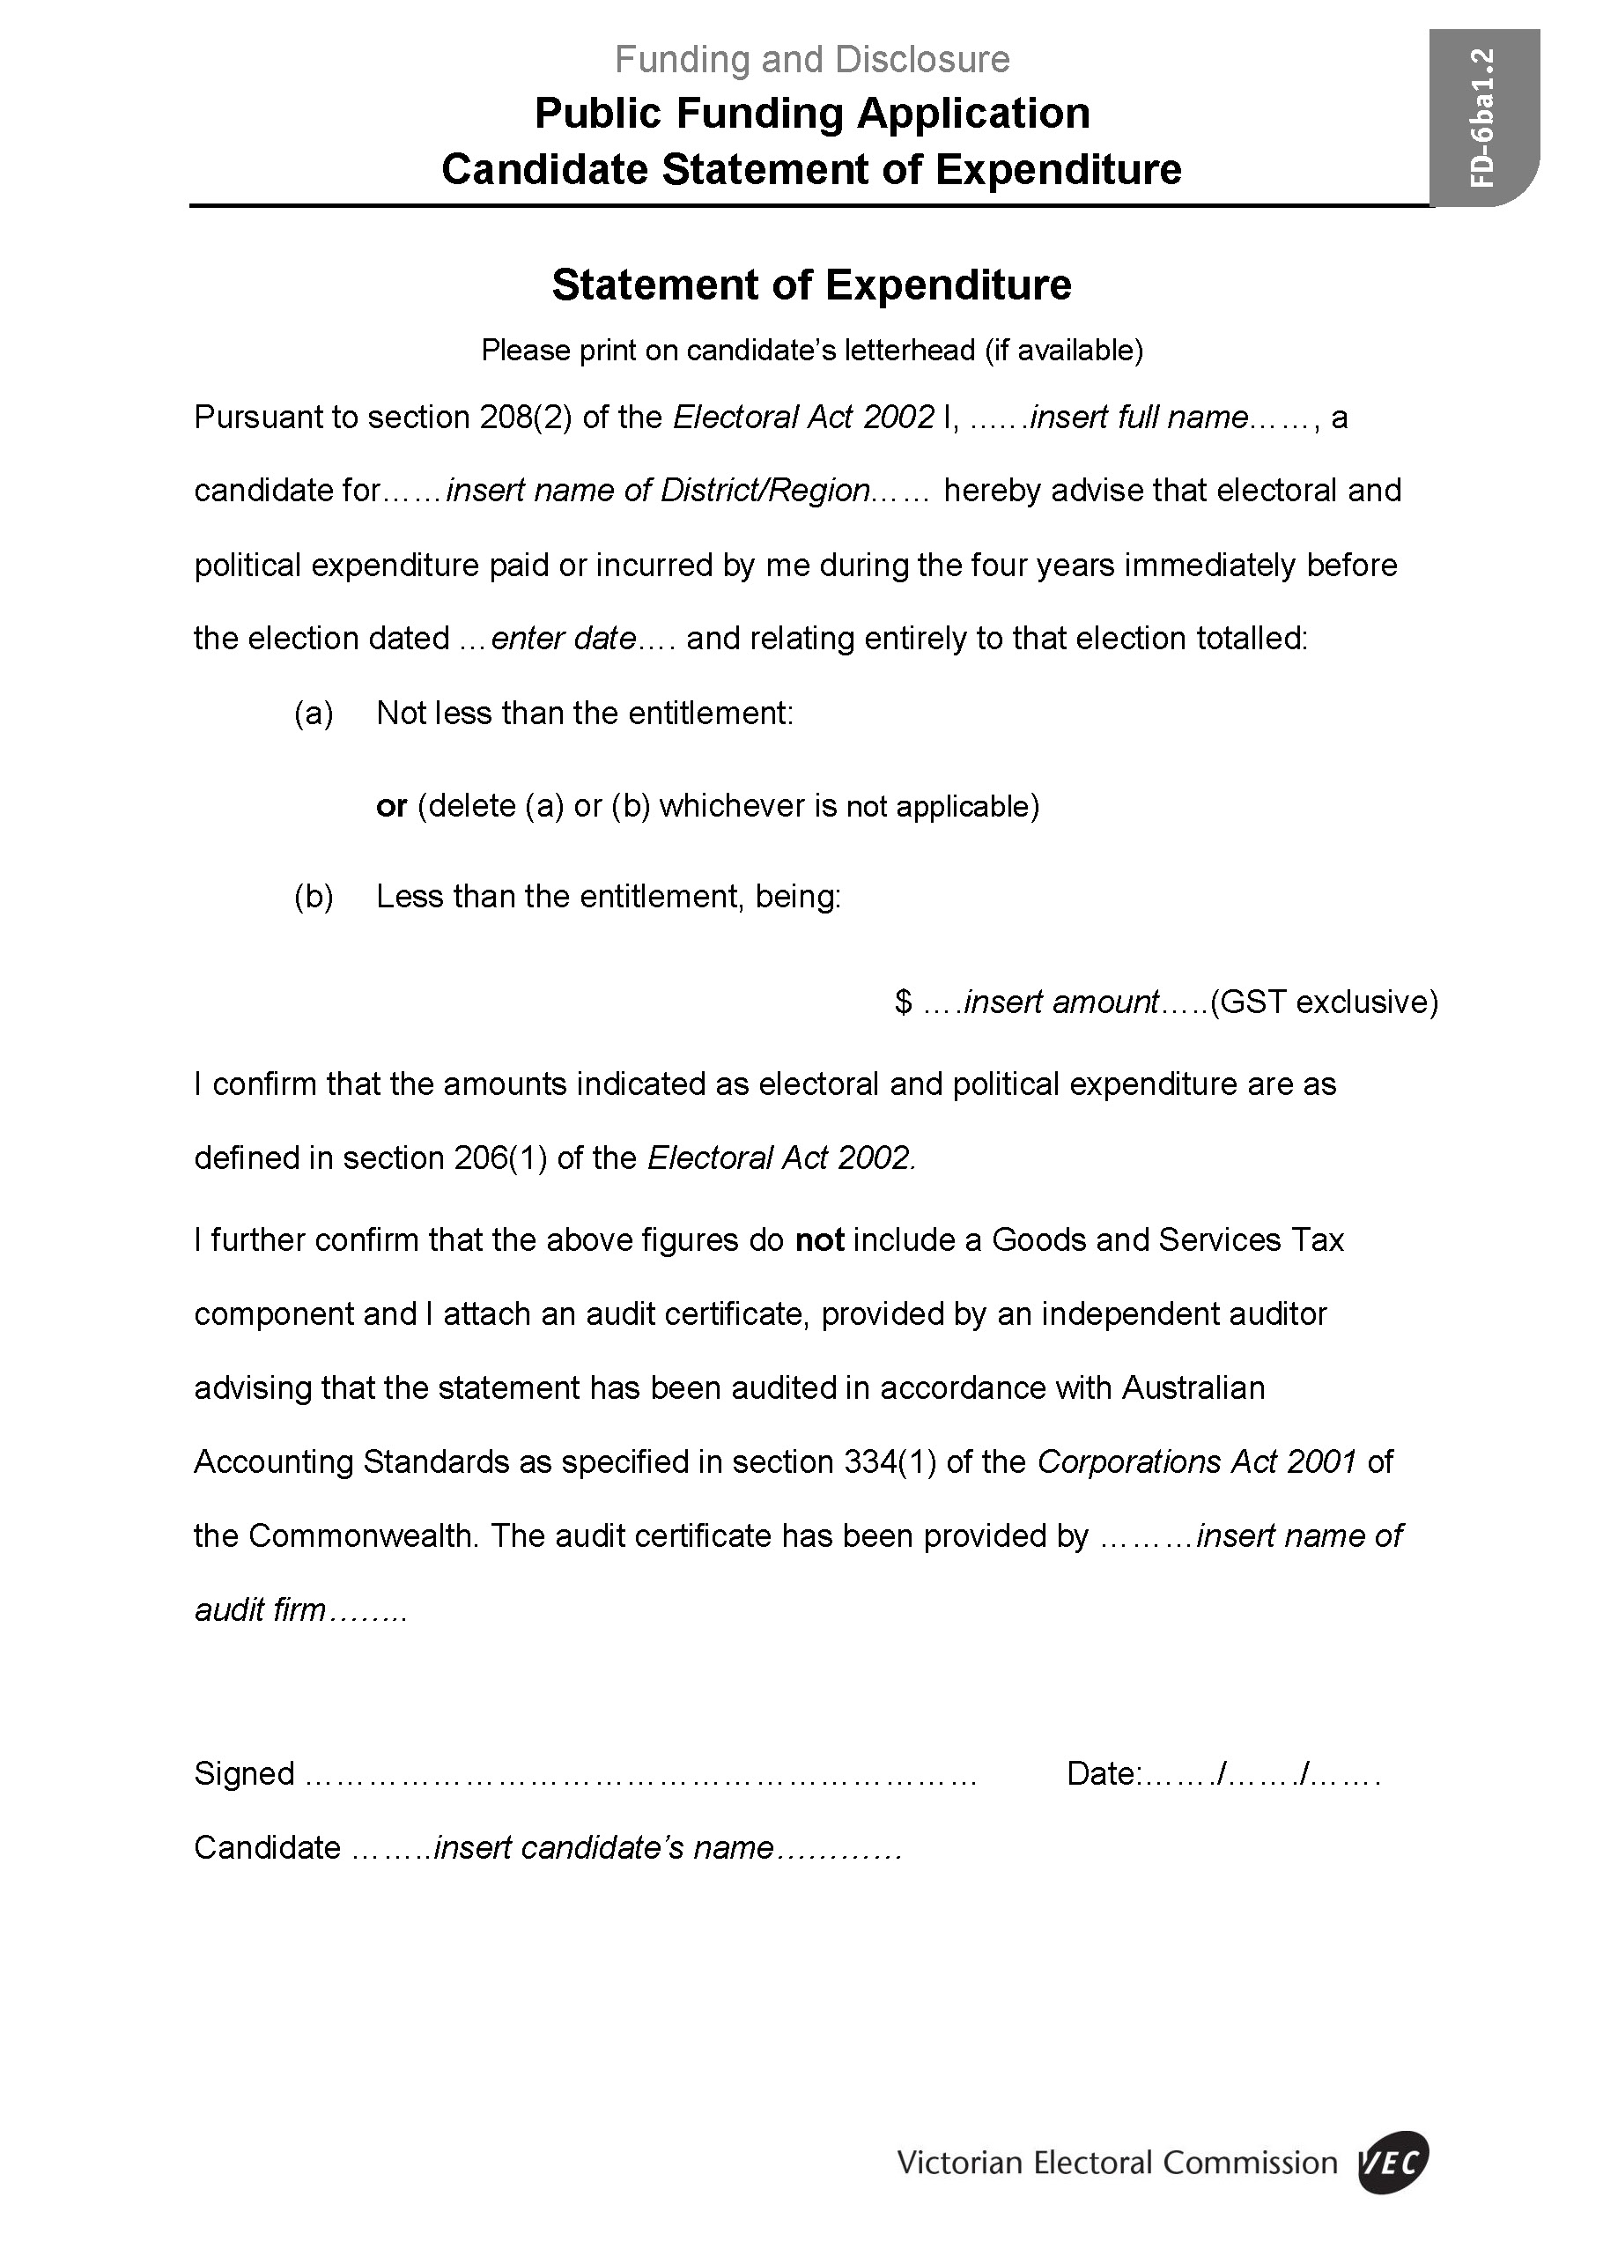

Appendix 1: How-to-vote Card Checklist
Do not print cards until the VEC notifies that the card is registered | Candidate Check
Card is for single District only (for applicants other than RPP)
An electronic copy on USB key, or PDF format, is submitted in final print ready format
Two hard copies of card are submitted in final print ready format
Completed declaration is attached and signed by the person on whose behalf it is being distributed
Translation attached if text included in a language other than English
Clearly identifies person, political party, organisation, or group on whose behalf the card is to be distributed
For District cards, order of voting preference is included for all candidates listed, or statement that a number must be placed against the name of each candidate
No number is used more than once
No empty boxes against names on a District ballot paper (could be misleading)
Candidates are listed in ballot paper order with correct spelling
No titles or other designations are included against the names of candidates
Logo/emblem/insignia is at least the prescribed size (4cm²)
Approval has been obtained from persons/organisations depicted in any photographs or quotes on the card
Is not misleading, deceptive, offensive, or obscene
Name and street address of authoriser (not a PO Box) are included
Name and place of business of printer are included
Endorsement “Registered by the Victorian Electoral Commission” is included
Important: Prior to VEC approval of registration, the endorsement must not appear on card if being distributed outside an early voting centre

Appendix 2: How-to-vote Card Sample Templates

District Card
- Clearly identifies the person, political party, organisation, or group on whose behalf the card is to be distributed.
- The size of any logo, emblem, or insignia belonging to the person or group on whose behalf the card is being distributed is at least 4cm².
- Indicates an order of voting preference for all candidates listed on the card, or a statement that a number must be placed against the name of each candidate.
- Contains:
- the name and address of authoriser;
- the name and place of business of printer; and
- endorsement required to indicate registration.
The following examples are for an election with six candidates.
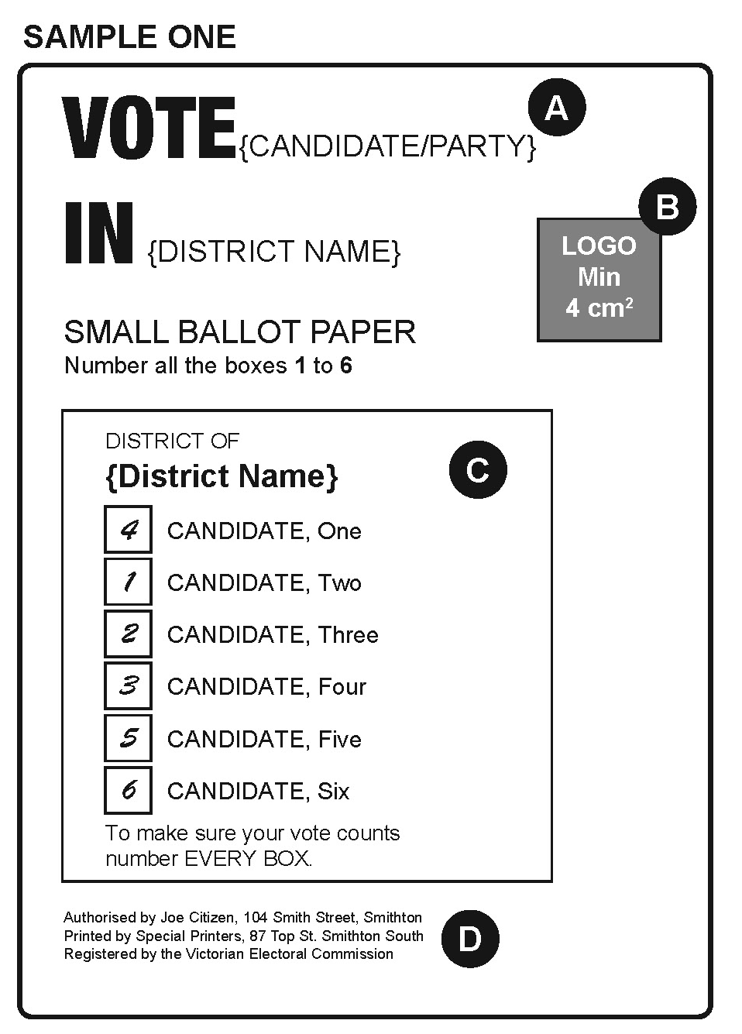
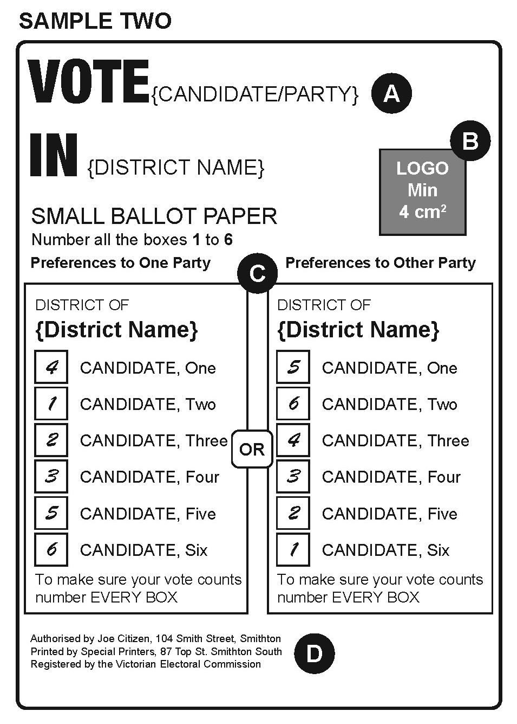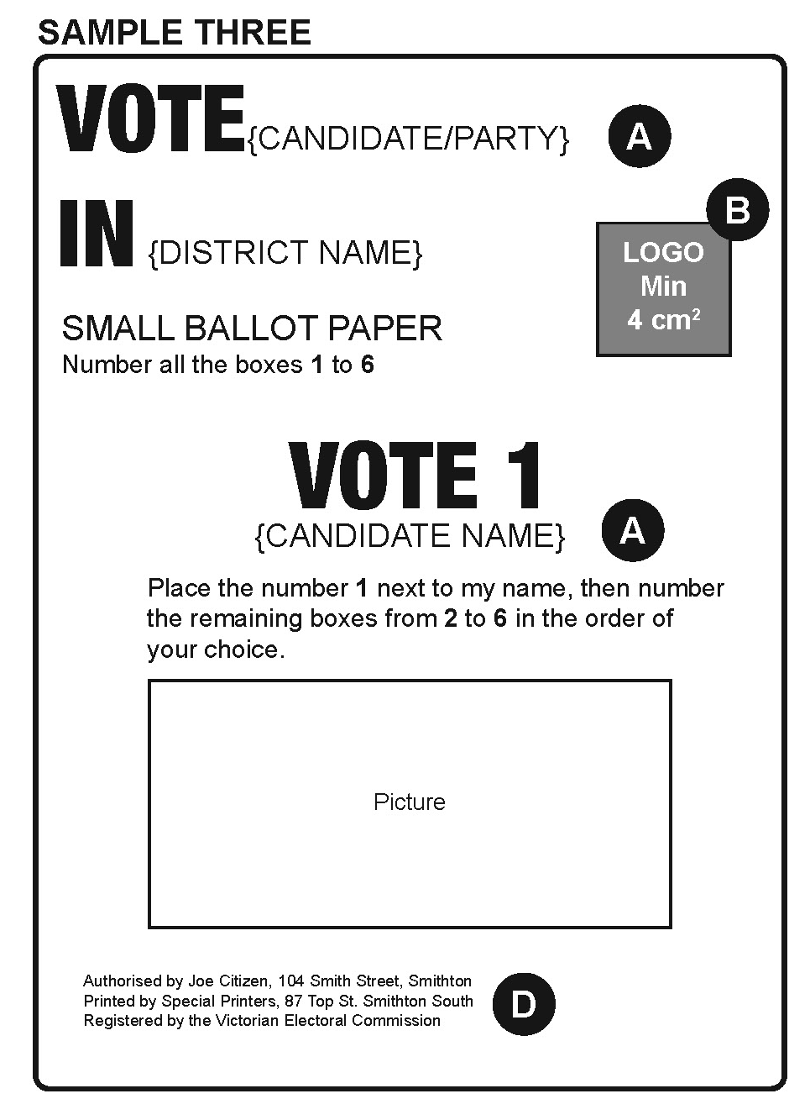

Region Card
- Clearly identifies the person, political party, organisation, or group on whose behalf the card is to be distributed.
- The size of any logo, emblem, or insignia belonging to the person or group on whose behalf the card is being distributed is at least 4cm².
- Indicates a voting preference for one group in a square above the line; or
Indicates a voting preference for all candidates whose names are printed on the ballot paper; or
Contains a statement to the effect that:
- the number 1 must be placed in the square in relation to the group for which the elector votes as first preference; or
- the number 1 must be placed opposite the name of the candidate for whom the elector votes as first preference and at least the numbers 2, 3, 4, and 5 opposite the names of the remaining candidates so as to indicate by unbroken numerical sequence the order of preference of contingent votes.
- Contains:
- the name and address of authoriser;
- the name and place of business of printer; and
- endorsement required to indicate registration.
The following examples are for a Region election with six groups, three ungrouped candidates, and a total of 22 candidates.
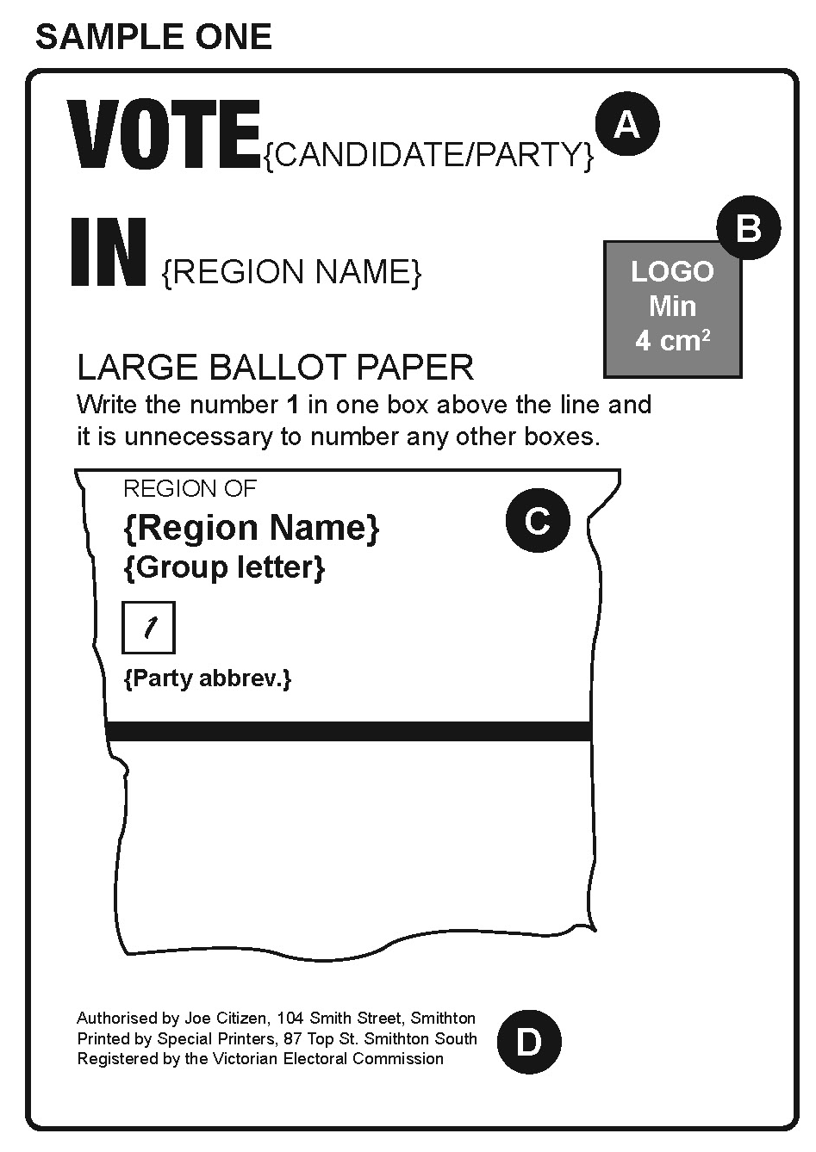
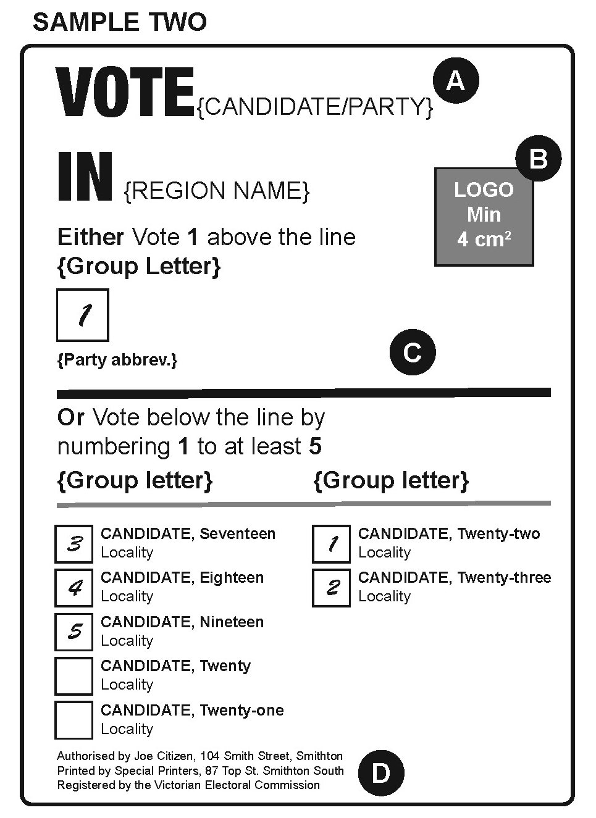
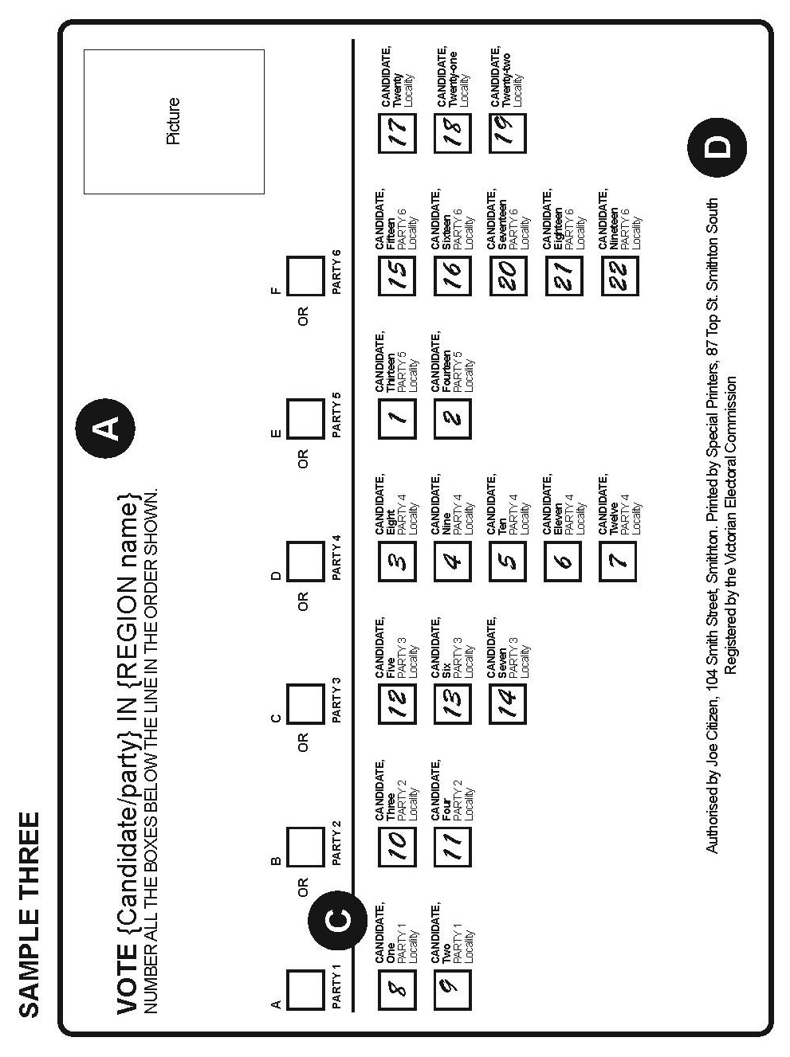

Combined District/Region Card (RPP’s ONLY)
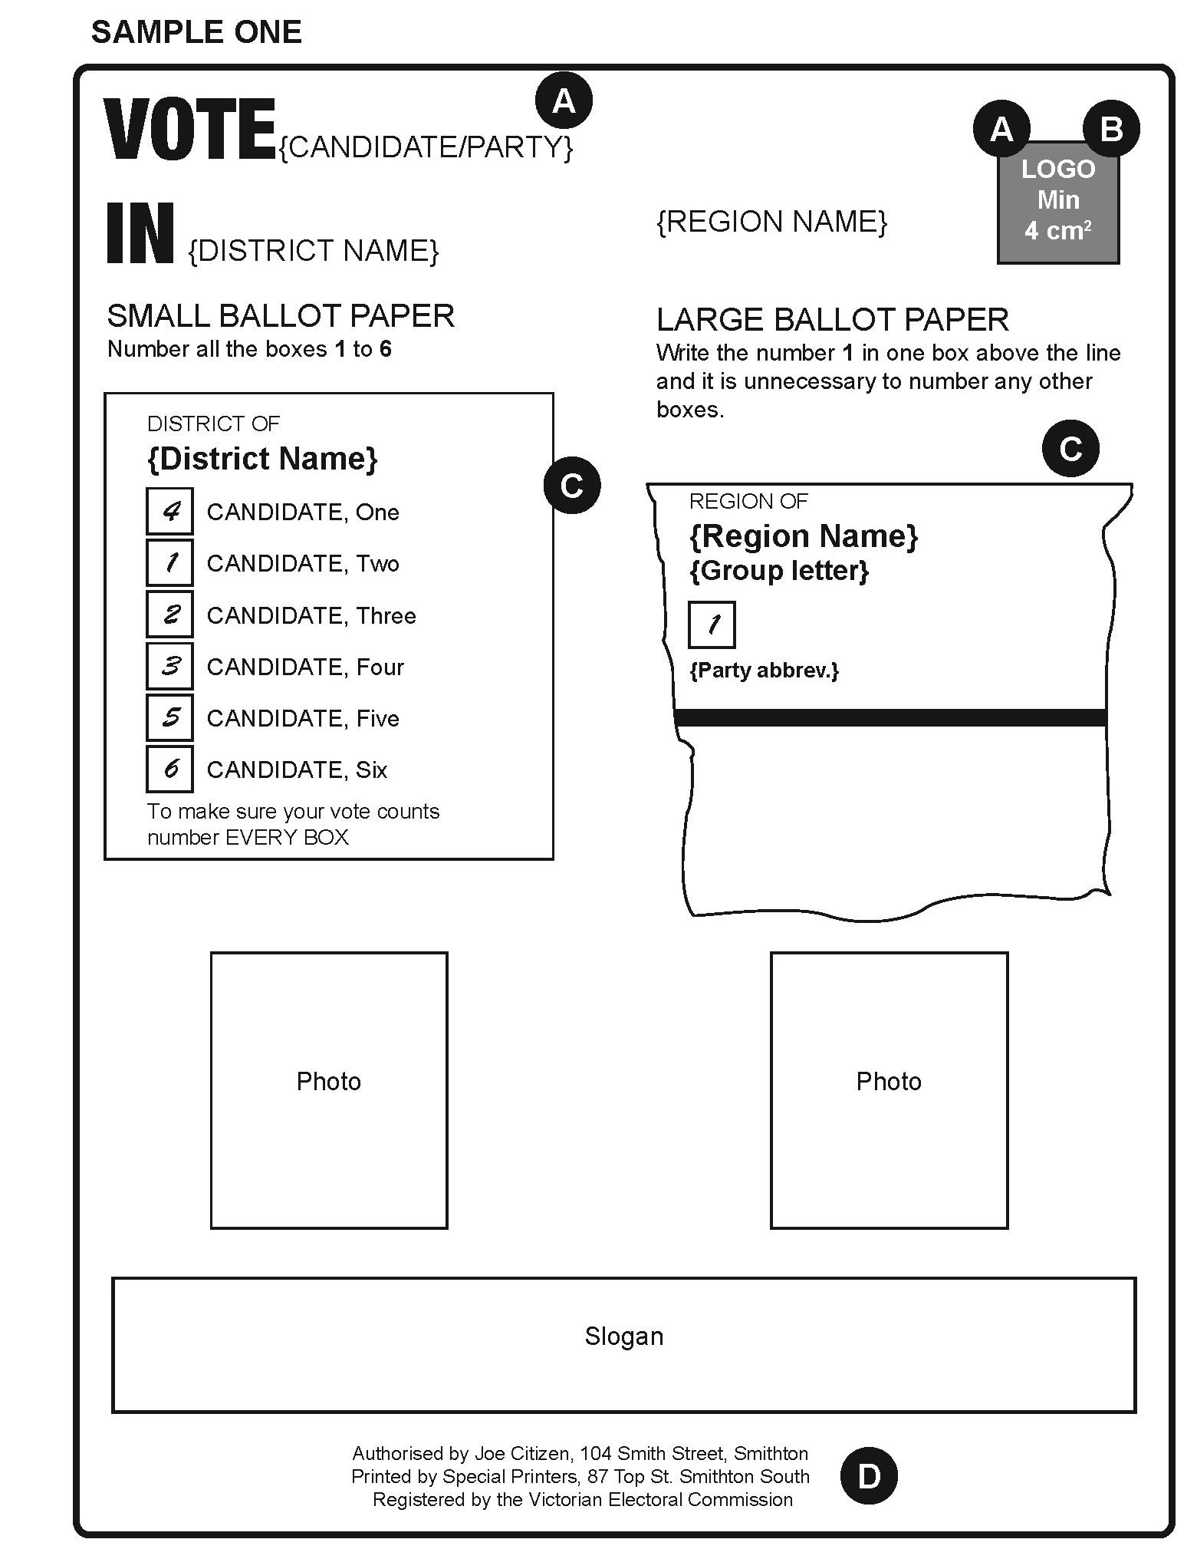

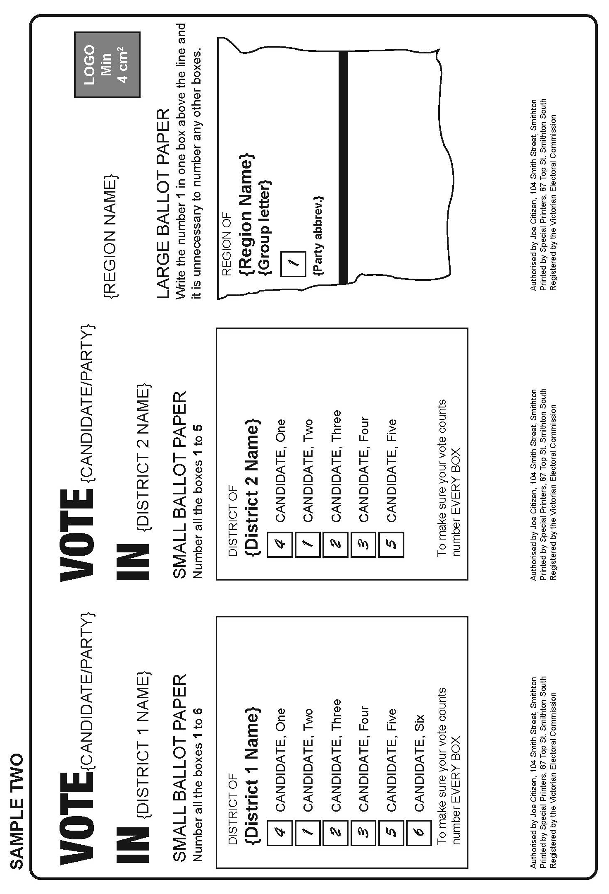

Appendix 3: Lower-House Counting Timetable
Date | Notes | Early Votes  Primary, 2CP and Recheck | Ordinary Votes  Primary, 2CP and Recheck | Absent Votes  Primary, 2CP and Recheck | Postal Votes  Primary, 2CP and Recheck | Marked as Voted (MAV) and Provisional Votes  Primary, 2CP and Recheck | Preference Distributions and Recounts | 2PP where required
Saturday 24 November | Election Day | 4.00 – 6.00 pm: Sort own District votes.  6.00 pm: Primary and 2CP count of own District votes. Sort other Districts. | Primary and 2CP count in voting centres | Commence sort/package of Absent votes for inclusion in dec exchange | 8.00 am: Extract and sort all admitted votes at Postal Vote Count Centre (PVCC).  6.00 pm: Primary and 2CP count. | Commence sort/package of MAV and Provisional votes for inclusion in dec exchange
Sunday 25 November | Preparation for dec exchange | Complete sort/package for dec exchange |  | Complete sort/package for dec exchange | Election offices package postal votes for dispatch to PVCC | Complete sort/package for dec exchange
Monday 26 November | Dec exchange collected | Correct any incorrect 2CPs.  Commence rechecks. | Correct any incorrect 2CPs.  Commence rechecks. |  | Correct any incorrect 2CPs.  Extraction and primary, 2CP and recheck counts for close seats only (at PVCC). | Provisional vote checking commences at VEC (close seats prioritised)
Tuesday 27 November | Dec exchange received | Complete 2CP corrections.  Continue Primary, 2CP and recheck counts. | Complete 2CP corrections.  Continue rechecks. | Commence marking absent votes off election roll | Complete 2CP corrections.  Commence rechecks. Continue counts for close seats only. | Commence primary, 2CP and recheck counts of admitted provisional votes
Wednesday 28 November |  | Continue Primary, 2CP and recheck counts | Complete rechecks | Commence primary, 2CP and recheck counts. | Continue rechecks.  Continue counts for close seats.
Thursday 29 November |  | Complete Primary, 2CP and recheck counts. |  | Complete primary, 2CP and recheck counts | Continue rechecks.  Continue counts for close seats. | Primary, 2CP and recheck all MAV votes.
Friday 30 November | Last day to accept postal votes into count (6.00 pm) |  |  |  | Complete rechecks.  Continue counts for close seats. | Complete checking at VEC.  Complete primary, 2CP and recheck counts of admitted provisional votes.
Saturday 1 December |  | Complete primary, 2CP and recheck counts of votes returned from interstate/ overseas (at PVCC) |  |  | Conduct primary, 2CP and recheck counts of remaining postal votes
Sunday 2 December
Monday 3 December |  | PVCC dispatches early votes to Districts requiring preference distributions |  |  | PVCC dispatches postal votes to Districts requiring preference distributions |  | Commence amalgamation (where preference distribution is required)
Tuesday 4 December |  |  |  |  |  |  | Commence preference distributions.  Commence recounts (where required)
Wednesday 5 December |  |  |  |  |  |  | Complete preference distributions.  Continue recounts (where required). | Commence 2PP counts
Thursday 6 December |  |  |  |  |  |  | Continue recounts (where required)
Friday 7 December |  |  |  |  |  |  | Complete any recounts
Saturday 8 December
Sunday 9 December
Monday 10 December |  |  |  |  |  |  |  | All 2PP counts completed
Tuesday 11 December
Wednesday 12 December
Thursday 13 December
Friday 14 December
Saturday 15 December | Last Day for Return of Writs
Notes:
This is a proposed timeline only. Timings are subject to change and close seats will have their timelines expedited where possible
Activities will occur at the election office unless stated otherwise
All primary counts will be followed by a 2CP distribution, and then a recheck of all ballot papers
2CP results will not be adjusted after rechecks are conducted. Therefore, there may be some minor variations between 2CP and recheck totals
District declarations will commence from Friday 30 November 2018

This page is intentionally left blank

This page is intentionally left blank



